Unit 5 Lesson 11: Generate Equivalent Fractions

WU Number Talk: Something Times 8 (Warm up)

Student Task Statement
Find the value of each expression mentally.
- $2×8$
- $6×8$
- $10×8$
- $12×8$

1 Show Equivalence

Student Task Statement
- The diagram represents 1.​​​​​​
  - What fraction does the shaded part of the diagram represent?
  - Jada says it represents $\frac{4}{8}$. Tyler is not so sure.
  - Do you agree with Jada? If so, explain or show how you would convince Tyler that Jada is correct. If not, explain or show your reasoning.
- Each diagram represents 1.
  - Show that the shaded part of this diagram represents both $\frac{1}{3}$ and $\frac{2}{6}$.
  - Show that the shaded part represents both $\frac{6}{8}$ and $\frac{3}{4}$.
  - Show that the shaded part represents both $\frac{6}{6}$ and $\frac{2}{2}$.

2 More Than One Name

Images for Launch
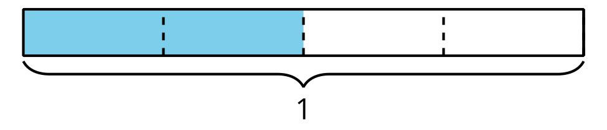

Student Task Statement
- Each diagram represents 1. Write two fractions to represent the shaded part of each diagram.

- Here’s another diagram.
- 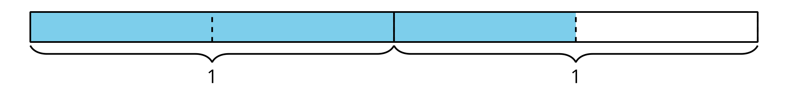
  - What fraction does the shaded part of the diagram represent?
  - Write another fraction that it represents.
© CC BY 2021 Illustrative Mathematics®

