Unit 2 Lesson 14: Find the Area of Figures with Missing Sides

WU Notice and Wonder: Mystery Sides (Warm up)

Student Task Statement
What do you notice? What do you wonder?
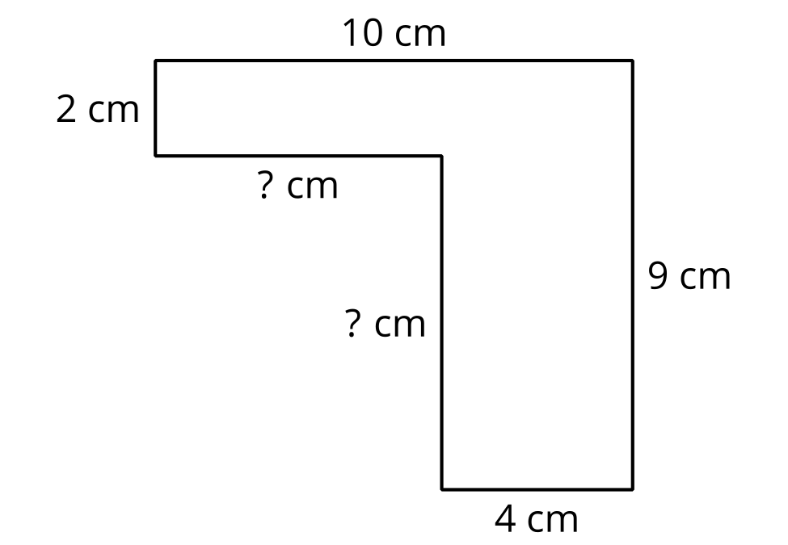

1 The Mystery Side

Student Task Statement
Tyler says that the missing side length is 5 meters because it looks longer than the sides that are 4 meters long.
Do you agree or disagree? Be prepared to explain your reasoning.
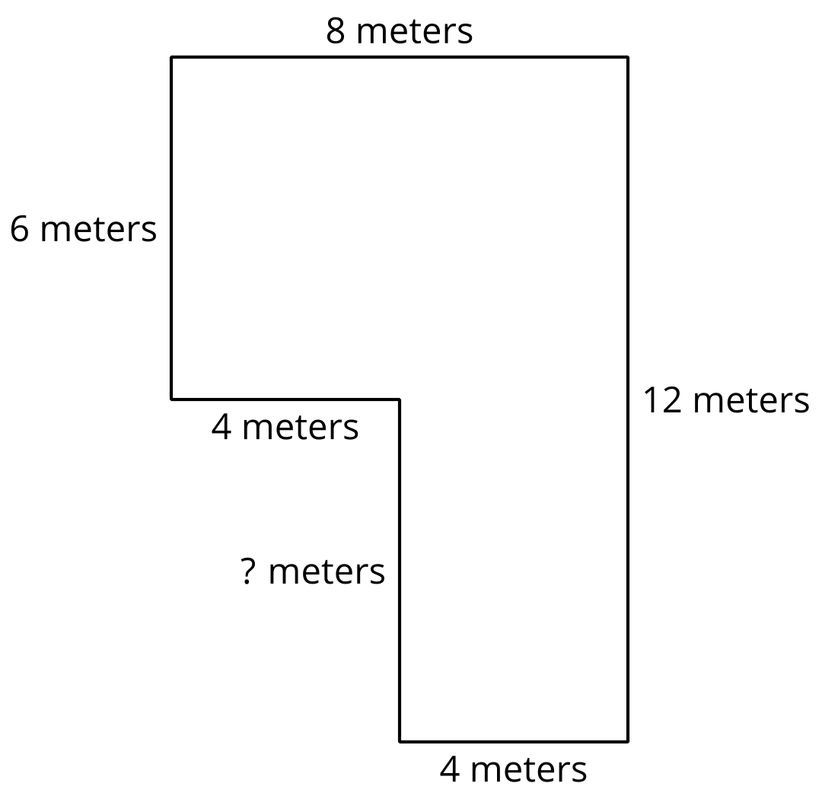

2 Practice with Mystery Sides

Student Task Statement
Find the area of each figure. Explain or show your reasoning.
A
B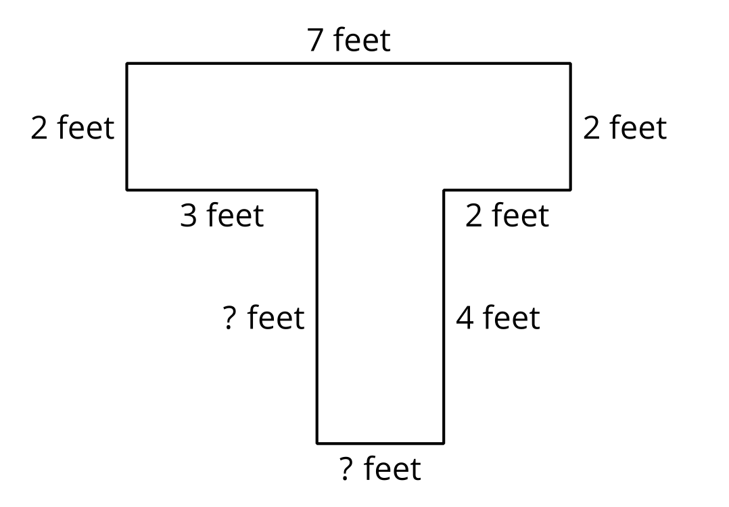
© CC BY 2021 Illustrative Mathematics®

