Lesson 4: Equal Groups of Non-Unit Fractions
- Let’s multiply any fraction by a whole number.

Warm-up: Notice and Wonder: Thirds
What do you notice? What do you wonder?
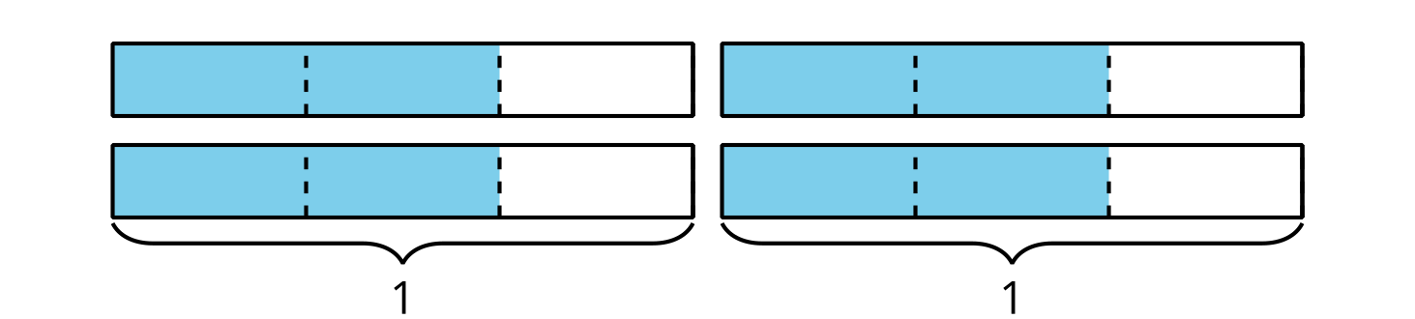

4.1: Jars of Jam
Elena fills 5 small jars with homemade jams to share with her friends. Each jar can fit $\frac{3}{4}$ cup of jam. How many cups of jam are in the jars? Explain or show your reasoning.
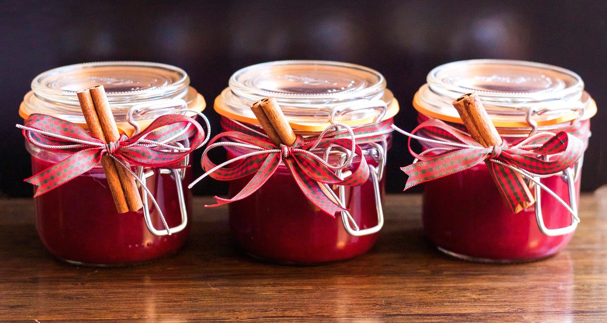
If you have time: Elena still has some jam left. She takes 2 large jars and puts $\frac{5}{4}$ cups of jam in each jar. How many cups of jam are in the jars?

4.2: How Do We Multiply?
- This diagram represents $\frac{2}{5}$.
  - Show how you would use or adjust the diagram to represent $4×\frac{2}{5}$.
  - What is the value of the shaded parts in your diagram?
- This diagram represents $\frac{5}{8}$.
  - Show how you would use or adjust the diagram to represent $3×\frac{5}{8}$.
  - What is the value of the shaded parts in your diagram?
- Find the value of each expression. Draw a diagram if you find it helpful. Be prepared to explain your reasoning.
  - $2×\frac{1}{6}$
  - $2×\frac{4}{6}$
  - $2×\frac{5}{6}$
  - $4×\frac{5}{6}$
- Mai said that to multiply any fraction by a whole number, she would multiply the whole number and the numerator of the fraction and keep the same denominator. Do you agree with Mai? Explain your reasoning.
© CC BY 2021 Illustrative Mathematics®

