Unit 4 Lesson 1: Size of Divisor and Size of Quotient

1 Number Talk: Size of Dividend and Divisor (Warm up)

Student Task Statement
Find the value of each expression mentally.
$5,​000÷5$
$5,​000÷2,​500$
$5,​000÷10,​000$
$5,​000÷500,​000$

2 All Stacked Up

Student Task Statement
- Here are several types of objects. For each type of object, estimate how many are in a stack that is 5 feet high. Be prepared to explain your reasoning.
- Cardboard boxes
- 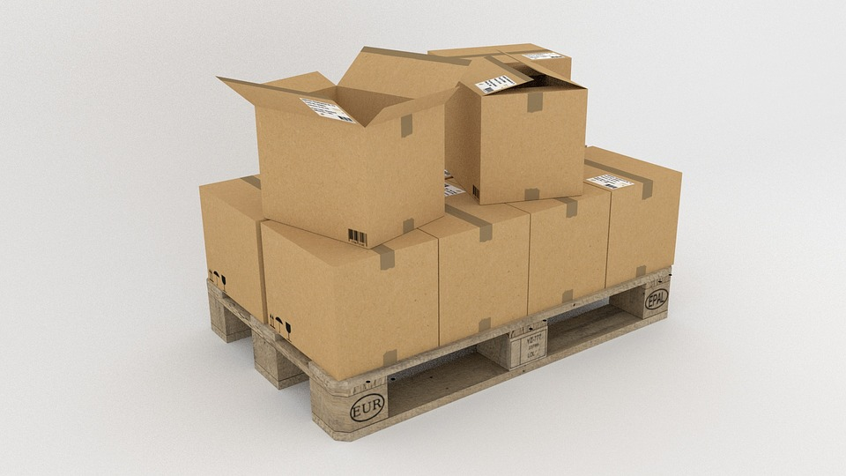
- Bricks
- 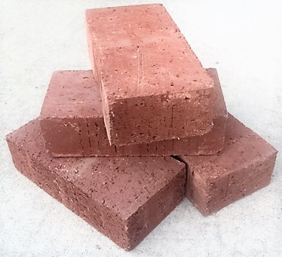
- Notebooks
- 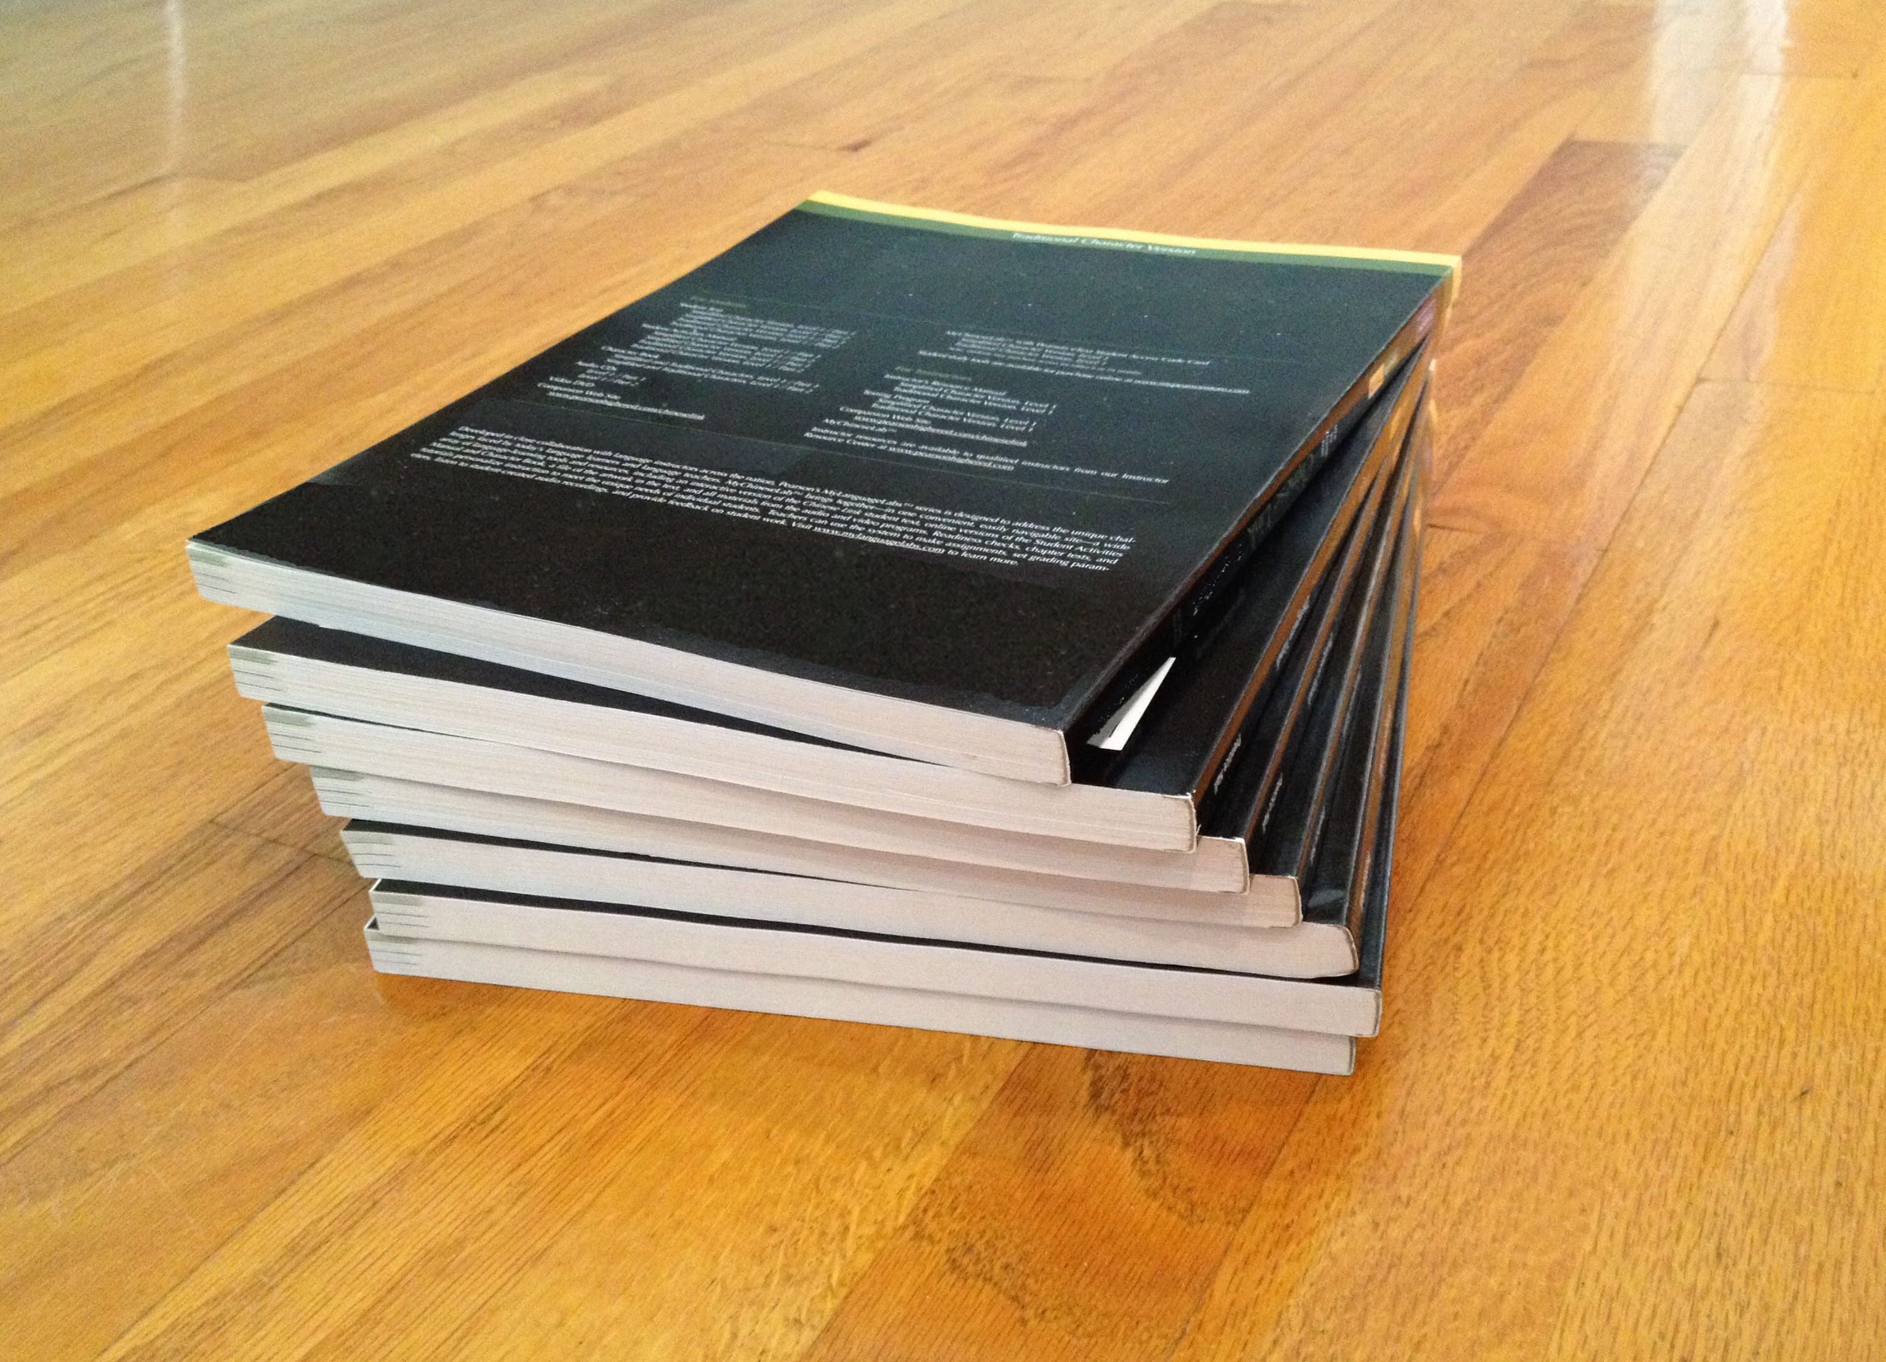
- Coins
- A stack of books is 72 inches tall. Each book is 2 inches thick. Which expression tells us how many books are in the stack? Be prepared to explain your reasoning.
  - $72⋅2$
  - $72−2$
  - $2÷72$
  - $72÷2$
- Another stack of books is 43 inches tall. Each book is $\frac{1}{2}$-inch thick. Write an expression that represents the number of books in the stack.

3 All in Order

Student Task Statement
Your teacher will give you two sets of papers with division expressions.
- Without computing, estimate the quotients in each set and order them from greatest to least. Be prepared to explain your reasoning.
- Pause here for a class discussion.
- Record the expressions in each set in order from the greatest value to the least.
  - Set 1
  - Set 2
- Without computing, estimate the quotients and sort them into the following three groups. Be prepared to explain your reasoning.
- $30÷\frac{1}{2}$
- $30÷0.45$
- $9÷10$
- $9÷10,​000$
- $18÷19$
- $18÷0.18$
- $15,​000÷1,​500,​000$
- $15,​000÷14,​500$
  - Close to 0
  - Close to 1
  - Much larger than 1
© CC BY Open Up Resources. Adaptations CC BY IM.

