Lesson 10: Are There Enough?
- Let’s figure out if there are enough supplies for everyone.

Warm-up: How Many Do You See: Building On
How many do you see?
How do you see them?

10.1: Act It Out: Four Little Speckled Frogs (Part 1)
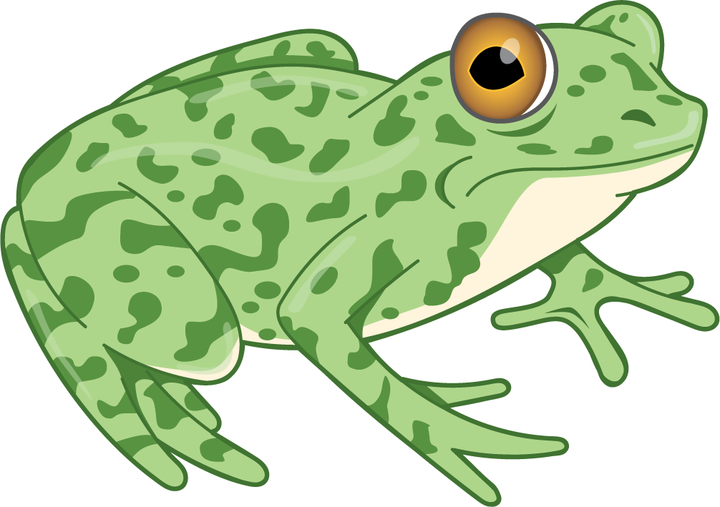
4 little speckled frogs sat on a speckled log,
eating the most delicious bugs. Yum! Yum!
1 jumped into the pool, where it was nice and cool.
Now there are 3 green speckled frogs. Glub! Glub!

10.3: Centers: Choice Time
Choose a center.
Geoblocks
Connecting Cubes
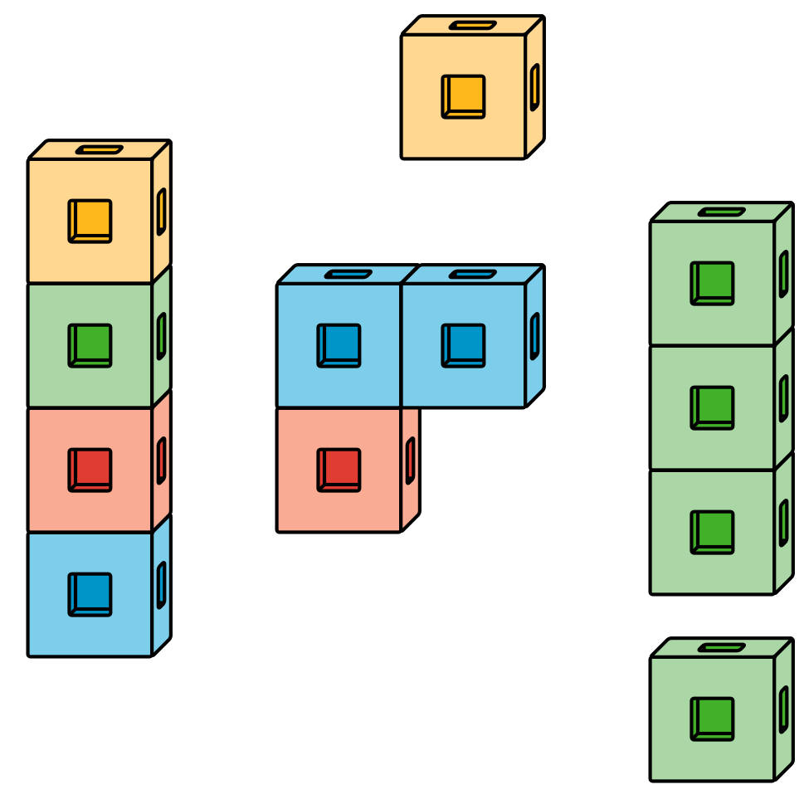
Pattern Blocks
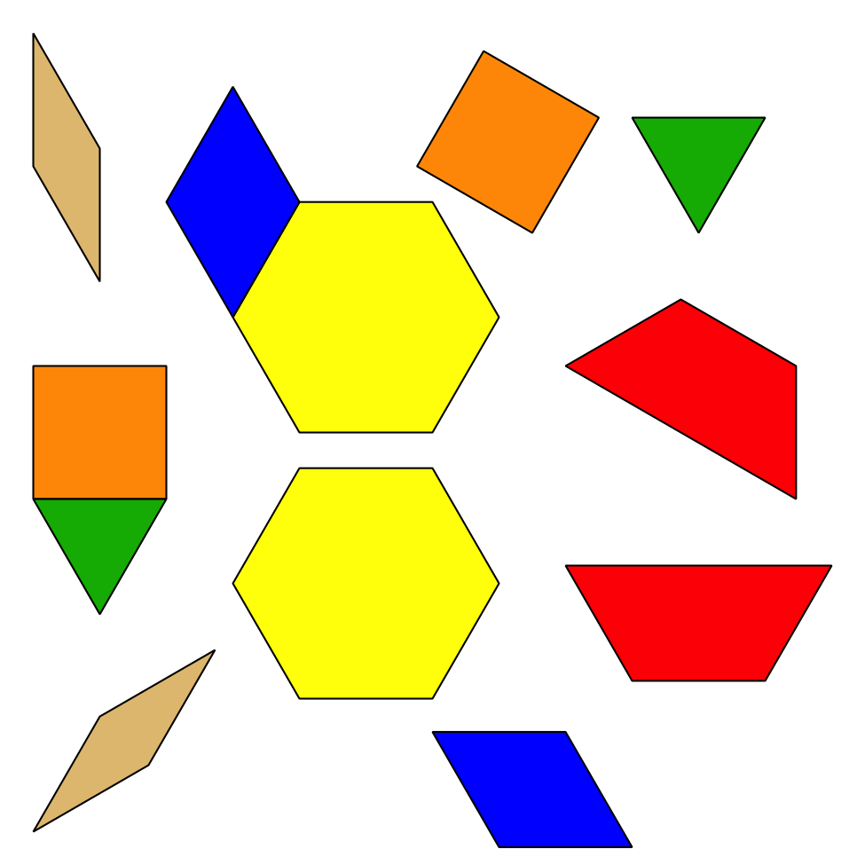
Picture Books
© CC BY 2021 Illustrative Mathematics®

