Lesson 17 Practice Problems
- The population of a city in 2010 is 50,000, and it grows by 5% each year after.
  - Write a function $f$ which models the population of the city $t$ years after 2010.
  - What is the population of the city in 2017?
  - What will the population of the city be in 2020? What about in 2030?
  - By what factor does the population grow between 2010 and 2020? What about between 2020 and 2030?
- A person charges $100 to a credit card with a 24% nominal annual interest rate.
- Assuming no other charges or payments are made, find the balance on the card, in dollars, after 1 year if interest is calculated:
  - annually
  - every 6 months
  - every 3 months
  - monthly
  - daily
- A couple has $5,000 to invest and has to choose between three investment options.
  - Option A: $2\frac{1}{4}\%$ interest applied each quarter
  - Option B: $3\%$ interest applied every 4 months
  - Option C: $4\frac{1}{2}\%$ interest applied twice each year
- If they plan on no deposits and no withdrawals for 5 years, which option will give them the largest balance after 5 years? Use a mathematical model for each option to explain your choice.
- Elena says that 6% interest applied semi-annually is the same as 1% interest applied every month: she reasons they are the same because they are both a 12% nominal annual interest rate.
  - Is Elena correct that these two situations both offer a 12% nominal annual interest rate?
  - Is Elena correct that the two situations pay the same amount of interest?
- A bank pays 8% annual interest, compounded at the end of each month. An account starts with $600, and no further withdrawals or deposits are made.
  - What is the monthly interest rate?
  - Write an expression for the account balance, in dollars, after one year.
  - What is the effective annual interest rate?
  - Write an expression for the account balance, in dollars, after $t$ years.
- At the end of each year, 10% interest is charged on a $500 loan. The interest applies to any unpaid balance on the loan, including previous interest.
- Select all the expressions that represent the loan balance after two years if no payments are made.
  - $500+2⋅(0.1)⋅500$
  - $500⋅(1.1)⋅(1.1)$
  - $500+(0.1)+(0.1)$
  - $500⋅(1.1)^{2}$
  - $(500+50)⋅(1.1)$
- (From Unit 5, Lesson 15.)
- Here is a graph of the function $f$ given by $f(x)=100⋅2^{x}$.
- Suppose $g$ is the function given by $g(x)=50⋅(1.5)^{x}$.
- Will the graph of $g$ meet the graph of $f$ for any positive value of $x$? Explain how you know.
- 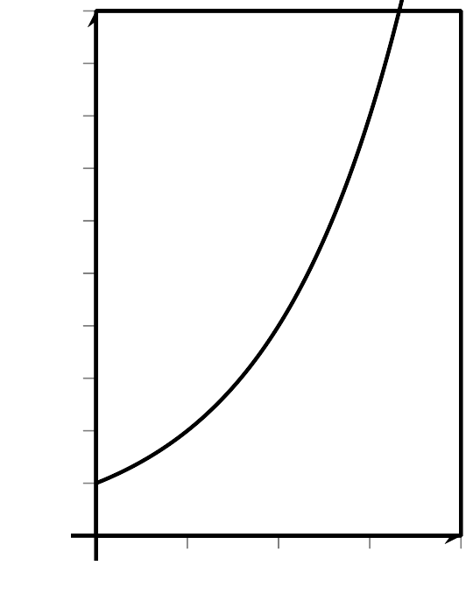
- (From Unit 5, Lesson 12.)
- Suppose $m$ and $c$ each represent the position number of a letter in the alphabet, but $m$ represents the letters in the original message, and $c$ represents the letters in a secret code.
- The equation $c=m+7$ is used to encode a message.
  - Write an equation that can be used to decode the secret code into the original message.
  - What does this code say: "AOPZ PZ AYPJRF!"?
- (From Unit 4, Lesson 15.)
© CC BY 2019 by Illustrative Mathematics®

