Lesson 7 Practice Problems
- Find two numbers that...
  - multiply to -40 and add to -6.
  - multiply to -40 and add to 6.
  - multiply to -36 and add to 9.
  - multiply to -36 and add to -5.
- If you get stuck, try listing all the factors of the first number.
- Create a diagram to show that $\left(x−5\right)\left(x+8\right)$ is equivalent to $x^{2}+3x−40$.
- Write a $+$ or a $−$ sign in each box so the expressions on each side of the equal sign are equivalent.
  - x 30 18x 30 3=x2−15x−54
  - x 30 18x 30 3=x2+21x+54
  - x 30 18x 30 3=x2+15x−54
  - x 30 18x 30 3=x2−21x+54
- Match each quadratic expression in standard form with its equivalent expression in factored form.​​​​​​
  - $x^{2}−2x−35$
  - $x^{2}+12x+35$
  - $x^{2}+2x−35$
  - $x^{2}−12x+35$
  - $\left(x+5\right)\left(x+7\right)$
  - $\left(x−5\right)\left(x−7\right)$
  - $\left(x+5\right)\left(x−7\right)$
  - $\left(x−5\right)\left(x+7\right)$
- Rewrite each expression in factored form. If you get stuck, try drawing a diagram.
  - $x^{2}−3x−28$
  - $x^{2}+3x−28$
  - $x^{2}+12x−28$
  - $x^{2}−28x−60$
- Which equation has exactly one solution?
  - $x^{2}=\text{-}4$
  - ${\left(x+5\right)}^{2}=0$
  - $\left(x+5\right)\left(x−5\right)=0$
  - ${\left(x+5\right)}^{2}=36$
- (From Unit 7, Lesson 5.)
- The graph represents the height of a passenger car on a ferris wheel, in feet, as a function of time, in seconds since the ride starts.
- Use the graph to help you:
  - Find $H\left(0\right)$.
  - Does $H\left(t\right)=0$ have a solution? Explain how you know.
  - Describe the domain of the function.
  - Describe the range of the function.
- 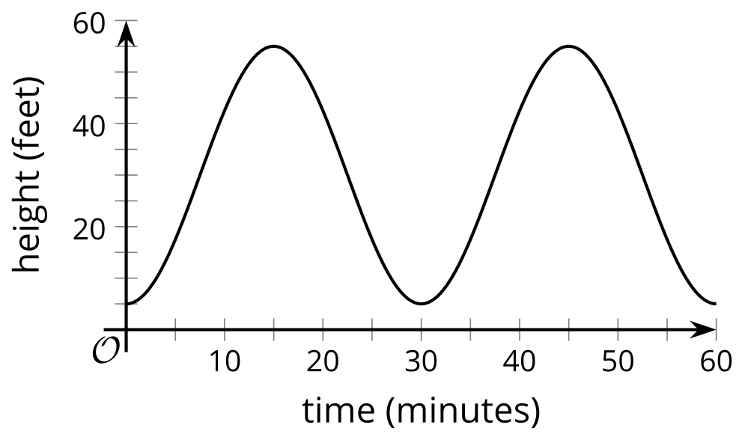
- (From Unit 4, Lesson 11.)
- Elena solves the equation $x^{2}=7x$ by dividing both sides by $x$ to get $x=7$. She says the solution is 7.
- Lin solves the equation $x^{2}=7x$ by rewriting the equation to get $x^{2}−7x=0$. When she graphs the equation $y=x^{2}−7x$, the $x$-intercepts are $\left(0,0\right)$ and $\left(7,0\right)$. She says the solutions are 0 and 7.
- Do you agree with either of them? Explain or show how you know.
- (From Unit 7, Lesson 5.)
- A bacteria population, $p$, can be represented by the equation $p=100,​000⋅{\left(\frac{1}{4}\right)}^{d}$, where $d$ is the number of days since it was measured.
  - What was the population 3 days before it was measured? Explain how you know.
  - What is the last day when the population was more than 1,000,000? Explain how you know.
- (From Unit 5, Lesson 7.)
© CC BY 2019 by Illustrative Mathematics®

