Lesson 14 Practice Problems
- Select all quadrilaterals for which a diagonal is also a line of symmetry.
  - trapezoid
  - isosceles trapezoid
  - parallelogram
  - rhombus
  - rectangle
  - square
- Show that diagonal $EG$ is a line of symmetry for rhombus $EFGH$.
- 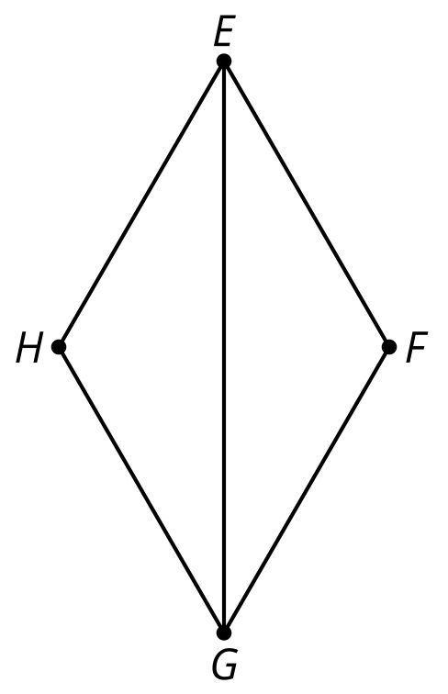
- $ABDE$ is an isosceles trapezoid. Priya makes a claim that triangle $AEB$ is congruent to triangle $DBE$. Convince Priya this is not true.
- 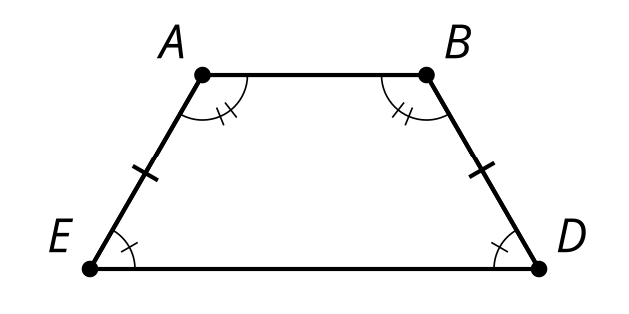

- (From Unit 2, Lesson 13.)
- In quadrilateral $ABCD$, triangle $ADC$ is congruent to $CBA$. Show that $ABCD$ is a parallelogram.
- 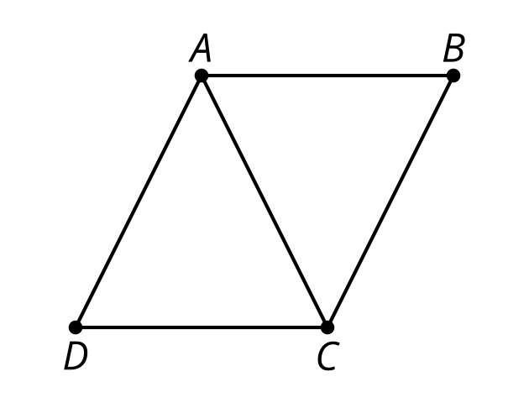

- (From Unit 2, Lesson 13.)
- Priya is convinced the diagonals of the isosceles trapezoid are congruent. She knows that if she can prove triangles congruent that include the diagonals, then she will show that diagonals are also congruent. Help her complete the proof.
- $ABDE$ is an isosceles trapezoid.
- Draw auxiliary lines that are diagonals $\underset{_}{1}$ and $\underset{_}{2}$. $AB$ is congruent to $\underset{_}{3}$because they are the same segment. We know angle $B$ and $\underset{_}{4}$ are congruent. We know $AE$ is congruent to $\underset{_}{5}$. Therefore, triangle $ABE$ and $\underset{_}{6}$ are congruent because of $\underset{_}{7}$. Finally, diagonal $BE$ is congruent to $\underset{_}{8}$ because $\underset{_}{9}$.
- (From Unit 2, Lesson 12.)
- Is triangle $AFE$ congruent to triangle $ADE$?
Explain your reasoning.

- $\overset{¯}{AF}≅\overset{¯}{AD},∠F≅∠D$
- 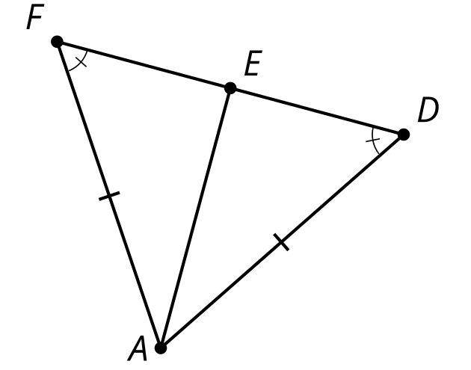
- (From Unit 2, Lesson 11.)
- Triangle $DAC$ is isosceles with congruent sides $AD$ and $AC$. Which additional given information is sufficient for showing that triangle $DBC$ is isosceles? Select all that apply.
- 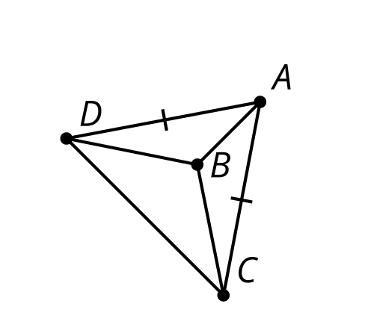
  - Segment $DB$ is congruent to segment $BC$.
  - Segment $AB$ is congruent to segment $BD$.
  - Angle $ABD$ is congruent to angle $ABC$.
  - Angle $ADC$ is congruent to angle $ACD$.
  - $AB$ is an angle bisector of $DAC$.
  - Triangle $BDA$ is congruent to triangle $BDC$.
- (From Unit 2, Lesson 6.)
© CC BY 2019 by Illustrative Mathematics®

