Lesson 15: Animals in the Jungle
- Let’s make a survey and collect and show data.

Warm-up: Notice and Wonder: Wild Animals
What do you notice?
What do you wonder?
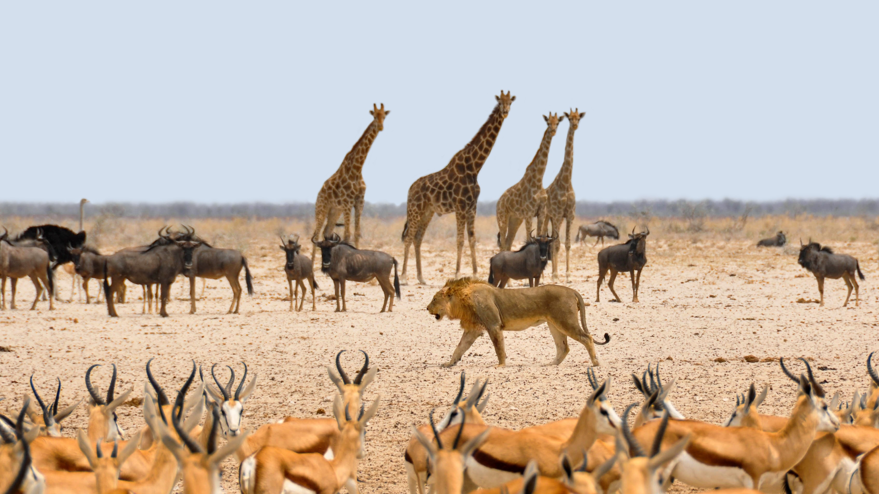

15.1: Collect Survey Data
Let’s survey our classmates.
- Circle 1 question:
  - Which animal would you like to meet in real life?
  - If you could spend one day as an animal, which one would you choose?
  - Which animal would you like to spend vacation with?
  - Which animal would you like to talk to?
- Animal choices:
- Collect and record 10 responses.

15.2: Ask Our Own Questions
Let’s come up with questions about our data and answer them.

15.3: Share Data
Let’s make posters to share what we learned from our surveys.
© CC BY 2021 Illustrative Mathematics®

