Unit 4 Lesson 6: Center Day 1

WU Number Talk: Decompose and Subtract (Warm up)

Student Task Statement
Find the value of each expression mentally.
- $65−25$
- $65−27$
- $55−17$
- $46−18$

1 Introduce Number Line Scoot, Twos, Fives, and Tens

Student Task Statement

2 Centers: Choice Time

Student Task Statement
Choose a center.
Capture Squares
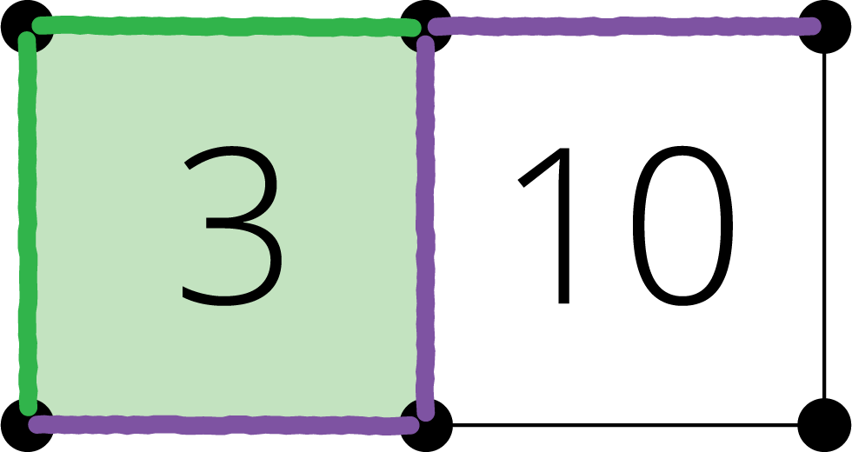
Number Line Scoot
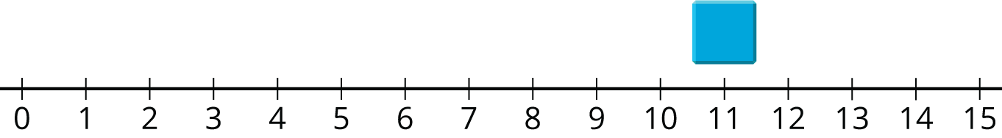
Number Puzzles
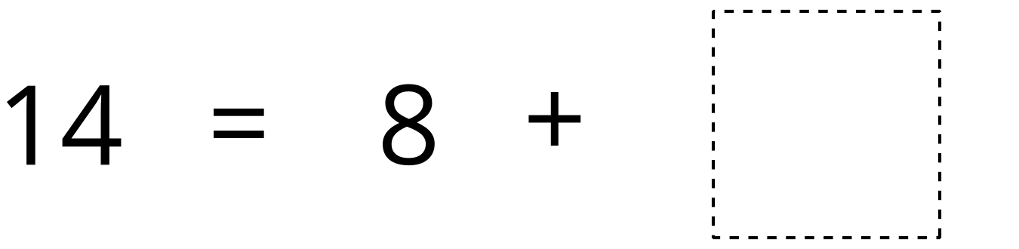
© CC BY 2021 Illustrative Mathematics®

