Unit 5 Lesson 12: Equivalent Fractions on a Number Line

WU Notice and Wonder: Running on a Trail (Warm up)

Student Task Statement
What do you notice? What do you wonder?
Tyler ran part of the length of a trail.
Han ran part of the length of the same trail.
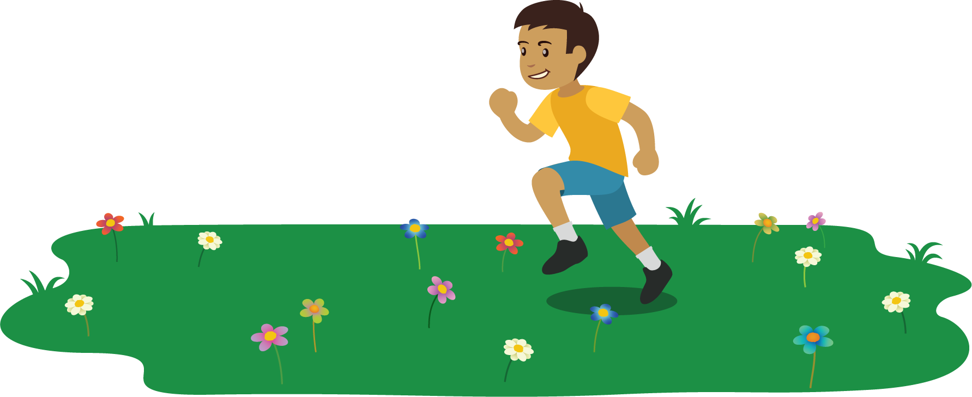

1 Running Part of a Trail

Student Task Statement
Some students are running on a trail at a park. Decide if each pair of students ran the same distance.
You can use number lines if they are helpful to you.
- Elena ran $\frac{3}{6}$ of the trail.
- Han ran $\frac{1}{2}$ of the trail.
- Jada ran $\frac{1}{4}$ of the trail.
- Kiran ran $\frac{2}{8}$ of the trail.
- Lin ran $\frac{2}{3}$ of the trail.
- Mai ran $\frac{5}{6}$ of the trail.

2 Locate and Pair

Student Task Statement
- Locate and label the following numbers on a number line. You can use more than one number line if you wish.
- $\frac{1}{2}$, $\frac{1}{3}$, $\frac{1}{4}$, $\frac{2}{3}$, $\frac{2}{6}$, $\frac{3}{8}$, $\frac{3}{4}$, $\frac{4}{6}$, $\frac{4}{8}$, $\frac{6}{8}$, $\frac{7}{8}$
- Find 4 pairs of fractions that are equivalent. Write equations to represent them.
- $\underset{_}{}=\underset{_}{}$
- $\underset{_}{}=\underset{_}{}$
- $\underset{_}{}=\underset{_}{}$
- $\underset{_}{}=\underset{_}{}$
If you have time: Use the number lines to generate as many equivalent fractions as you can.

3 Rolling for Equivalent Fractions

Student Task Statement
- Roll 6 number cubes. If you roll any fives, they count as a wild card and can be any number you’d like.
- Can you put the numbers you rolled in the boxes to make a statement that shows equivalent fractions? Work with your partner to find out.
- If you cannot, re-roll as many number cubes as you’d like. You can re-roll your number cubes twice.
- If you can make equivalent fractions, record your statement and show or explain how you know the fractions are equivalent. You get 1 point for each pair of equivalent fractions you write.
Round 1:
333333333333=333333333333
Show or explain how your fractions are equivalent.
Round 2:
333333333333=333333333333
Show or explain how your fractions are equivalent.
Round 3:
333333333333=333333333333
Show or explain how your fractions are equivalent.
Round 4:
333333333333=333333333333
Show or explain how your fractions are equivalent.
Round 5:
333333333333=333333333333
Show or explain how your fractions are equivalent.
Round 6:
333333333333=333333333333
Show or explain how your fractions are equivalent.
Round 7:
333333333333=333333333333
Show or explain how your fractions are equivalent.
Round 8:
333333333333=333333333333
Show or explain how your fractions are equivalent.
© CC BY 2021 Illustrative Mathematics®

