Unit 3 Lesson 3: Are the Expressions Equal?

WU How Many Do You See: Sums within 10 (Warm up)

Student Task Statement
How many do you see?
How do you see them?
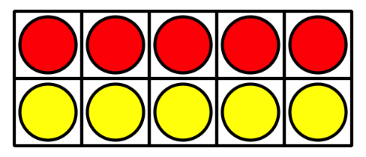
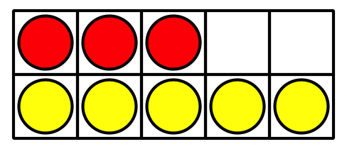
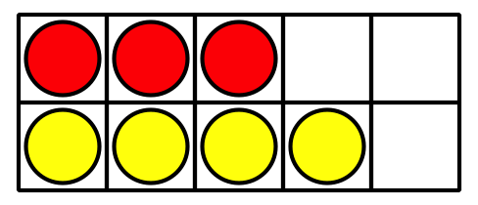

1 Sort Addition Expressions

Student Task Statement

2 Are Both Sides Equal?

Student Task Statement
Determine whether each equation is true or false.
Be ready to explain your reasoning in a way that others will understand.
- $4+2=2+4$
- 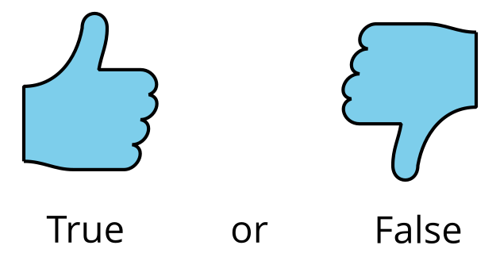
- $3+6=6+4$
- $5+3=1+7$
- $6+4=5+3$
- $6+3=9+2$
If you have time: Change the false equations to make them true.
© CC BY 2021 Illustrative Mathematics®

