Lesson 5: Equivalent Multiplication Expressions
- Let's write multiplication expressions in different ways.

Warm-up: How Many Do You See?
How many thirds do you see? How do you see them?
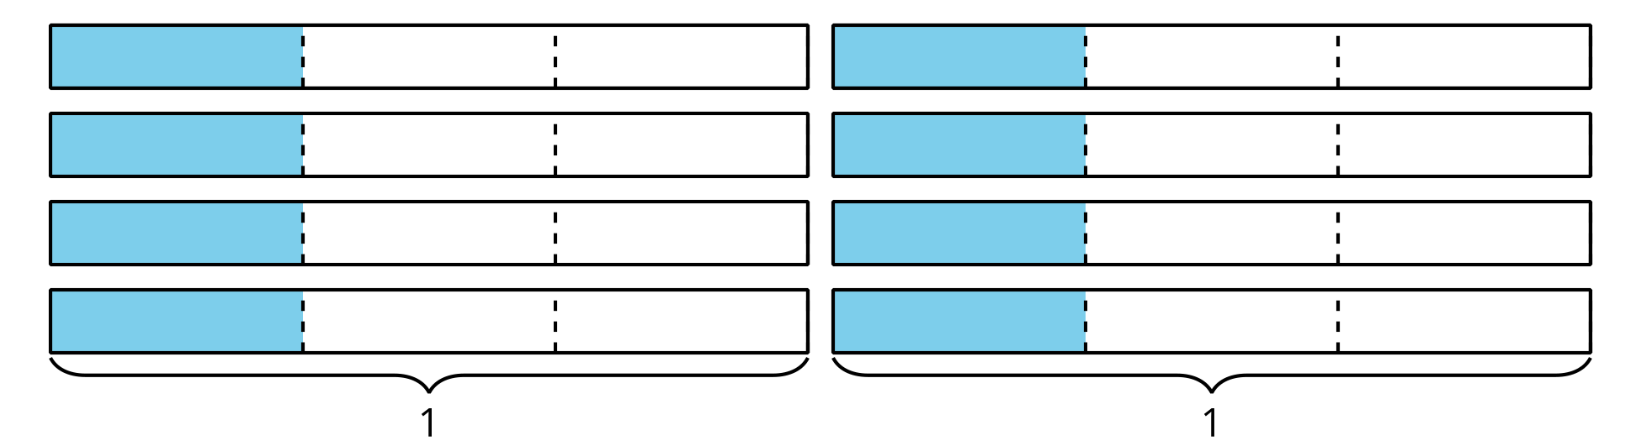

5.1: Complete the Equations
- Find the number that makes each equation true. Draw a diagram if it is helpful.
- $\frac{12}{5}=12×\underset{_}{​}$
- $\frac{12}{5}=6×\underset{_}{​}$
- $\frac{12}{5}=4×\underset{_}{​}$
- $\frac{12}{5}=3×\underset{_}{​}$
- $\frac{12}{5}=2×\underset{_}{​}$
- $\frac{12}{5}=1×\underset{_}{​}$
- Here are two sets of numbers:
- Set A:
- 1, 2, 3, 4, 5, 6, 7, 8, 9, 10, 11
- Set B:
- $\frac{1}{7},\frac{2}{7},\frac{3}{7},\frac{4}{7},\frac{5}{7},\frac{6}{7},\frac{7}{7}$
  - Choose a number from set A and a number from set B to complete this equation and make it true:
  - $\frac{6}{7}=\underset{_}{​}×\underset{_}{​}$
  - Choose a different number from set A and a number from set B to complete the equation to make it true.
  - $\frac{6}{7}=\underset{_}{​}×\underset{_}{​}$
- Explain or show how you know that the two equations you wrote are both true.

5.2: Fractions and Matching Expressions
Here is a set of expressions.
A.
$6×\frac{1}{10}$
B.
$2×4×\frac{1}{9}$
C.
$4×\frac{1}{5}$
D.
$3×2×\frac{1}{10}$
E.
$5×2×\frac{1}{12}$
F.
$2×2×\frac{1}{5}$
G.
$4×4×\frac{1}{9}$
H.
$10×\frac{1}{12}$
I.
$4×\frac{1}{12}$
- Match each expression to one of the following fractions, if possible. Record your matches. Be prepared to explain how you know there is or isn't a match.
- $\frac{4}{5}$
- $\frac{10}{12}$
- $\frac{6}{10}$
- $\frac{8}{9}$
- Complete each equation to make it true. Try to do so without using unit fractions.
  - $\frac{4}{5}=\underset{_}{​}×\underset{_}{​}$
  - $\frac{4}{5}=\underset{_}{​}×\underset{_}{​}$
  - $\frac{10}{12}=\underset{_}{​}×\underset{_}{​}$
  - $\frac{10}{12}=\underset{_}{​}×\underset{_}{​}$
  - $\frac{6}{10}=\underset{_}{​}×\underset{_}{​}$
  - $\frac{6}{10}=\underset{_}{​}×\underset{_}{​}$
  - $\frac{8}{9}=\underset{_}{​}×\underset{_}{​}$
  - $\frac{8}{9}=\underset{_}{​}×\underset{_}{​}$
© CC BY 2021 Illustrative Mathematics®

