Lesson 1: Patterns that Grow

Standards Alignments
Addressing | 4.OA.C.5
Building Towards | 4.OA.C.5

Teacher-facing Learning Goals
- Analyze and describe number and shape patterns.

Student-facing Learning Goals
- Let's describe patterns and think about what might come next.

Lesson Purpose
The purpose of this lesson is for students to analyze, describe, and extend visual patterns in which one or more shapes grow by a rule.
In grade 3, students identified patterns in numbers and used mathematical operations to explain them. In this lesson and the next few, students continue the work of analyzing and describing shape and number patterns, looking for features of patterns that are not apparent in the rule.
The patterns in this lesson consist of shapes that use an increasing number of objects in each step. Students describe not only the rule of the pattern (that is, how the number of objects is changing), but also any features of the patterns that are not explicit in the rule. They also extend patterns and make predictions by looking for and making use of structure (MP7), rather than by drawing or writing out each step along the way.

Access for:

Students with Disabilities
- Action and Expression (Activity 1)

English Learners
- MLR2 (Activity 1)

Instructional Routines
5 Practices (Activity 2), MLR7 Compare and Connect (Activity 2), Notice and Wonder (Warm-up)

Materials to Gather
- Pattern blocks: Activity 2

Lesson Timeline
Warm-up | 10 min
Activity 1 | 15 min
Activity 2 | 20 min
Lesson Synthesis | 10 min
Cool-down | 5 min

Teacher Reflection Question
Reflect on whose thinking was heard today. Reflect on whose thinking was not heard but could have enriched the conversations. What prompts or structures might better enable the latter to share their voices and reasoning?

Cool-down
(to be completed at the end of the lesson) 5min
Andre's House Pattern

Standards Alignments
Addressing | 4.OA.C.5

Student-facing Task Statement
Andre used pattern blocks to make houses in a pattern. For each new step, he adds a new “floor” made of squares. The triangles are used for the roof of the house.
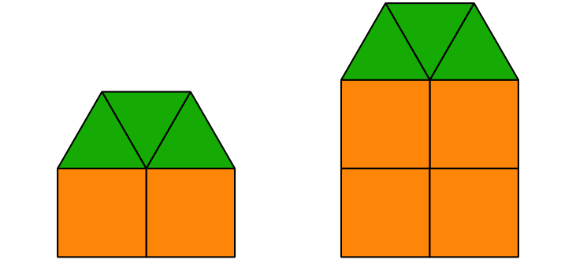
- Draw the next step in Andre’s pattern.
- If Andre continues the pattern:
  - How many triangles will Andre use in the 15th house? Explain or show your reasoning.
  - How many squares will Andre use in the 15th house? Explain or show your reasoning.

Student Responses
- See drawing.

  - Andre will use 3 triangles. Sample response: I know because the number of triangles is not changing.
  - Andre will use 30 squares. Sample response: He adds a row of 2 squares each time. The 15th house will have 15 rows or $15×2$ squares.
