Lesson 3: Measuring with Different-Sized Units

3.1: Width of a Paper
Your teacher will show you two rods. Does it take more green rods or blue rods lined up end to end to measure the width of a piece of printer paper?

3.2: Measurement Stations
Station 1
- Each large cube is 1 cubic inch. Count how many cubic inches completely pack the box without gaps.
- Each small cube is 1 cubic centimeter. Each rod is composed of 10 cubic centimeters. Count how many cubic centimeters completely fill the box.
 | cubic  inches | cubic  centimeters
volume of
the box
Station 2
Your teacher showed you a length.
- Use the meter stick to measure the length to the nearest meter.
- Use a ruler to measure the length to the nearest foot.
 | meters | feet
length of
__________________
Station 3
If not using real water, open https://vimeo.com/illustrativemathematics/water.
- Count how many times you can fill the quart bottle from the gallon jug.
- Count how many times you can fill the liter bottle from the gallon jug.
 | quarts | liters
1 gallon
of water
Station 4
If not using a real scale, open http://ggbm.at/eQQVYB7D.
- Select 2–3 different objects to measure on the scale.
- Record the weights in ounces, pounds, grams, and kilograms.
object | ounces | pounds | grams | kilograms
Station 5
- Count how many level teaspoons of salt fill the graduated cylinder to 20 milliliters, 40 milliliters, and 50 milliliters.
- Pour the salt back into the original container.
 | milliliters | teaspoons
small amount  of salt | 20
medium amount  of salt | 40
large amount  of salt | 50
After you finish all five stations, answer these questions with your group.
  - Which is larger, a cubic inch or a cubic centimeter?
  - Did more cubic inches or cubic centimeters fit in the cardboard box? Why?
- Did it take more feet or meters to measure the indicated length? Why?
- Which is larger, a quart or a liter? Explain your reasoning.
- Use the data from Station 4 to put the units of weight and mass in order from smallest to largest. Explain your reasoning.
  - About how many teaspoons of salt would it take to fill the graduated cylinder to 100 milliliters?
  - If you poured 15 teaspoons of salt into an empty graduated cylinder, about how many milliliters would it fill?
  - How many milliliters per teaspoon are there?
  - How many teaspoons per milliliter are there?

Are you ready for more?
People in the medical field use metric measurements when working with medicine. For example, a doctor might prescribe medication in 10 mg tablets.
Brainstorm a list of reasons why healthcare workers would do this. Organize your thinking so it can be followed by others.

Lesson 3 Summary
The size of the unit we use to measure something affects the measurement.
If we measure the same quantity with different units, it will take more of the smaller unit and fewer of the larger unit to express the measurement. For example, a room that measures 4 yards in length will measure 12 feet.
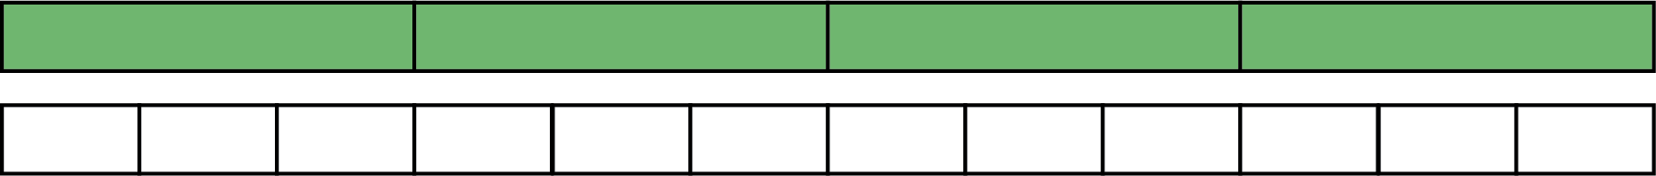
There are 3 feet in a yard, so one foot is $\frac{1}{3}$ of a yard.
- It takes 3 times as many feet to measure the same length as it does with yards.
- It takes $\frac{1}{3}$ as many yards to measure the same length as it does with feet.
© CC BY Open Up Resources. Adaptations CC BY IM.

