Unit 2 Lesson 16: Comparing Speeds and Prices

1 Closest Quotient (Warm up)

Student Task Statement
Is the value of each expression closer to $\frac{1}{2}$, 1, or $1\frac{1}{2}$?
- $20÷18$
- $9÷20$
- $7÷5$

2 More Treadmills

Student Task Statement
Some students did treadmill workouts, each one running at a constant speed. Answer the questions about their workouts. Explain or show your reasoning.
- Tyler ran 4,200 meters in 30 minutes.
- Kiran ran 6,300 meters in $\frac{1}{2}$ hour.
- Mai ran 6.3 kilometers in 45 minutes.
- What is the same about the workouts done by:
  - Tyler and Kiran?
  - Kiran and Mai?
  - Mai and Tyler?
- At what rate did each of them run?
- How far did Mai run in her first 30 minutes on the treadmill?

3 The Best Deal on Beans

Student Task Statement
Four different stores posted ads about special sales on 15-oz cans of baked beans.
- Which store is offering the best deal? Explain your reasoning.
- 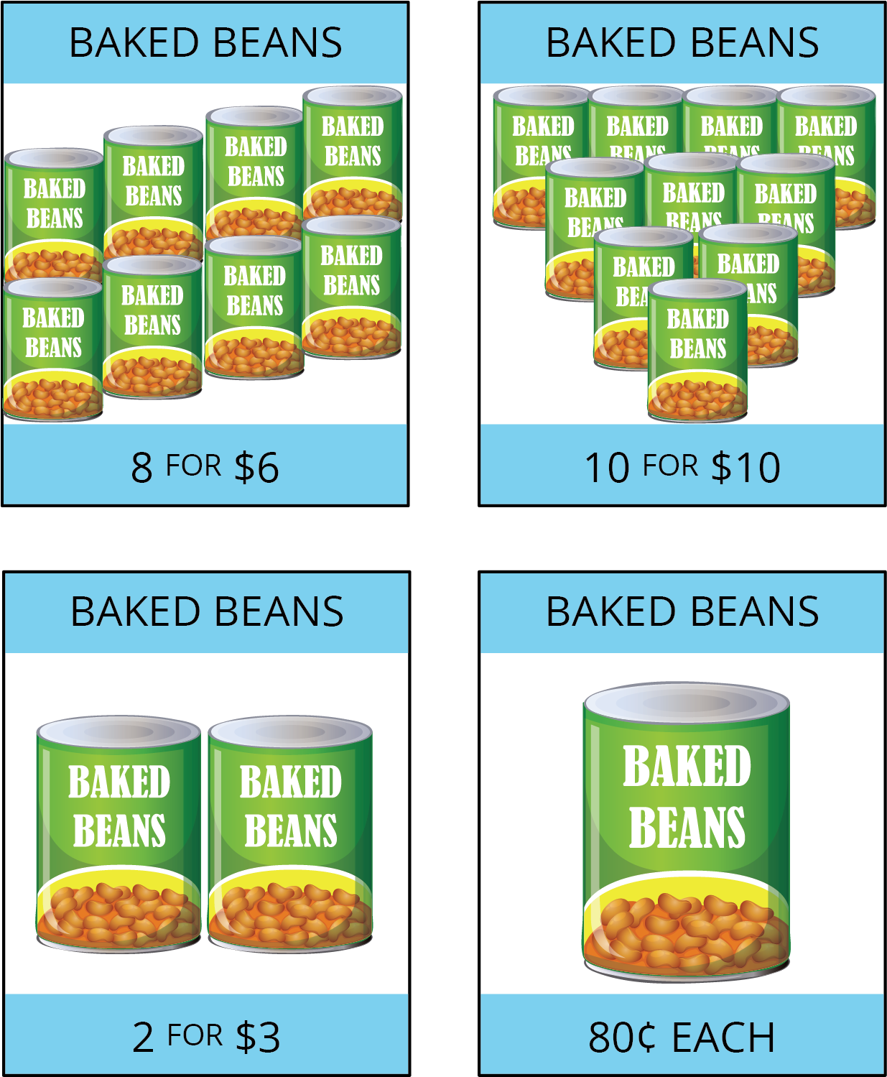
- The last store listed is also selling 28-oz cans of baked beans for $1.40 each. How does that price compare to the other prices?
© CC BY Open Up Resources. Adaptations CC BY IM.

