Lesson 3: Half an Equilateral Triangle
- Let’s investigate the properties of altitudes of equilateral triangles.

3.1: Notice and Wonder: Triangle Slices
Sketch an equilateral triangle and an altitude from any vertex in the equilateral triangle.
What do you notice? What do you wonder?

3.2: Decomposing Equilateral Triangles
- Here is an equilateral triangle with side length 2 units and an altitude drawn. Find the values of $x$ and $y$.
- Measure several more of these “half equilateral triangles” by drawing equilateral triangles and altitudes. Compute the ratios of the side lengths of these new triangles.
- Make a conjecture about side lengths in “half equilateral triangles.”

3.3: Generalize Half Equilateral Triangles
Calculate the lengths of the 5 unlabeled sides.

Are you ready for more?
Here is a collection of triangles which all have angles measuring 30, 60 and 90 degrees.
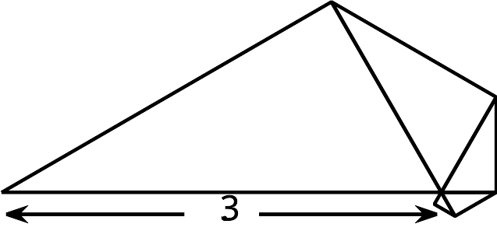
What is the total area enclosed by the 5 triangles?

Lesson 3 Summary
Drawing the altitude of an equilateral triangle decomposes the equilateral triangle into 2 congruent triangles. They are right triangles with acute angles of 30 and 60 degrees. These congruent angles make all triangles with angles 30, 60, and 90 degrees similar by the Angle-Angle Triangle Similarity Theorem.
If we consider a right triangle with angle measures of 30, 60, and 90 degrees, and with the shortest side 1 unit long, then the hypotenuse must be 2 units long since the triangle can be thought of as half of an equilateral triangle. Call the length of the altitude $a$. By the Pythagorean Theorem, we can say $a^{2}+1^{2}=2^{2}$ so $a=\sqrt{3}$.
Now, consider another right triangle with angle measures of 30, 60, and 90 degrees, and with the shortest side $y$ units long. By the Angle-Angle Triangle Similarity Theorem, it must be similar to the right triangle with angles 30, 60, and 90 degrees and with sides 1, $\sqrt{3}$, and 2 units long. The scale factor is $y$, so a triangle with angles 30, 60, and 90 degrees has side lengths $y,y\sqrt{3},$ and $2y$ units long.
In triangle $ABC,2y=5$ so $y=\frac{5}{2}$. That means $DB$ is $\frac{5}{2}$ units and $DC$ is $\frac{5}{2}\sqrt{3}$ units.
In triangle $EGH,y\sqrt{3}=4$ so $y=\frac{4}{\sqrt{3}}$. That means $FG$ is $\frac{4}{\sqrt{3}}$ units and $EG$ is $2\frac{4}{\sqrt{3}}$ or $\frac{8}{\sqrt{3}}$ units.
© CC BY 2019 by Illustrative Mathematics®

