Lesson 2: Midamos volúmenes

Standards Alignments
Addressing | 5.MD.C.3, 5.MD.C.3.b, 5.MD.C.4

Teacher-facing Learning Goals
- Find the volume of solid figures, including rectangular prisms, in unit cubes, in a way that makes sense to them.
- Understand that volume is measured in unit cubes.

Student-facing Learning Goals
- Contemos cubos.

Lesson Purpose
The purpose of this lesson is for students to understand that volume is the amount of unit cubes that fills a space.
Students are introduced to rectangular prisms as they begin to informally use the structure of rectangular prisms to find the number of cubes in the prism. In previous grades, students learned to measure area by counting unit squares, decomposed a rectangular region into rows and columns, and multiplied the number of unit squares in a row by the number of rows or the number of unit squares in a column by the number of columns. Similarly, in this lesson, students make use of the layered structure in a rectangular prism to count the cubes in a more systematic way (MP7). Students will have many opportunities to count the number of cubes in rectangular prisms in lessons 3 and 4 before the introduction of formulas in Lesson 5.
Math Community
Tell students they will have an opportunity to revise their “Mathematical Community” ideas at the end of this lesson, so as they work today they should think about actions that may be missing from the current list.

Access for:

Students with Disabilities
- Representation (Activity 2)

Instructional Routines
MLR2 Collect and Display (Activity 2), Which One Doesn’t Belong? (Warm-up)

Lesson Timeline
Warm-up | 10 min
Activity 1 | 15 min
Activity 2 | 20 min
Lesson Synthesis | 10 min
Cool-down | 5 min

Teacher Reflection Question
What did students understand about the volume of solid objects as they came into the lesson? In what ways did their understanding of volume change upon completing the lesson?

Cool-down
(to be completed at the end of the lesson) 5min
El volumen de un prisma rectangular

Standards Alignments
Addressing | 5.MD.C.4

Student-facing Task Statement
Encuentra el volumen del prisma rectangular. Explica o muestra tu razonamiento.
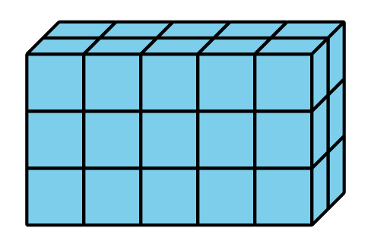

Student Responses
- The volume is 30 cubes. Sample responses: $5×6=30$, $5×3=15$ and $15×2=30$, or $3×2=6$ and $6×5=30$

