Lesson 12: How Many Are There? (Part 1)
- Let’s count collections of objects.

12.3: Introduce Pattern Blocks, Get and Build
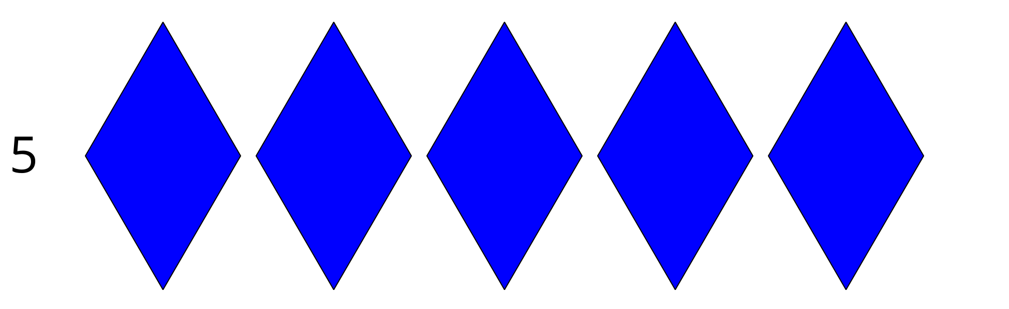
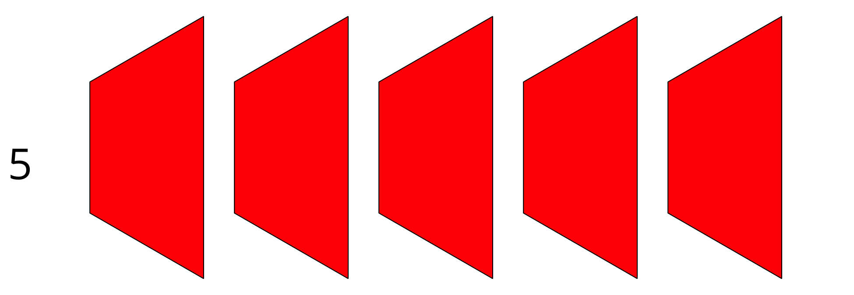
Choose a center.
Geoblocks
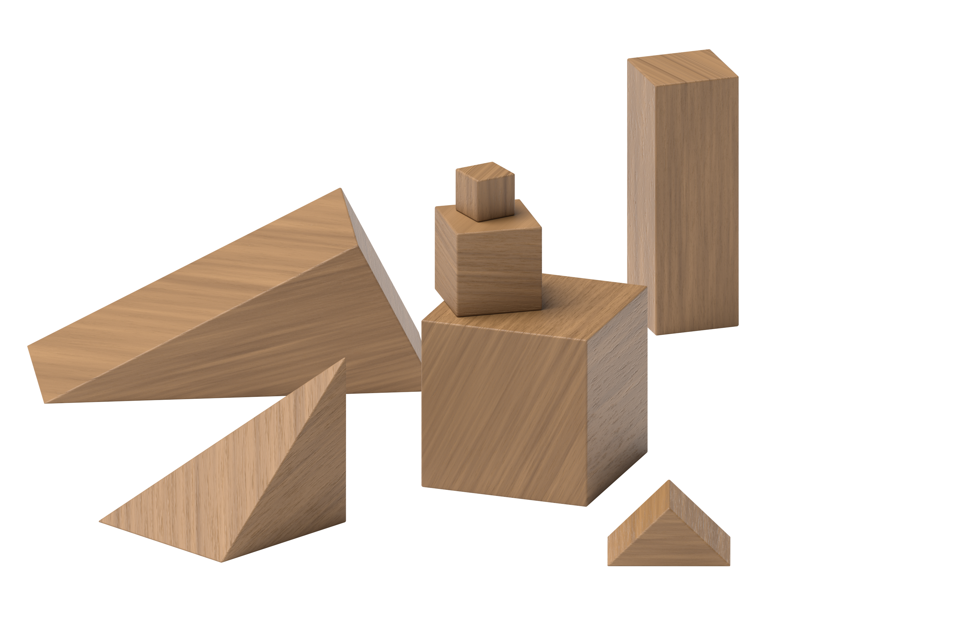
Connecting Cubes
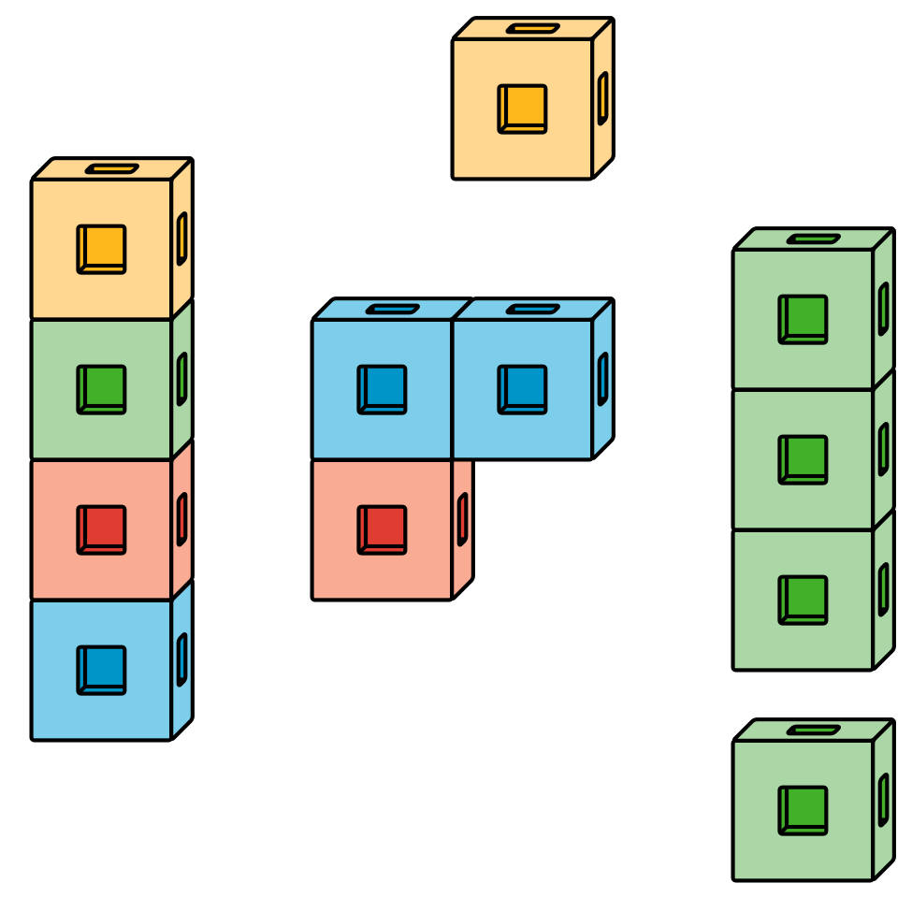
Pattern Blocks
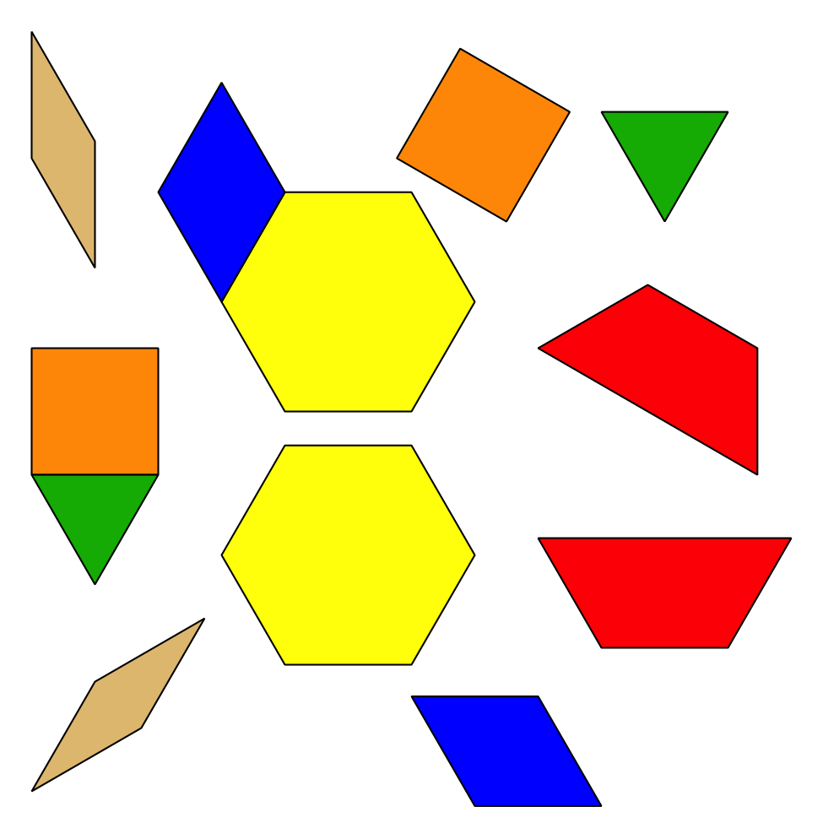
Picture Books
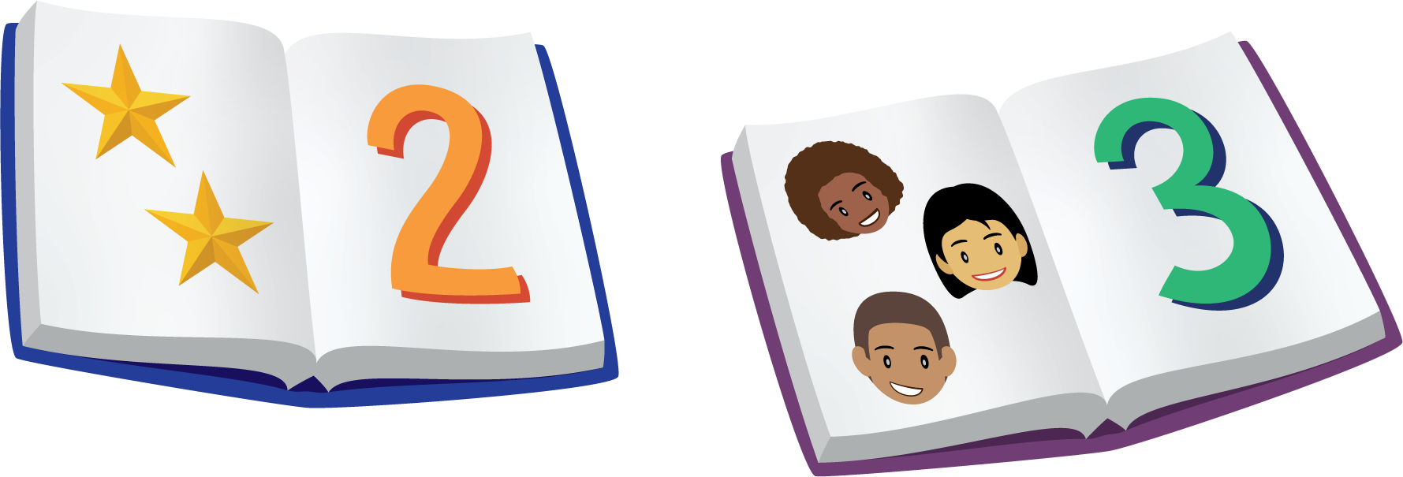
© CC BY 2021 Illustrative Mathematics®

