Lesson 19: Evidence, Angles, and Proof
- Let’s make convincing explanations.

19.1: Math Talk: Supplementary Angles
Mentally evaluate all of the missing angle measures in each figure.

Figure A
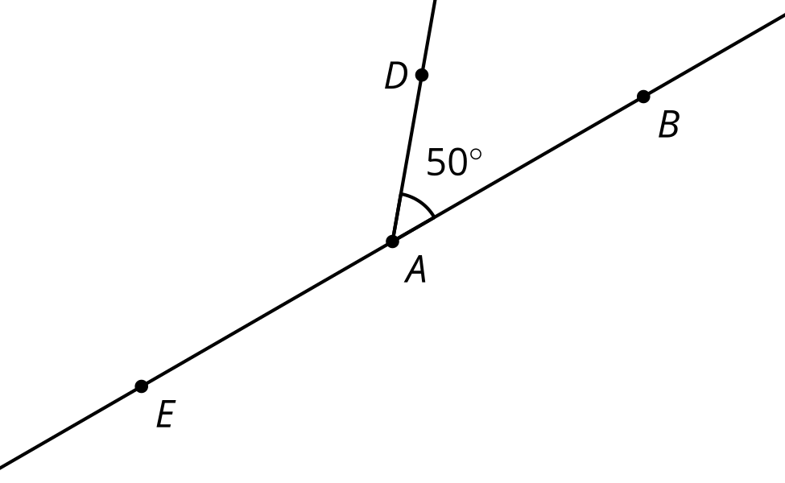

Figure B
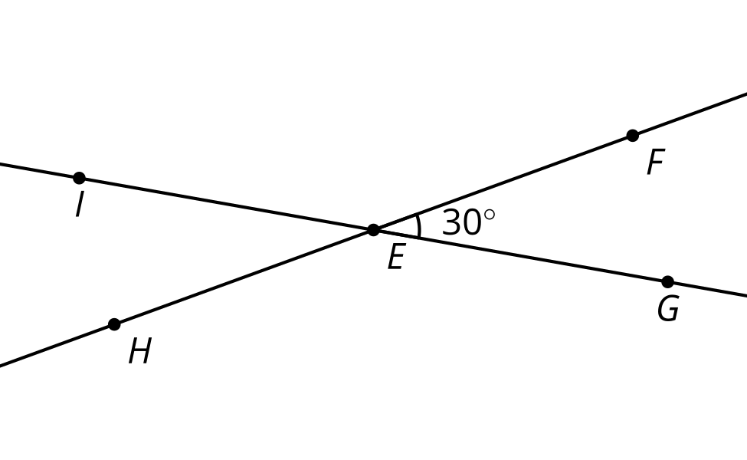

Figure C
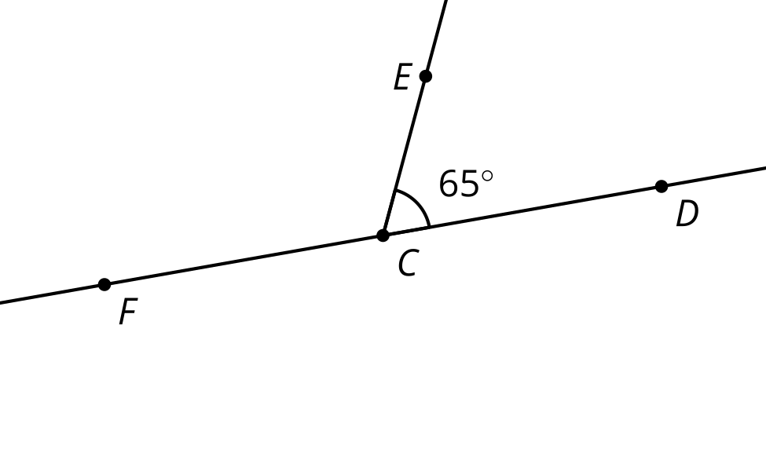

Figure D
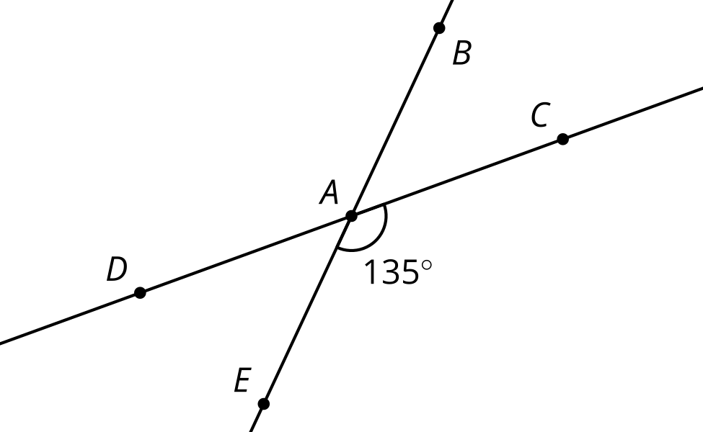

19.2: That Can’t Be Right, Can It?
Here is a figure where ray $r$ meets line $ℓ$. The dashed rays are angle bisectors.
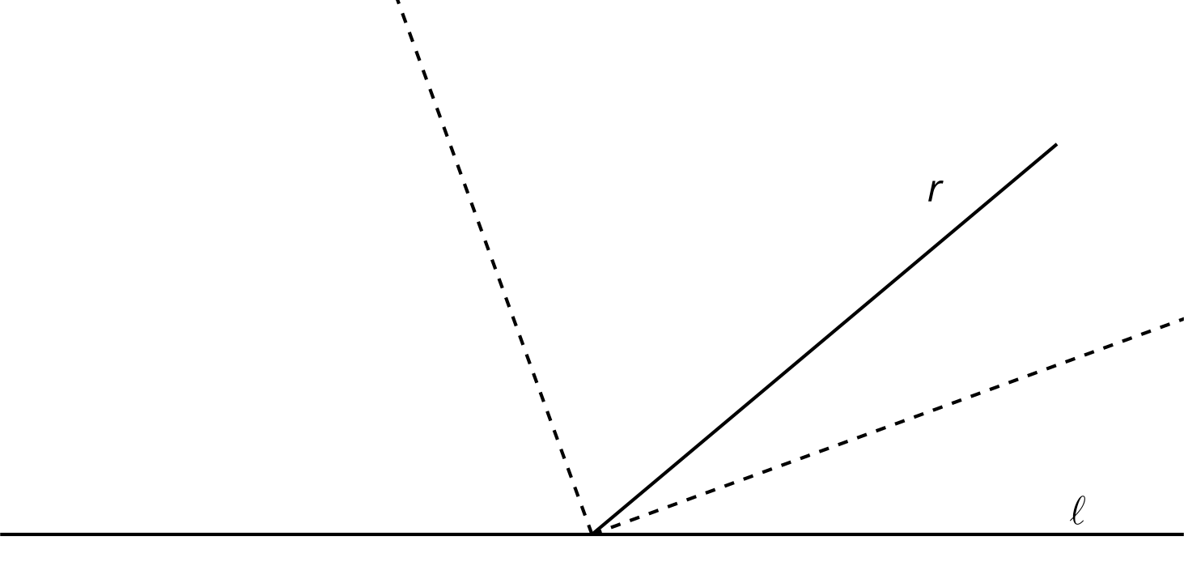
- Diego made the conjecture: “The angle formed between the angle bisectors is always a right angle, no matter what the angle between $r$ and $ℓ$ is.” It is difficult to tell specifically which angles Diego is talking about in his conjecture. Label the diagram and rephrase Diego’s conjecture more precisely using your labels.
- Is the conjecture true? Explain your reasoning.

19.3: Convince Me
Here are 2 intersecting lines that create 2 pairs of vertical angles:
1. What is the relationship between vertical angles? Write down a conjecture. Label the diagram to make it easier to write your conjecture precisely.
2. How do you know your conjecture is true for all possible pairs of vertical angles? Explain your reasoning.

Are you ready for more?
One reason mathematicians like to have rigorous proofs even when conjectures seem to be true is that sometimes conjectures that are made turn out to not be true. Here is one famous example. If we draw $n$ points on a circle and connect each pair of points how many regions does that divide the circle into? If we draw only 1 point there are no line segments to connect and so just 1 region in the circle. If we draw 2 points they are connected by a line segment which divides the circle into 2 regions.
- If we draw 3 points on a circle and connect each pair of points with a line segment how many regions do we get in our circle?
- If we draw 4 points on a circle and connect each pair of points with a line segment how many regions do we get in our circle?
- If we draw 5 points on a circle and connect each pair of points with a line segment how many regions do we get in our circle?
- Make a conjecture about how many regions we get if we draw $n$ points on a circle and connect each pair of points with a line segment.
- Test your conjecture with 6 points on a circle. How many regions do we get?

Lesson 19 Summary
In many situations, it is important to understand the reasons why an idea is true. Here are some questions to ask when trying to convince ourselves or others that a statement is true:
- How do we know this is true?
- Would these reasons convince someone who didn’t think it was true?
- Is this true always, or only in certain cases?
- Can we find any situations where this is false?
In this lesson, we reasoned that pairs of vertical angles are always congruent to each other:
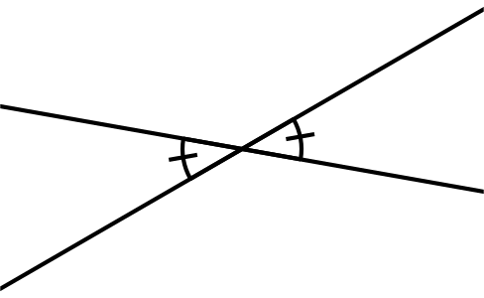
We saw this by labeling the diagram and making precise arguments having to do with transformations or angle relationships. For example, label the diagram with points:
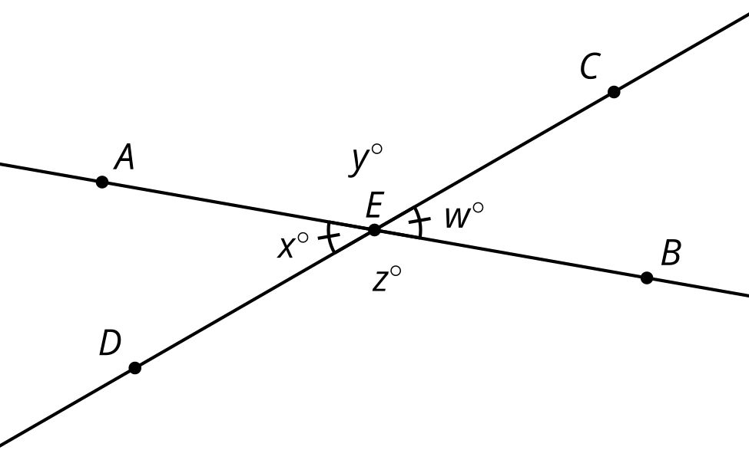
Rotate the figure 180 degrees around point $E$. Then ray $EA$ goes to ray $EB$ and ray $ED$ goes to ray $EC$. That means the rotation takes angle $AED$ onto angle $BEC$, and so angle $AED$ is congruent to angle $BEC$.
Many true statements have multiple explanations. Another line of reasoning uses angle relationships. Notice that angles $AED$ and $AEC$ together form line $CD$. That means that $x+y=180$. Similarly, $y+w=180$. That means that both $x$ and $w$ are equal to $180−y$, so they are equal to each other. Since angle $AED$ and angle $CEB$ have the same degree measure, they must be congruent.
© CC BY 2019 by Illustrative Mathematics®

