Unit 5 Lesson 14: How Do You Compare Fractions?

WU Number Talk: Which Whole Numbers? (Warm up)

Student Task Statement
Find the whole number that each fraction is equivalent to.
- $\frac{16}{1}$
- $\frac{16}{2}$
- $\frac{16}{4}$
- $\frac{20}{4}$

1 Equivalent or Not?

Student Task Statement
Are these fractions equivalent? Show your thinking using diagrams, symbols, or other representations.
- $\frac{1}{2}$ and $\frac{1}{3}$
- $\frac{4}{6}$ and $\frac{5}{6}$
- $\frac{3}{4}$ and $\frac{6}{8}$

2 Same Fractions, Different Result?

Student Task Statement
Han says $\frac{4}{6}$ is less than $\frac{5}{6}$. His work is shown.
Lin says $\frac{4}{6}$ is greater than $\frac{5}{6}$. Her work is shown.
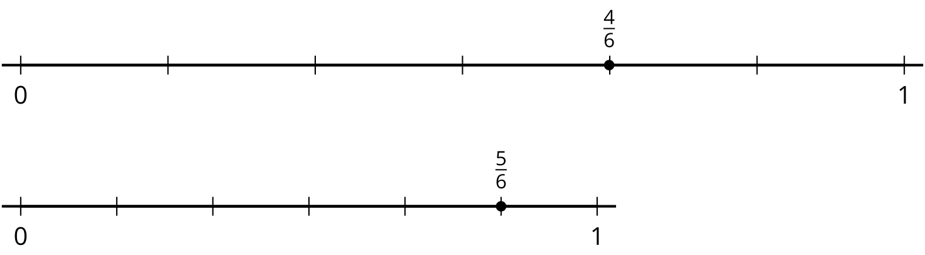
Why might Han and Lin make different comparison statements for the same fractions?
© CC BY 2021 Illustrative Mathematics®

