Lesson 3: From Visual Patterns to Numerical Patterns

Standards Alignments
Building On | 4.NBT.A.1, 4.OA.B.4
Addressing | 4.OA.C.5
Building Towards | 4.NBT.B.5

Teacher-facing Learning Goals
- Analyze patterns represented visually and numerically.
- Use numbers, words, and the idea of factors and multiples to describe and extend patterns in the features of rectangles.

Student-facing Learning Goals
- Let’s look at numerical patterns we can write to describe patterns in rectangles.

Lesson Purpose
The purpose of this lesson is for students to analyze, describe, and extend numerical patterns that follow a rule.
Previously, students explored growing and repeating patterns and reasoned about the patterns using words, numbers, and operations. In this lesson, students investigate patterns in a geometric context and explore how the side lengths, area, perimeter, and other features of a rectangle change when the rectangle changes by a rule. In doing so, students practice looking for and making use of structure (MP7).
Students also practice reasoning quantitatively and abstractly (MP2) as they interpret the values in number sequences that represent geometric features of rectangles, and vice versa. (For example, 6, 8, 10, 12, . . . may represent the area, in square centimeters, of a series of rectangles whose width is 2 centimeters and whose length grows by 1 centimeter each time.)
The second activity in this lesson is optional as it allows students more time to work with the ideas from the first activity.

Access for:

Students with Disabilities
- Representation (Activity 1)

English Learners
- MLR2 (Activity 3)

Instructional Routines
MLR1 Stronger and Clearer Each Time (Activity 2), MLR3 Clarify, Critique, Correct (Activity 1), Number Talk (Warm-up)

Materials to Gather
- Graph paper: Activity 1

Lesson Timeline
Warm-up | 10 min
Activity 1 | 20 min
Activity 2 | 20 min
Activity 3 | 15 min
Lesson Synthesis | 10 min
Cool-down | 5 min

Teacher Reflection Question
Identify who has been sharing their ideas in class lately. Make a note of students whose ideas have not been shared and look for an opportunity for them to share their thinking in tomorrow’s lesson.

Cool-down
(to be completed at the end of the lesson) 5min
Another Set of Rectangles

Standards Alignments
Addressing | 4.OA.C.5

Student-facing Task Statement
Here are steps 1 and 3 in a pattern of rectangles where a side length grows by 3 centimeters each time.
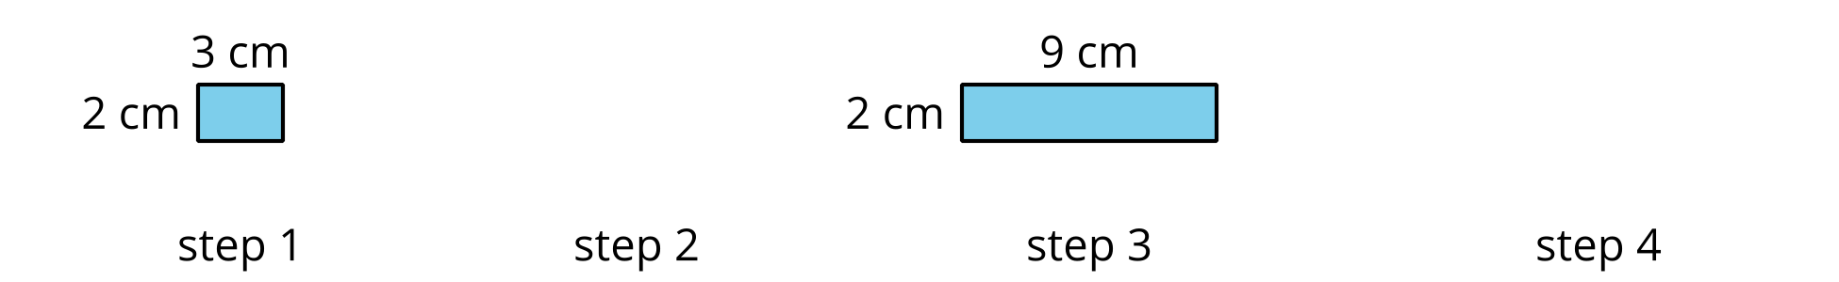
- Draw the missing rectangles in steps 2 and 4. Label the sides with their lengths.
- Write a numerical pattern to represent the pattern. Explain how your numerical pattern represents the rectangles.
- If the pattern continues, could 50 represent the side length or area of one of the rectangles? If so, which step? If not, why not? Explain or show your reasoning.

Student Responses
- Completed drawing:
- 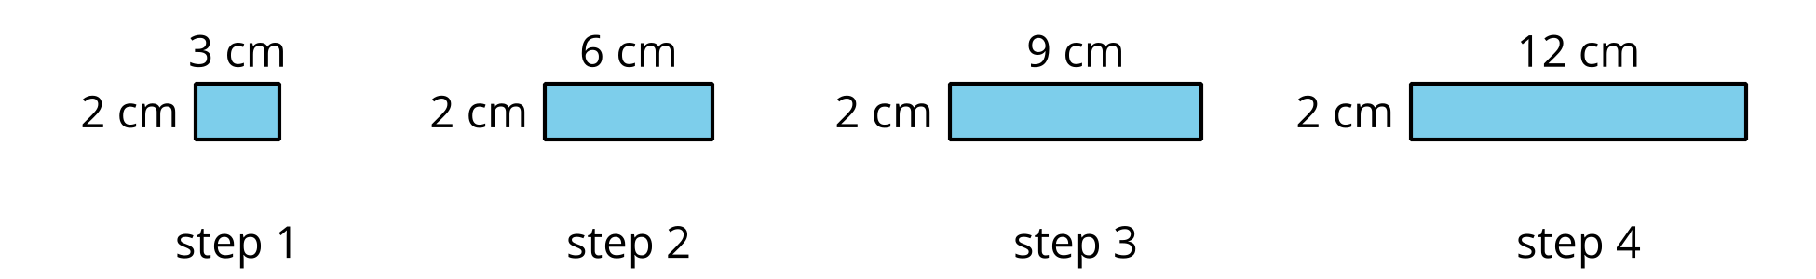
- Sample responses:
  - Side length: 3, 6, 9, 12, 15, 18
  - Area: 6, 12, 18, 24, 30, 36
  - Perimeter: 10, 16, 22, 28, 34, 40
- Sample response: No, 50 is not a multiple of 3 so it can’t represent the side length of a rectangle. It is not a multiple of 6, so it cannot represent the area of a rectangle.

