Lesson 15: Shapes on the Coordinate Plane

15.1: Figuring Out The Coordinate Plane
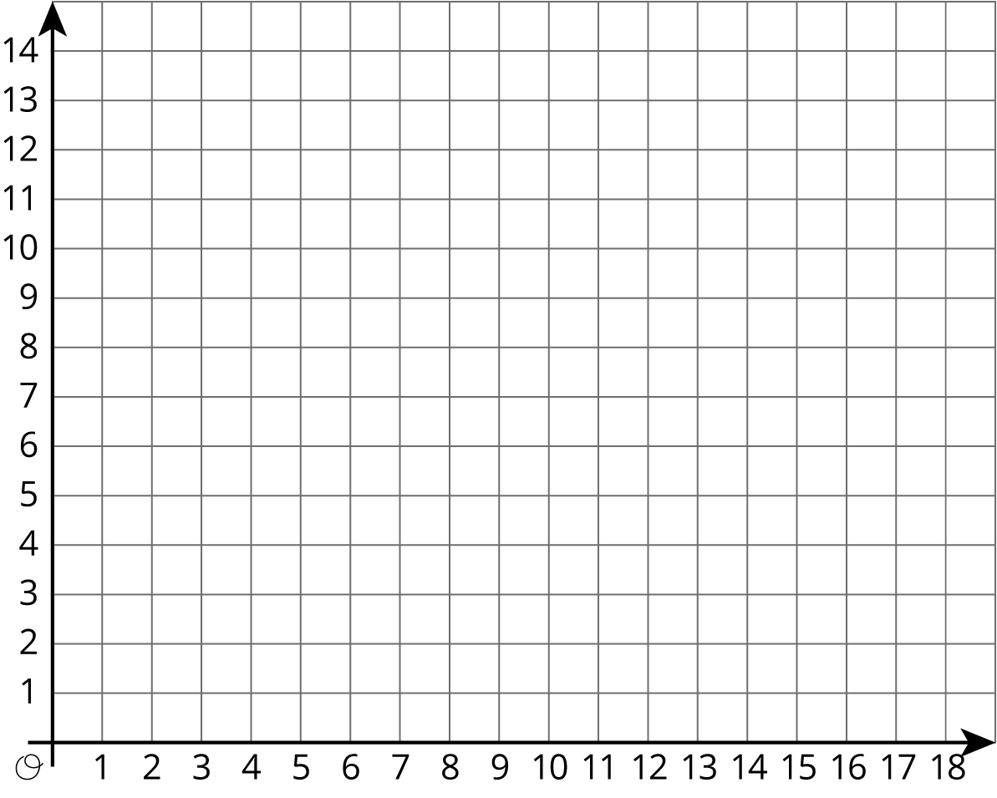
- Draw a figure in the coordinate plane with at least three of following properties:
  - 6 vertices
  - Exactly 1 pair of parallel sides
  - At least 1 right angle
  - 2 sides with the same length
- Is your figure a polygon? Explain how you know.

15.2: Plotting Polygons
Here are the coordinates for four polygons. Plot them on the coordinate plane, connect the points in the order that they are listed, and label each polygon with its letter name.
- Polygon A: $(\text{-}7,4),(\text{-}8,5),(\text{-}8,6),(\text{-}7,7),(\text{-}5,7),(\text{-}5,5),(\text{-}7,4)$
- Polygon B: $(4,3),(3,3),(2,2),(2,1),(3,0),(4,0),(5,1),(5,2),(4,3)$
- Polygon C: $(\text{-}8,\text{-}5),(\text{-}8,\text{-}8),(\text{-}5,\text{-}8),(\text{-}5,\text{-}5),(\text{-}8,\text{-}5)$
- Polygon D: $(\text{-}5,1),(\text{-}3,\text{-}3),(\text{-}1,\text{-}2),(0,3),(\text{-}3,3),(\text{-}5,1)$
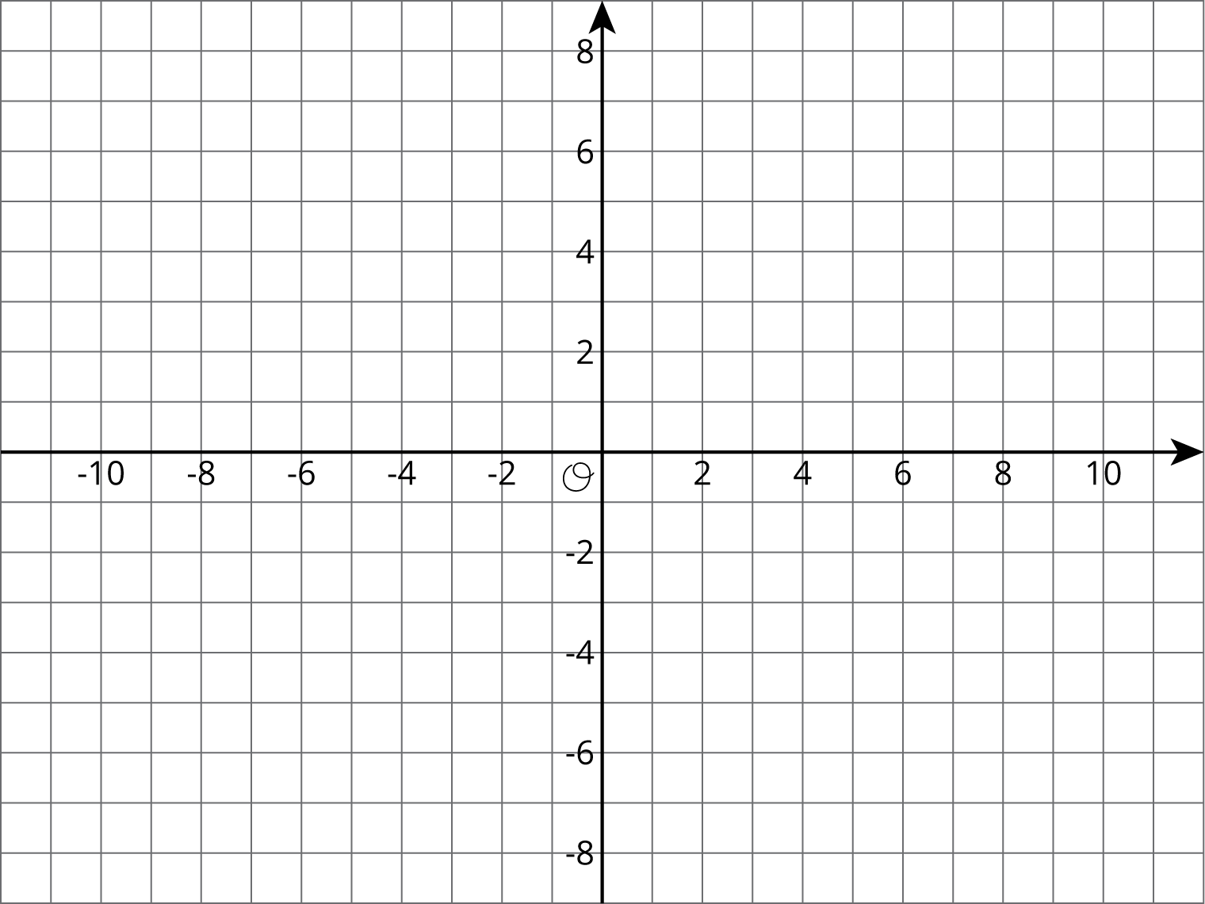

Are you ready for more?
Find the area of Polygon D in this activity.

15.3: Four Quadrants of A-Maze-ing
- The following diagram shows Andre’s route through a maze. He started from the lower right entrance.
- 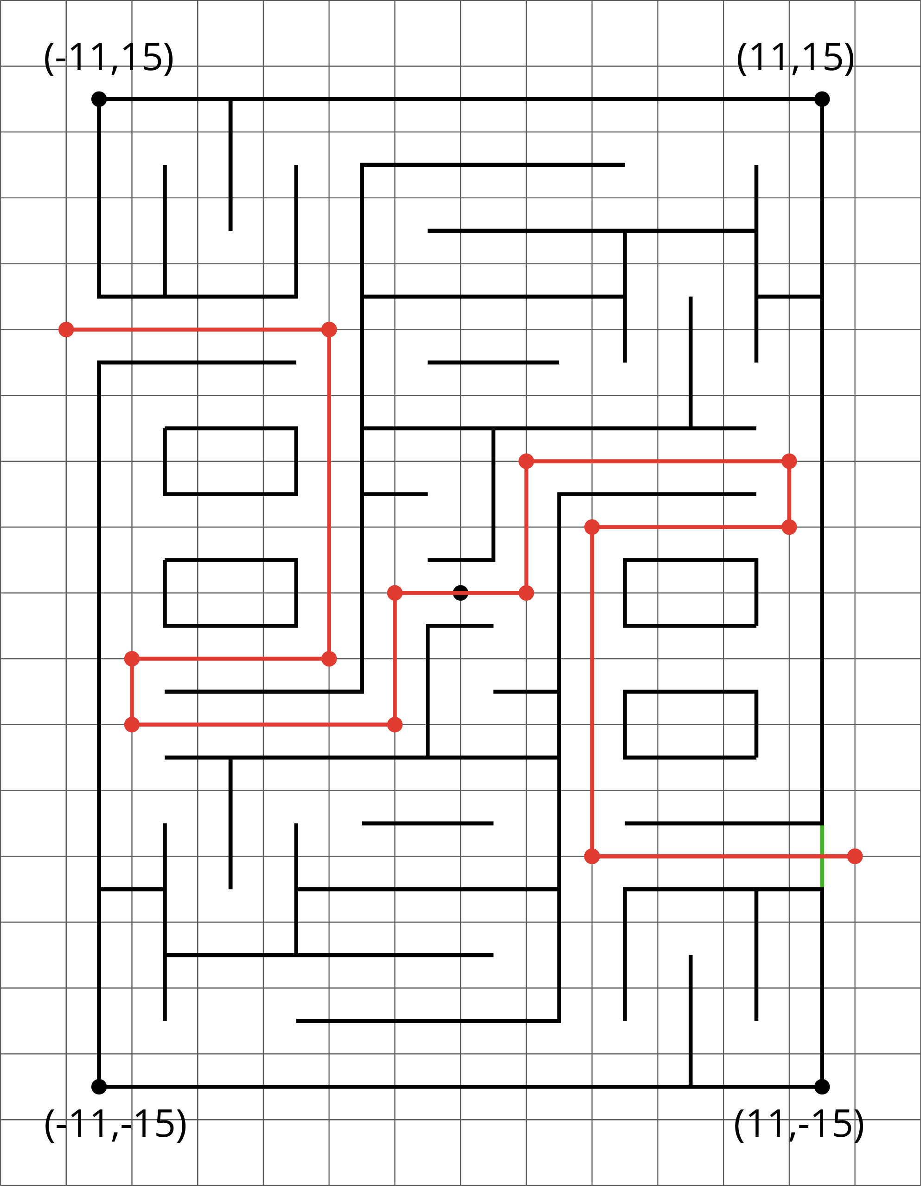
  - What are the coordinates of the first two and the last two points of his route?
  - How far did he walk from his starting point to his ending point? Show how you know.
- Jada went into the maze and stopped at $(\text{-}7,2)$.
  - Plot that point and other points that would lead her out of the maze (through the exit on the upper left side).
  - How far from $(\text{-}7,2)$ must she walk to exit the maze? Show how you know.

Lesson 15 Summary
We can use coordinates to find lengths of segments in the coordinate plane.
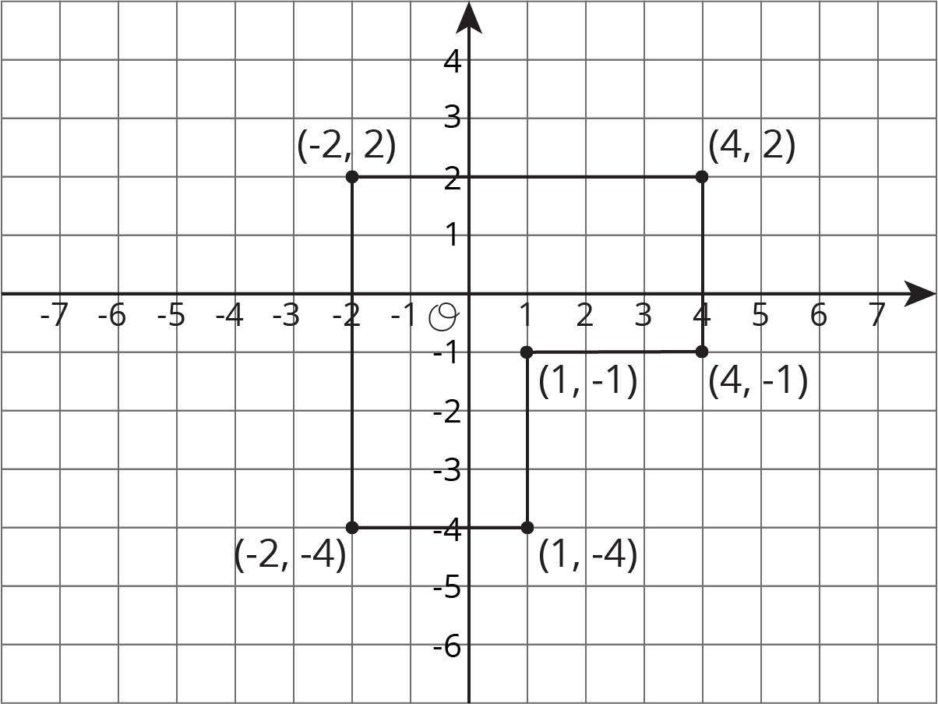
For example, we can find the perimeter of this polygon by finding the sum of its side lengths. Starting from $(\text{-}2,2)$ and moving clockwise, we can see that the lengths of the segments are 6, 3, 3, 3, 3, and 6 units. The perimeter is therefore 24 units.
In general:
- If two points have the same $x$-coordinate, they will be on the same vertical line, and we can find the distance between them.
- If two points have the same $y$-coordinate, they will be on the same horizontal line, and we can find the distance between them.
© CC BY Open Up Resources. Adaptations CC BY IM.

