Lesson 13: How Many Are There? (Part 2)
- Let’s count collections of objects.

13.3: Centers: Choice Time
Choose a center.
Geoblocks
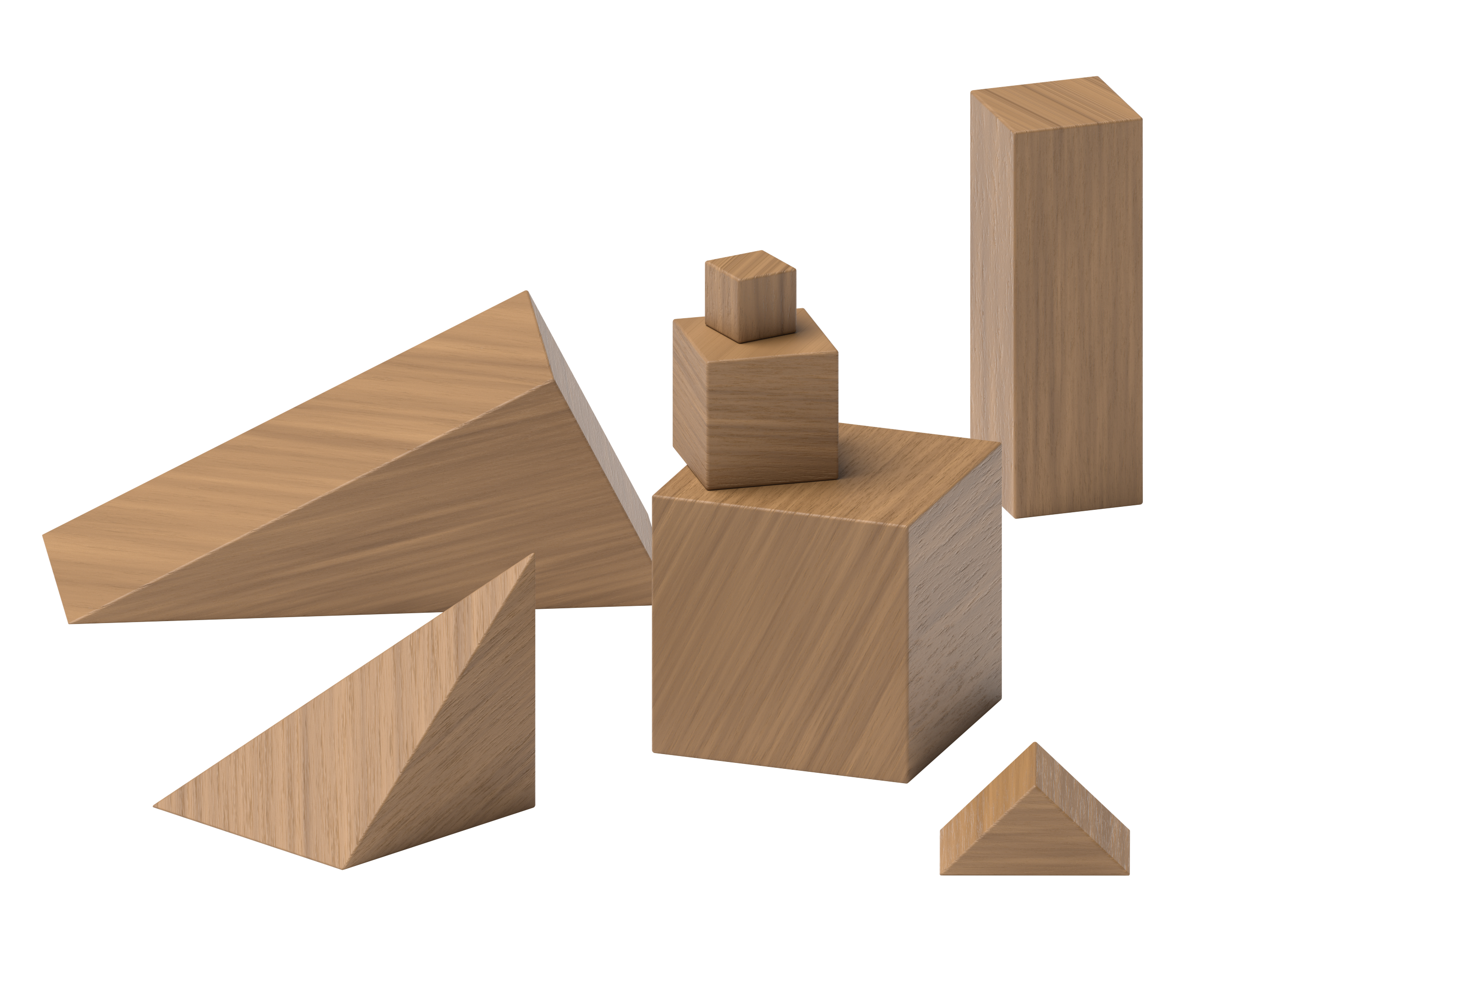
Connecting Cubes
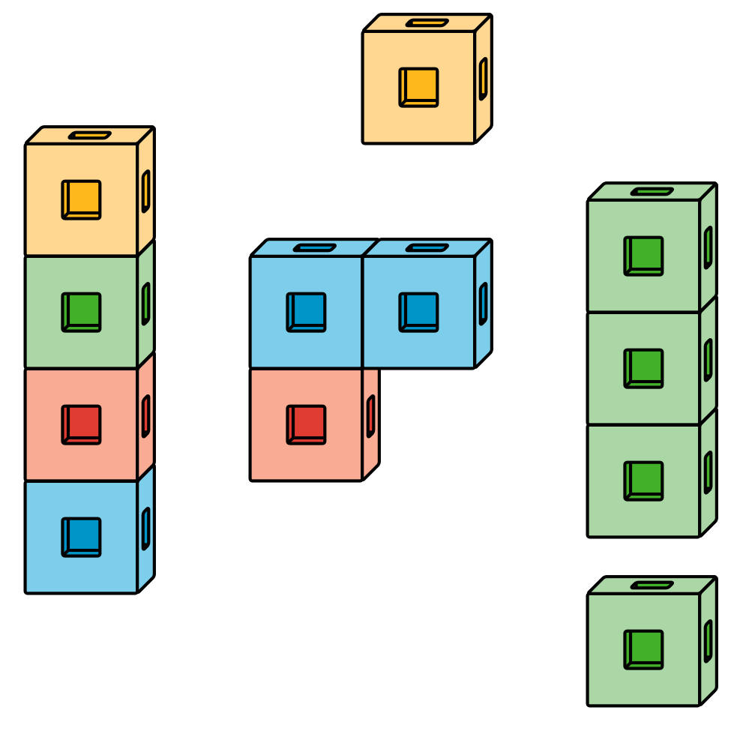
Pattern Blocks
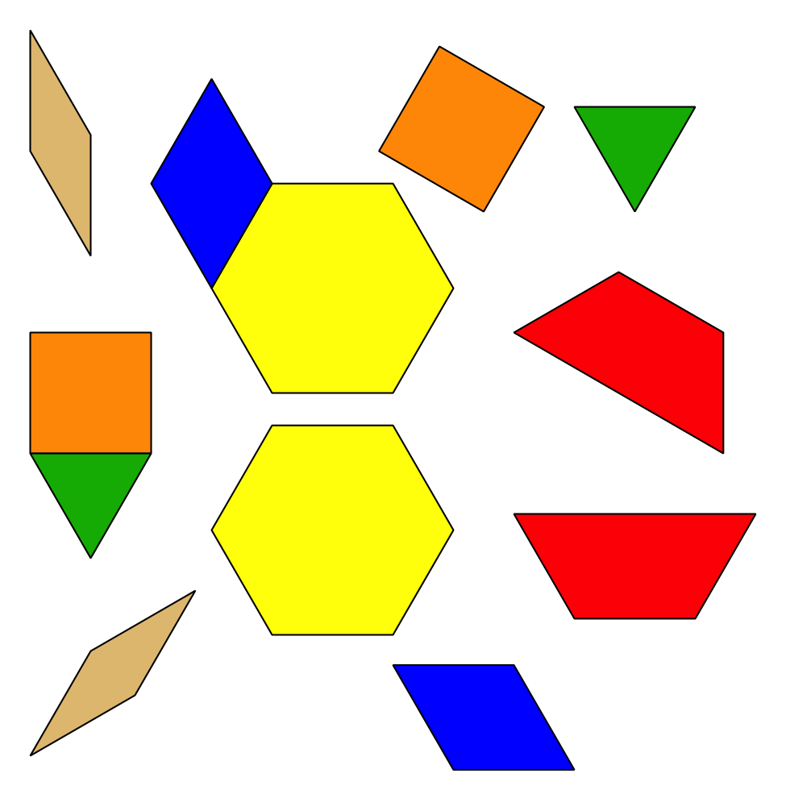
Picture Books
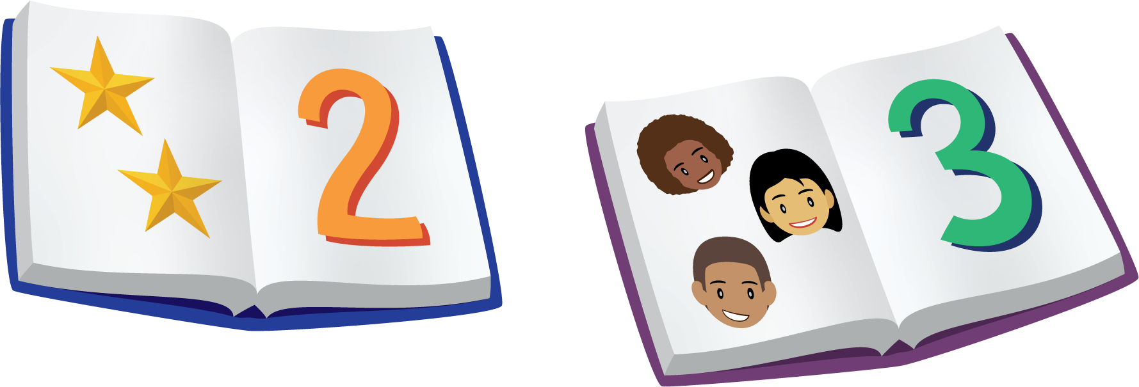
© CC BY 2021 Illustrative Mathematics®

