Unit 3 Lesson 18: The Quadratic Formula and Complex Solutions

1 Math Talk: Real or Not? (Warm up)

Student Task Statement
Mentally decide whether the solutions to each equation are real numbers or not.
$w^{2}=\text{-}367$
$x^{2}+25=0$
${\left(y+5\right)}^{2}=0$
${\left(z+5\right)}^{2}=\text{-}367$

2 Be Discriminating

Student Task Statement
Kiran was using the quadratic formula to solve the equation $x^{2}−12x+41=0$. He wrote this:
$x=\frac{12±\sqrt{144−164}}{2}$
Then he noticed that the number inside the square root is negative and said, “This equation doesn’t have any solutions.”
- Do you agree with Kiran? Explain your reasoning.
- Write $\sqrt{\text{-}20}$ as an imaginary number.
- Solve the equation $3x^{2}−10x+50=0$ and plot the solutions in the complex plane.
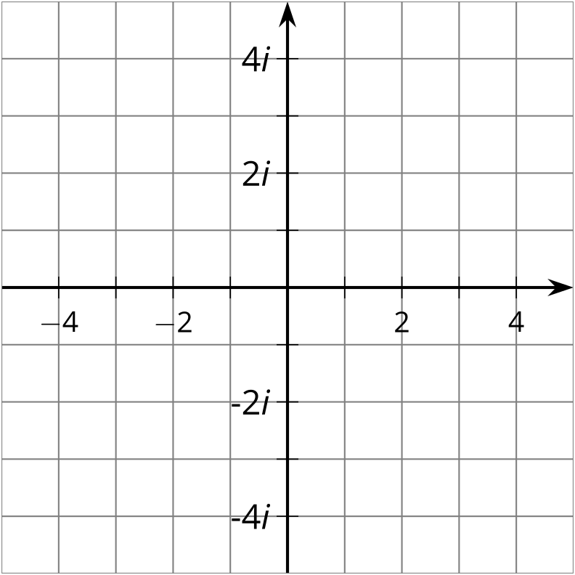

3 Solving All Kinds of Quadratics

Student Task Statement
For each row, you and your partner will each solve a quadratic equation. You should each get the same answer. If you disagree, work to reach agreement.
partner A | partner B
$x^{2}−4x−4=0$ | ${\left(x−2\right)}^{2}=8$
${\left(y−2\right)}^{2}=\text{-}8$ | $y^{2}−4y+12=0$
${\left(z+\frac{3}{2}\right)}^{2}=\text{-}\frac{29}{4}$ | $2z^{2}+6z=\text{-}19$
$w^{2}+3w=5$ | ${\left(w+\frac{3}{2}\right)}^{2}=\frac{29}{4}$
$4t^{2}−20t+25=0$ | $4\left(t^{2}−5t\right)=\text{-}25$

© CC BY 2019 by Illustrative Mathematics®

