Lesson 10 Practice Problems
- To write $11x^{2}+17x−10$ in factored form, Diego first listed pairs of factors of -10.
- $\left(\underset{_}{​}+5\right)\left(\underset{_}{​}+\text{-}2\right)$
- $\left(\underset{_}{​}+2\right)\left(​_{\underset{_}{​}}+\text{-}5\right)$
- $\left(\underset{_}{​}+10\right)\left(\underset{_}{​}+\text{-}1\right)$
- $\left(\underset{_}{​}+1\right)\left(\underset{_}{​}+\text{-}10\right)$
  - Use what Diego started to complete the rewriting.
  - How did you know you’ve found the right pair of expressions? What did you look for when trying out different possibilities?
- To rewrite $4x^{2}−12x−7$ in factored form, Jada listed some pairs of factors of $4x^{2}$:
- $\left(2x+\underset{_}{​}\right)\left(2x+\underset{_}{​}\right)$
- $\left(4x+\underset{_}{​}\right)\left(1x+\underset{_}{​}\right)$
- Use what Jada started to rewrite $4x^{2}−12x−7$ in factored form.
- Rewrite each quadratic expression in factored form. Then, use the zero product property to solve the equation.
  - $7x^{2}−22x+3=0$
  - $4x^{2}+x−5=0$
  - $9x^{2}−25=0$
- Han is solving the equation $5x^{2}+13x−6=0$.
- Here is his work:
- $\begin{matrix}5x^{2}+13x−6 & =0 \\ \left(5x−2\right)\left(x+3\right) & =0 \\ x=2 & \text{ or } x=\text{-}3\end{matrix}$
- Describe Han’s mistake. Then, find the correct solutions to the equation.
- A picture is 10 inches wide by 15 inches long. The area of the picture, including a frame that is $x$ inch thick, can be modeled by the function $A\left(x\right)=\left(2x+10\right)\left(2x+15\right)$.
  - Use function notation to write a statement that means: the area of the picture, including a frame that is 2 inches thick, is 266 square inches.
  - What is the total area if the picture has a frame that is 4 inches thick?
- (From Unit 7, Lesson 1.)
- To solve the equation $0=4x^{2}−28x+39$, Elena uses technology to graph the function $f\left(x\right)=4x^{2}−28x+39$. She finds that the graph crosses the $x$-axis at $\left(1.919,0\right)$ and $\left(5.081,0\right)$.
  - What is the name for the points where the graph of a function crosses the $x$-axis?
  - Use a calculator to compute $f\left(1.919\right)$ and $f\left(5.081\right)$.
  - Explain why 1.919 and 5.081 are approximate solutions to the equation $0=4x^{2}−28x+39$ and are not exact solutions.
- (From Unit 7, Lesson 2.)
- Which equation shows a next step in solving $9{\left(x−1\right)}^{2}=36$ that will lead to the correct solutions?
  - $9\left(x−1\right)=6 \text{ or } 9\left(x−1\right)=\text{-}6$
  - $3\left(x−1\right)=6$
  - ${\left(x−1\right)}^{2}=4$
  - ${\left(9x−9\right)}^{2}=36$
- (From Unit 7, Lesson 3.)
- Here is a description of the temperature at a certain location yesterday.
- “It started out cool in the morning, but then the temperature increased until noon. It stayed the same for a while, until it suddenly dropped quickly! It got colder than it was in the morning, and after that, it was cold for the rest of the day.”
Sketch a graph of the temperature as a function of time.
- 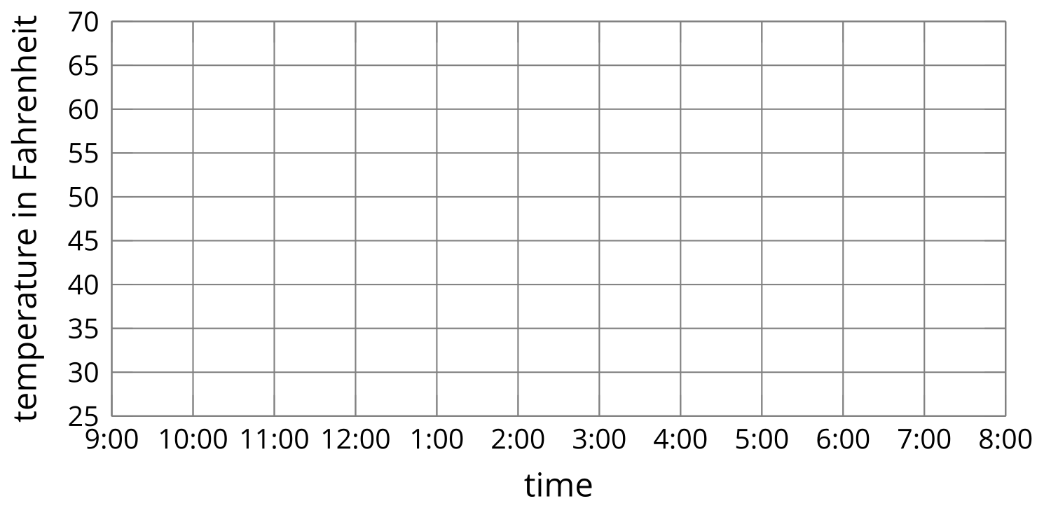
- (From Unit 4, Lesson 8.)
- Technology required. The number of people, $p$, who watch a weekly TV show is modeled by the equation $p=100,​000⋅{\left(1.1\right)}^{w}$, where $w$ is the number of weeks since the show first aired.
  - How many people watched the show the first time it aired? Explain how you know.
  - Use technology to graph the equation.
  - On which week does the show first get an audience of more than 500,000 people?
- (From Unit 5, Lesson 9.)
© CC BY 2019 by Illustrative Mathematics®

