Unit 6 Lesson 8: Areas and Equivalent Expressions

1 Ways to Express the Area (Warm up)

Student Task Statement
- Here are two rectangles with their side lengths labeled. Write the sum of the areas of the two rectangles.
- 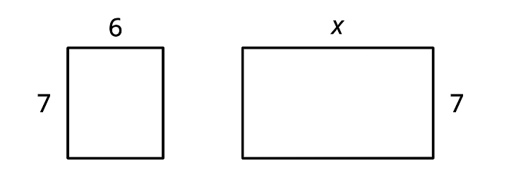
- The two rectangles can be composed into a larger rectangle as shown.
- 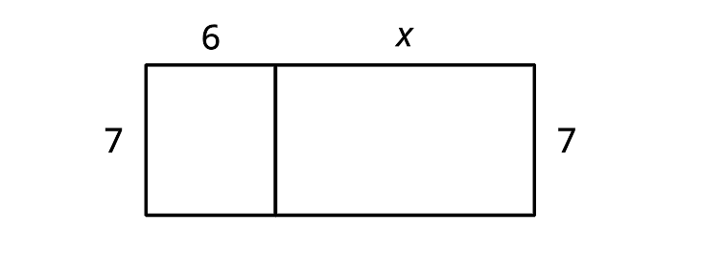
  - Write the length and width of the new, large rectangle.
  - Write an expression for the area of the new rectangle.
- How are the two expressions for area alike? How are they different?

2 Multiplying Two-Digit Numbers and the Distributive Property

Student Task Statement
- Here are two rectangles.
- 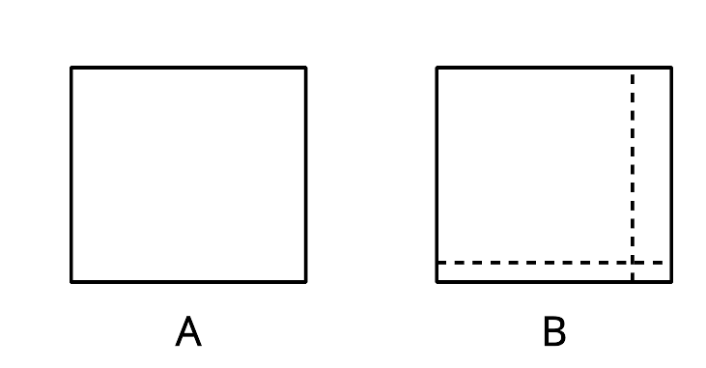
  - Find the area of Rectangle A.
  - Find the area of each of the 4 smaller rectangles that make up Rectangle B.
  - Use the sum of the areas of the small rectangles to find the area of Rectangle B.
  - How is finding the area of Rectangle B like multiplying $(10+1)(10+2)$?
- Find the area of this rectangle two different ways:
- 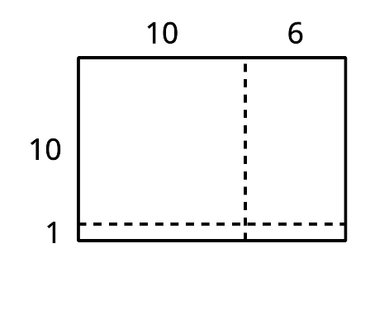

3 Using the Distributive Property to Write Equivalent Expressions

Student Task Statement
- Express the area of each rectangle in two ways: as a sum of the areas of the sub-rectangles, and a product of length and width of the large rectangle.
- Select all the expressions that are equivalent to $4(2+3x)$. Be prepared to explain or show how you know.
  - $8+12x$
  - $8+3x$
  - $4(5x)$
  - $12x+8$
  - $2(4)+3x(4)$
  - $12x+2$
  - $2(2+3x)+2(2+3x)$
- Write at least three expressions that can represent the area of a rectangle that is 12 units long by $(10+a)$ units wide. If you get stuck, try drawing a diagram.
- Each expression represents the area of a rectangle. Name a possible length and width of each rectangle. Be prepared to explain or show how you know.
  - $3x+21$
  - $4(9)+4(20)$
  - $8^{2}+8a$
  - $(30)(30)+30(4)+30(b)$
- Sort the expressions into three groups, so that all three of the expressions in a group could represent the area of the same rectangle.
- $100+20+90+18$
- $100+90+90+81$
- $(10+9)(10+9)$
- $10(2⋅10+2)$
- $12⋅19$
- $10⋅22$
- $(10+2)(10+9)$
- ${19}^{2}$
- $2⋅100+20$
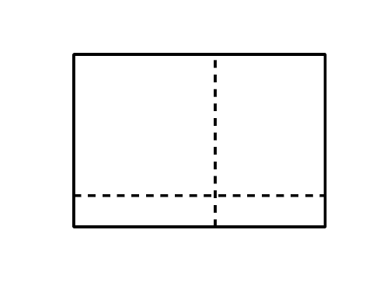
© CC BY 2019 by Illustrative Mathematics

