Lesson 7: Center Day 1
- Let’s estimate the length of an object and then measure it.

Warm-up: Number Talk: Subtract from 37
Find the value of each expression mentally.
- $37−20$
- $37−21$
- $37−17$
- $37−16$

7.2: Centers: Choice Time
Choose a center.
Estimate and Measure
Math Stories
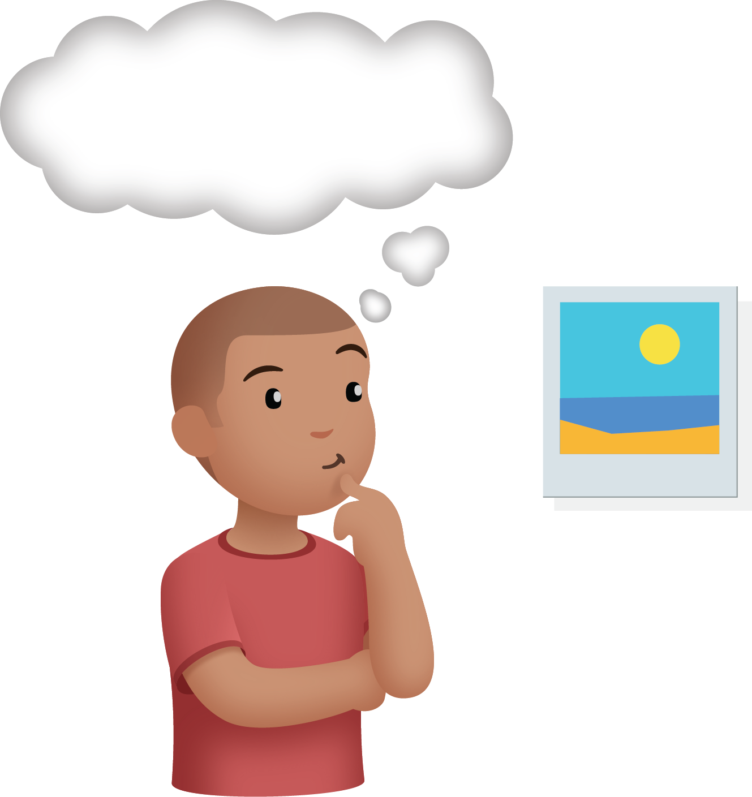
© CC BY 2021 Illustrative Mathematics®

