Unit 5 Lesson 15: Compare Fractions with the Same Denominator

WU Notice and Wonder: Two More Strips (Warm up)

Student Task Statement
What do you notice? What do you wonder?
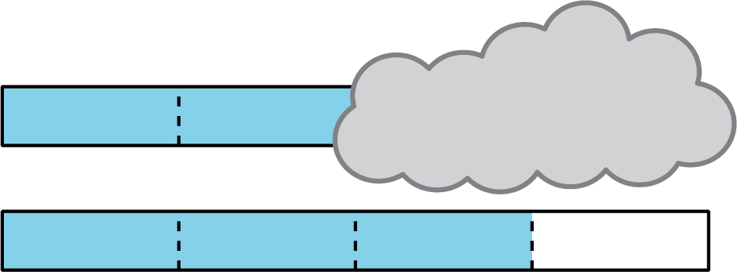

1 Compare Fractions with the Same Denominator

Student Task Statement
- For each pair of fractions, circle the fraction that is greater. Explain or show your reasoning.
  - $\frac{1}{2}$ and $\frac{3}{2}$
  - $\frac{3}{8}$ and $\frac{2}{8}$
- Use the symbols > or < to make each statement true. Explain or show your reasoning.
  - 16 11 _ 46
  - 44 11 _ 54
  - 23 11 _ 13
  - 48 11 _ 68
If you have time: Write in the missing numerator of the fraction to make each statement true. Explain or show your reasoning.
- 12<00002
- 64>00004
- 43<00003
- 58>00008

2 Spin to Win: Same Denominator

Student Task Statement
In this game, you will record fractions on number lines. Choose a writing utensil in a color different than your partner's so you can tell which fraction is whose on each number line.
- Each player spins the paper clip. The player who spins the highest number is Player 1.
- Player 1 chooses a denominator for the first round: 2, 3, 4, 6, or 8.
- Each player spins for the numerator of their fraction.
- Each player locates and labels their fraction on the same number line on the recording sheet.
- The player with the greater fraction wins and picks the denominator for the next round.
- Repeat for 10 rounds. The player who wins the most rounds wins the game.
© CC BY 2021 Illustrative Mathematics®

