Unit 3 Lesson 6: Story Problems within 10

WU Notice and Wonder: Han's Cup (Warm up)

Student Task Statement
What do you notice?
What do you wonder?
Han is playing Shake and Spill.
He has some counters in his cup.
Then he puts more counters in his cup.

1 A Shake and Spill Story Problem

Student Task Statement
Han is playing Shake and Spill.
He has some counters in his cup.
Then he puts 3 more counters in his cup.
Now he has 10 counters in his cup.
How many counters did he start with?
Show your thinking using drawings, numbers, or words.
Equation: ________________________________
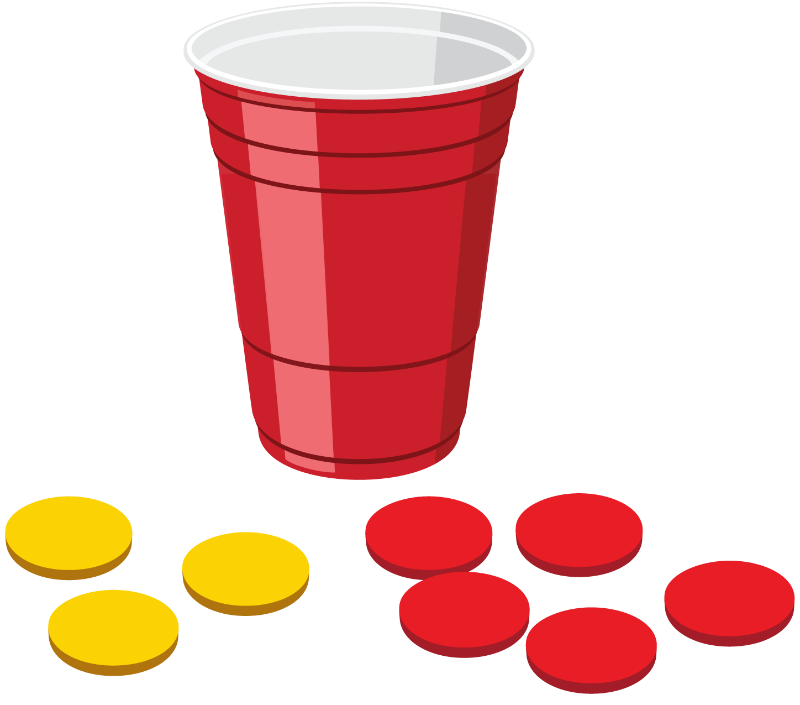

2 Shake and Spill Story Problems

Student Task Statement
- Noah is playing Shake and Spill with 10 counters.
4 of the counters fall out of the cup.
How many counters are still in the cup?
Show your thinking using drawings, numbers, or words.
- Equation: ________________________________
- Kiran has 4 counters in a cup.
He doesn’t have enough so he puts more counters in.
Now he has 7 counters in his cup.
How many more counters did Kiran put in his cup?
Show your thinking using drawings, numbers, or words.
- Equation: ________________________________
- Clare has some counters in a cup.
She puts 3 more counters in her cup.
Now she has 9 counters in her cup.
How many counters were in her cup before she added more?
Show your thinking using drawings, numbers, or words.
- Equation: ________________________________
- Priya has some counters in a cup.
She has 2 red counters and 8 yellow counters.
How many counters does she have?
Show your thinking using drawings, numbers, or words.
- Equation: ________________________________
© CC BY 2021 Illustrative Mathematics®

