Lesson 2: Factor Pairs
- Let’s learn about factor pairs.

Warm-up: Number Talk: Multiplication
Find the value of each expression mentally.
- $2×7$
- $4×7$
- $3×7$
- $7×7$

2.1: How Many Rectangles?
Your teacher will assign 2 numbers to your group. Each number represents the area of a rectangle.
- On grid paper:
  - Draw all the possible rectangles that have the given area.
  - Label the area and the side lengths.
  - Use each pair of side lengths only once.
  - (For example, if you draw a rectangle with 4 units across and 6 units down, you don’t need to also draw a rectangle with 6 units across and 4 units down because they have the same pair of side lengths.)
- When you think you've drawn all the possible rectangles for both areas, cut out your rectangles and put them on a poster for each area you were assigned.
- Display your poster for all to see.
- 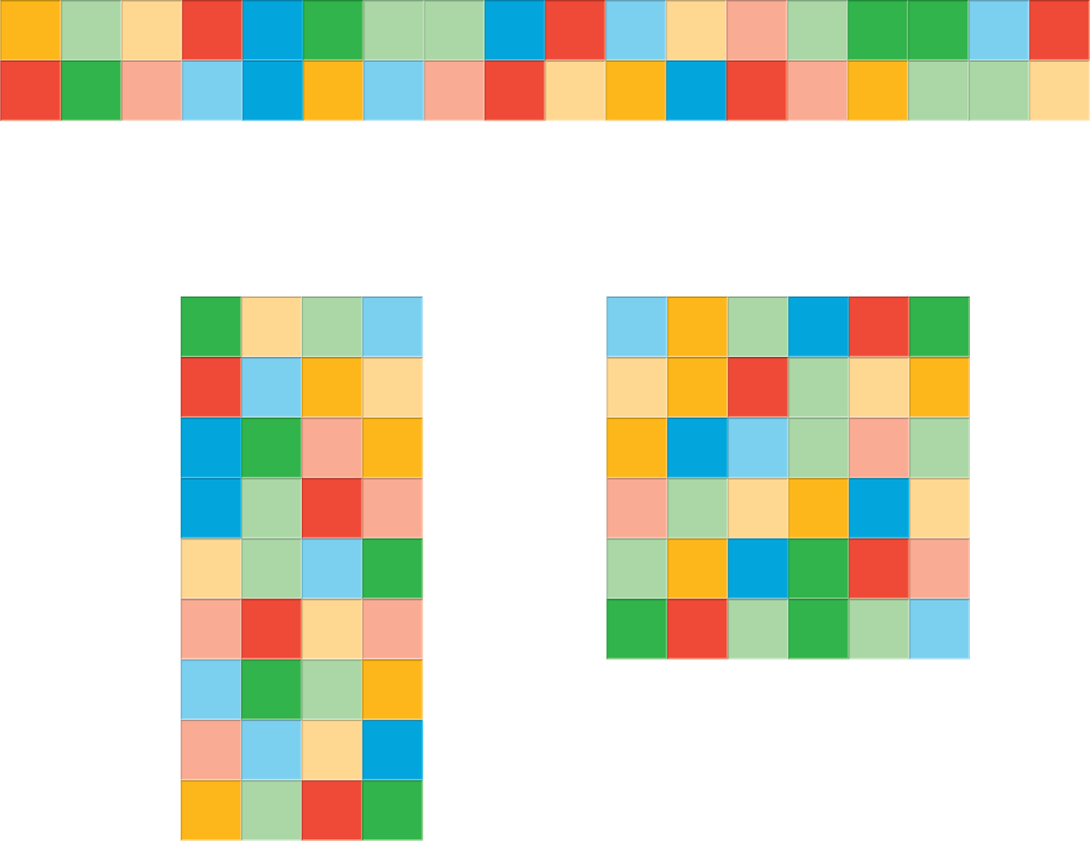

2.2: How Many Rectangles: Gallery Walk
As you visit each poster, discuss with your partner:
- What do you notice? Use the following sentence frames when you share:
  - “I notice that some of the posters . . . .”
  - “I notice the posters for numbers _____ and _____ are alike because . . . .”
- How do you know that all possible rectangles were found for the given area?
© CC BY 2021 Illustrative Mathematics®

