Lesson 8: Addition of Fractions
- Let’s explore sums of fractions on a number line.

Warm-up: Notice and Wonder: A Fraction on a Number Line
What do you notice? What do you wonder?

8.1: Sum of Jumps

  - On each number line, draw two “jumps” to show how to use sixths to make a sum of $\frac{8}{6}$. Then, write an equation to represent each combination of jumps.
  - Noah draws the following diagram and writes: $\frac{8}{6}=\frac{6}{6}+\frac{2}{6}$ and $\frac{8}{6}=1+\frac{2}{6}$. Which equation is correct? Explain your reasoning.
  - 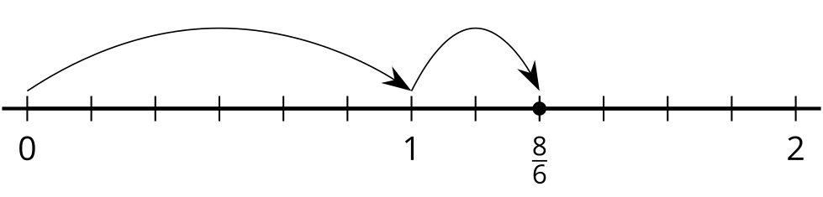

  - On each number line, draw “jumps” to show how to use thirds to make a sum of $\frac{7}{3}$. Then, write an equation to represent each combination of jumps.
  - Write $\frac{7}{3}$ as a sum of a whole number and a fraction.

8.2: What is the Sum?
- Use a number line to represent each addition expression and to find its value.
  - $\frac{5}{8}+\frac{2}{8}$
  - $\frac{1}{8}+\frac{9}{8}$
  - $\frac{11}{8}+\frac{9}{8}$
  - $2\frac{1}{8}+\frac{4}{8}$
- Priya says the sum of $1\frac{2}{5}$ and $\frac{4}{5}$ is $1\frac{6}{5}$. Kiran says the sum is $\frac{11}{5}$. Tyler says it is $2\frac{1}{5}$. Do you agree with any of them? Explain or show your reasoning. Use one or more number lines if you find them helpful.

8.3: Make Two Jumps
Here are four number lines, each with a point on it.
For each number line, label the point. This is your target. Make two forward jumps to get from 0 to the target.
- Pick a card from the set given to you. Use the fraction on it for your first jump. Draw the jump and label it with the fraction.
- From there, draw the second jump to reach the target. What fraction do you need to add? Label the jump with the fraction.
- Write an equation to represent the sum of your two fractions.
© CC BY 2021 Illustrative Mathematics®

