Unit 5 Lesson 1: Using Decimals in a Shopping Context

1 Snacks from the Concession Stand (Warm up)

Student Task Statement
Clare went to a concession stand that sells pretzels for $3.25, drinks for $1.85, and bags of popcorn for $0.99 each. She bought at least one of each item and spent no more than $10.
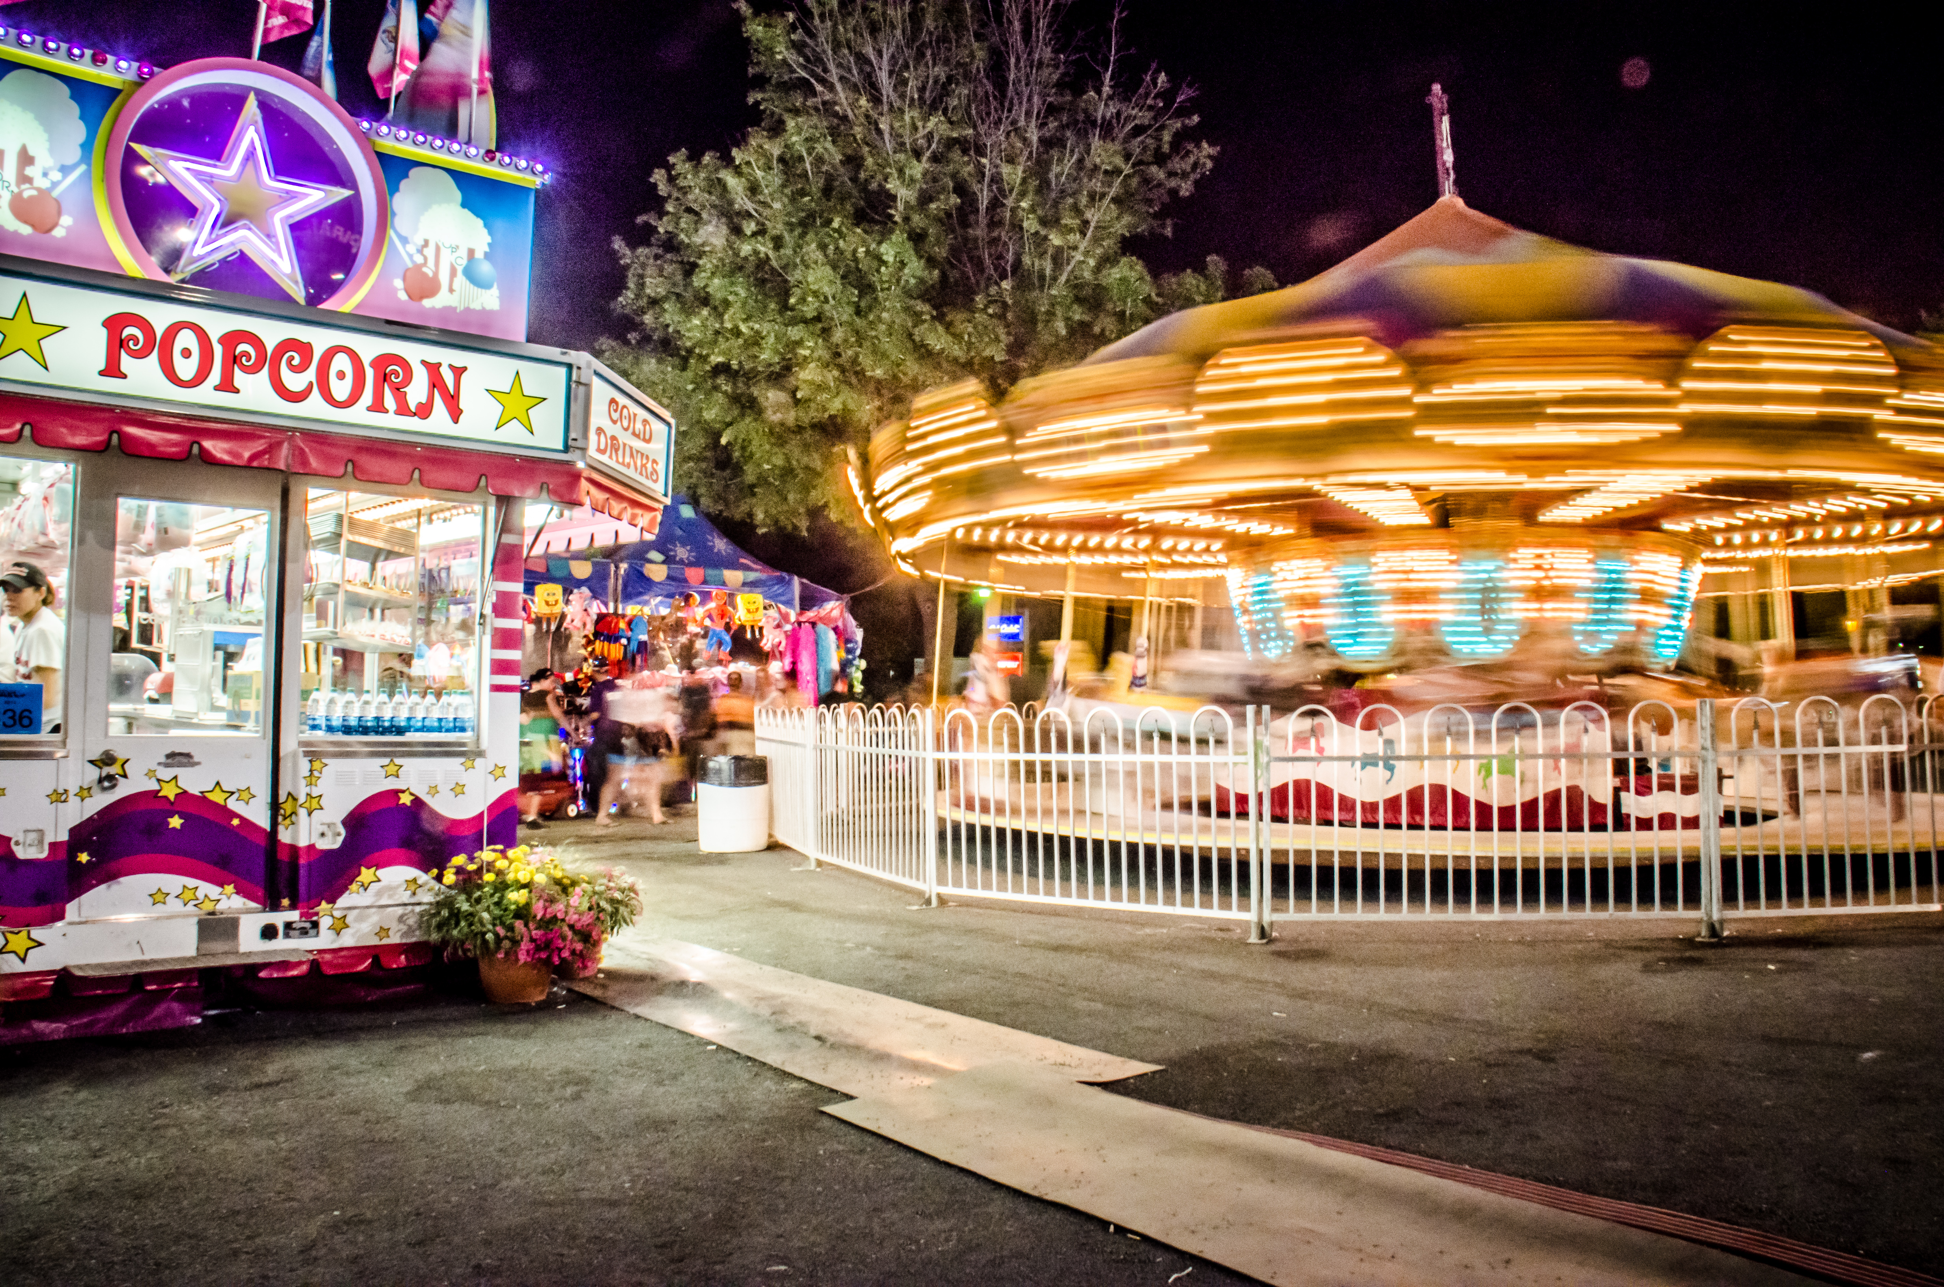
- Could Clare have purchased 2 pretzels, 2 drinks, and 2 bags of popcorn? Explain your reasoning.
- Could she have bought 1 pretzel, 1 drink, and 5 bags of popcorn? Explain your reasoning.

2 Planning a Dinner Party

Student Task Statement
You are planning a dinner party with a budget of $50 and a menu that consists of 1 main dish, 2 side dishes, and 1 dessert. There will be 8 guests at your party.
Choose your menu items and decide on the quantities to buy so you stay on budget. If you choose meat, fish, or poultry for your main dish, plan to buy at least 0.5 pound per person.
- The budget is $ ___________ per guest.
- Use the worksheet to record your choices and estimated costs. Then find the estimated total cost and cost per person. See examples in the first two rows.
- item | - quantity  needed | - advertised  price | - estimated  subtotal ($) | - estimated cost  per person ($)
- example  main dish: fish | - 4 pounds | - $6.69  per pound | - $4⋅7=28$ | - $28÷8=3.50$
- example  dessert: cupcakes | - 8 cupcakes | - $2.99 per  6 cupcakes | - $2⋅3=6$ | - $6÷8=0.75$
- main dish:
- side dish 1:
- side dish 2:
- dessert:
- estimated
total
- Is your estimated total close to your budget? If so, continue to the next question. If not, revise your menu choices until your estimated total is close to the budget.
- Calculate the actual costs of the two most expensive items and add them. Show your reasoning.
- How will you know if your total cost for all menu items will or will not exceed your budget? Is there a way to predict this without adding all the exact costs? Explain your reasoning.
© CC BY Open Up Resources. Adaptations CC BY IM.

