Lesson 14: Answer “How Many” Questions
- Let’s count to figure out how many objects are in our collections.

14.3: Introduce Connecting Cubes, Get and Build
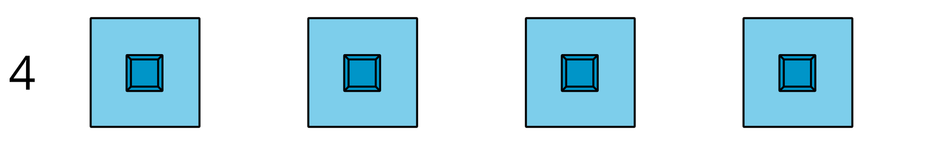
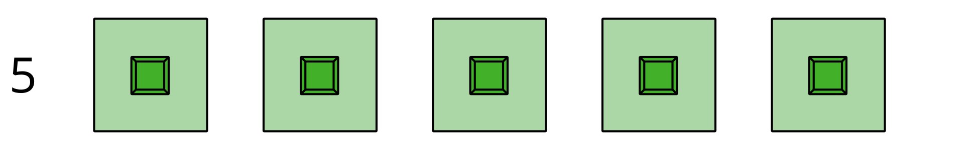
Choose a center.
Geoblocks
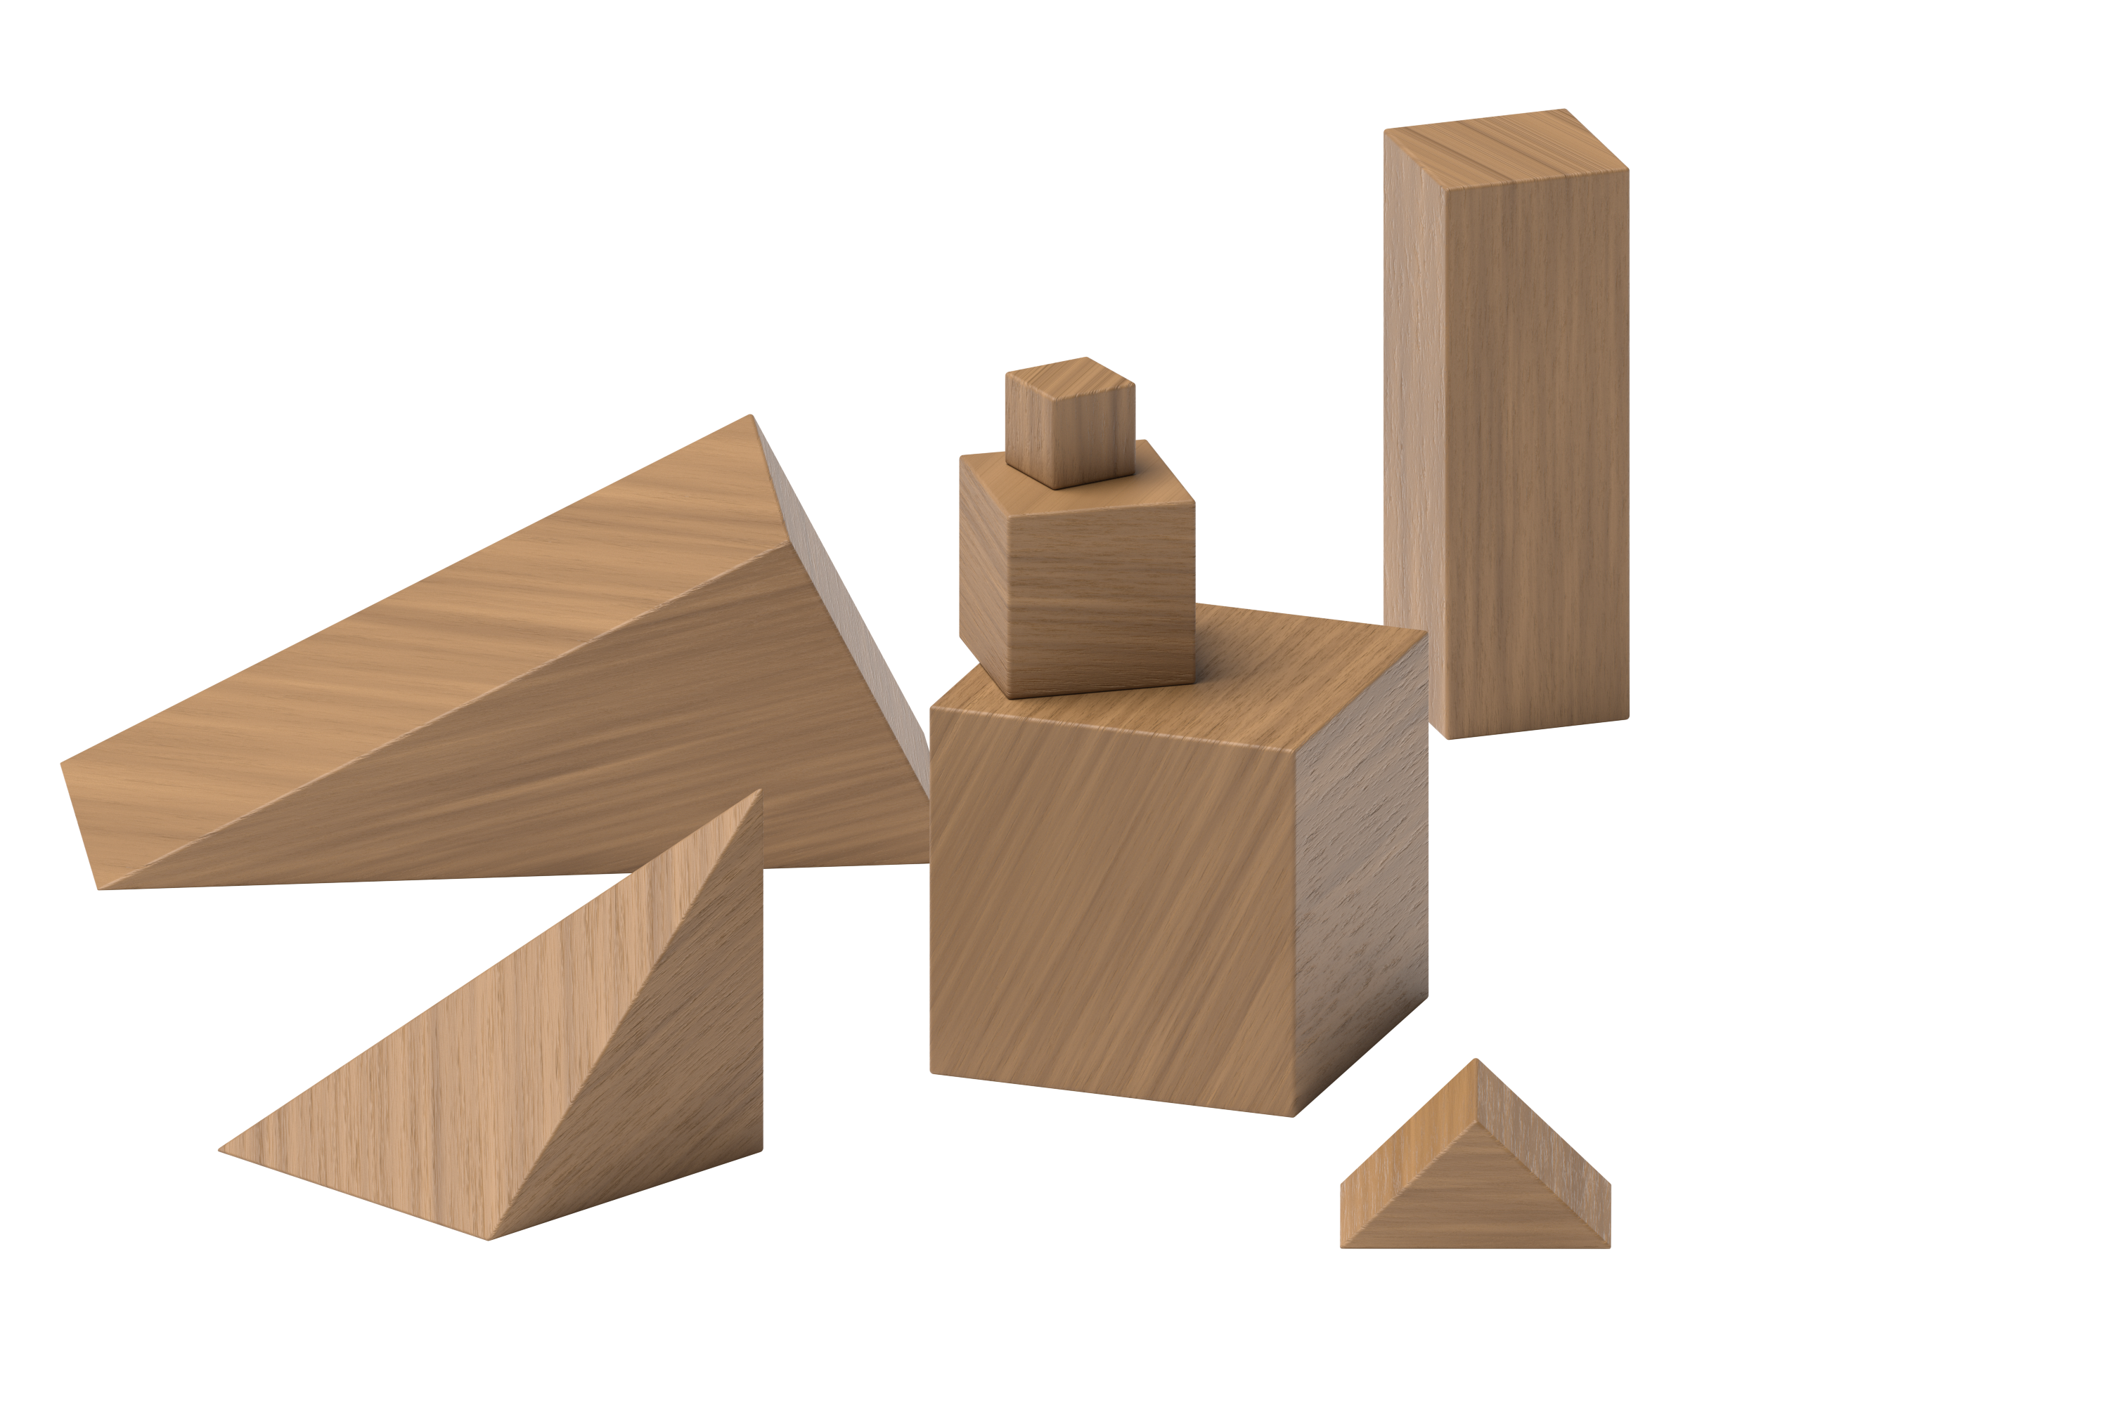
Connecting Cubes
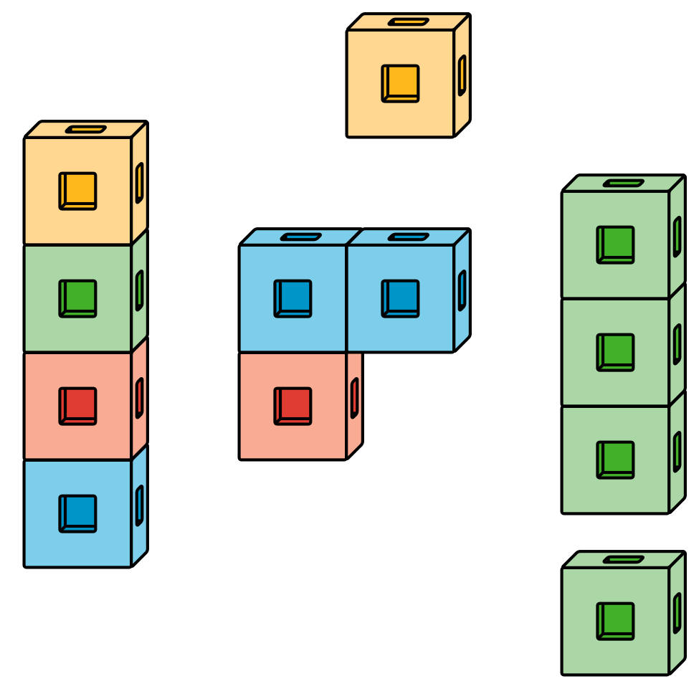
Pattern Blocks
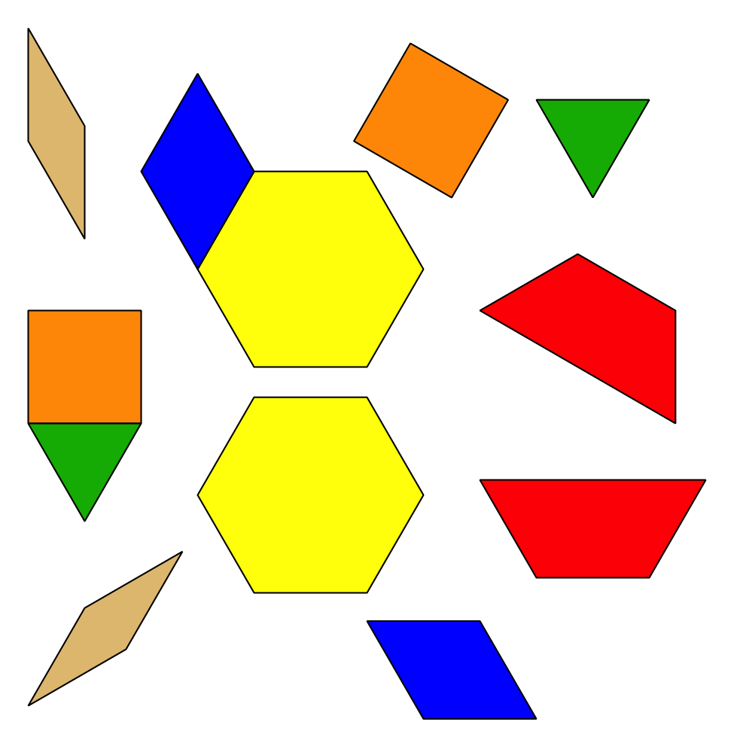
Picture Books
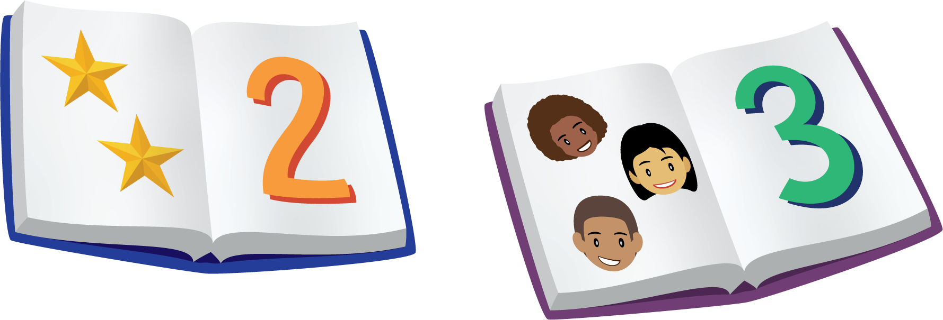
© CC BY 2021 Illustrative Mathematics®

