Lesson 21 Practice Problems
- The table shows the height of a ball after different numbers of bounces.
- $n$ | - 1 | - 2 | - 3 | - 4 | - 5
- $h$ | - 83 | - 61 | - 46 | - 35 | - 26
  - Can the height, $h$, in centimeters, after $n$ bounces be modeled accurately by a linear function? Explain your reasoning.
  - Can the height, $h$, after $n$ bounces be modeled accurately by an exponential function? Explain your reasoning.
  - Create a model for the height of the ball after $n$ bounces and plot the predicted values with the data.
  - Use your model to estimate the height the ball was dropped from.
  - Use your model to estimate how many bounces it takes before the rebound height is less than 10 cm.
- (From Unit 5, Lesson 11.)
- Mai used a computer simulation to roll number cubes and count how many rolls it took before all of the cubes came up sixes. Here is a table showing her results.
- $d$, number of cubes | - 1 | - 2 | - 3 | - 4
- $r$, number of rolls | - 5 | - 31 | - 143 | - 788
- Would a linear or exponential function be appropriate for modeling the relationship between $d$ and $r$? Explain how you know.
- (From Unit 5, Lesson 11.)
- A ramp is two meters long. Priya wants to investigate how the distance a basketball rolls is related to the location on the ramp where it is released.
- Recommend a way Priya can gather data to help understand this relationship.
- (From Unit 5, Lesson 11.)
- Here are the graphs of three functions.
- Which of these functions decays the most quickly? Which one decays the least quickly?
- 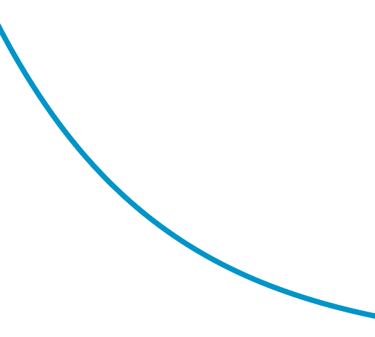
- (From Unit 5, Lesson 12.)
- The bungee jump in Rishikesh, India is 83 meters high. The jumper free falls for 5 seconds to about 30 meters above the river.
  - Draw a graph of the bungee jump in Rishikesh.
  - Identify and describe three pieces of important information you can learn from the graph of the bungee jump.
- (From Unit 4, Lesson 8.)
© CC BY 2019 by Illustrative Mathematics®

