Lesson 21: One Hundred and Eighty
- Let’s prove the Triangle Angle Sum Theorem.

21.1: What Went Wrong?
Here are 2 lines $ℓ$ and $m$ that are not parallel that have been cut by a transversal.
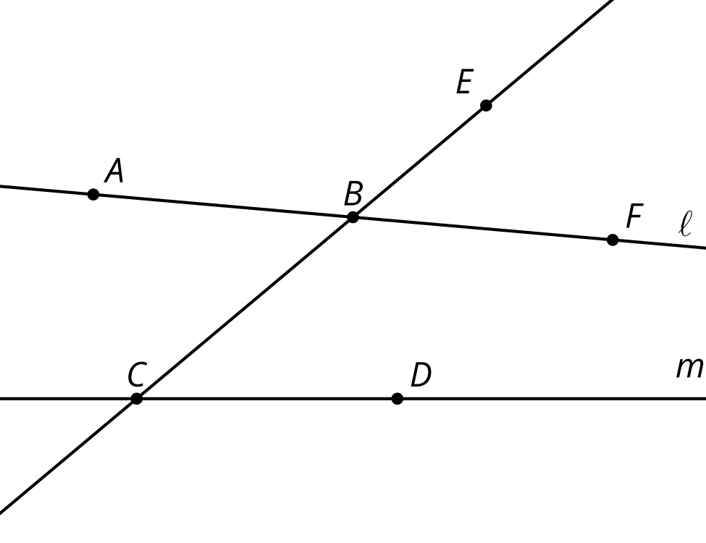
Tyler thinks angle $EBF$ is congruent to angle $BCD$ because they are corresponding angles and a translation along the directed line segment from $B$ to $C$ would take one angle onto the other. Here are his reasons.
- The translation takes $B$ onto $C$, so the image of $B$ is $C$.
- The translation takes $E$ somewhere on ray $CB$ because it would need to be translated by a distance greater than $BC$ to land on the other side of $C$.
- The image of $F$ has to land somewhere on line $m$ because translations take lines to parallel lines and line $m$ is the only line parallel to $ℓ$ that goes through $B^{′}$.
- The image of $F$, call it $F^{′}$, has to land on the right side of line $BC$ or else line $FF^{′}$ wouldn’t be parallel to the directed line segment from $B$ to $C$.
- Your teacher will assign you one of Tyler’s statements to think about. Is the statement true? Explain your reasoning.
- In what circumstances are corresponding angles congruent? Be prepared to share your reasoning.

21.2: Triangle Angle Sum One Way
- Use a straightedge to create a triangle. Label the 3 angle measures as $a^{∘}$, $b^{∘}$, and $c^{∘}$.
- Use paper folding to mark the midpoints of 2 of the sides.
- Extend the side of the triangle without the midpoint in both directions to make a line.
- Use what you know about rotations to create a line parallel to the line you made that goes through the opposite vertex.
- What is the value of $a+b+c$? Explain your reasoning.

21.3: Triangle Angle Sum Another Way
Here is triangle $ABC$ with angle measures $a^{∘}$, $b^{∘}$, and $c^{∘}$. Each side has been extended to a line.
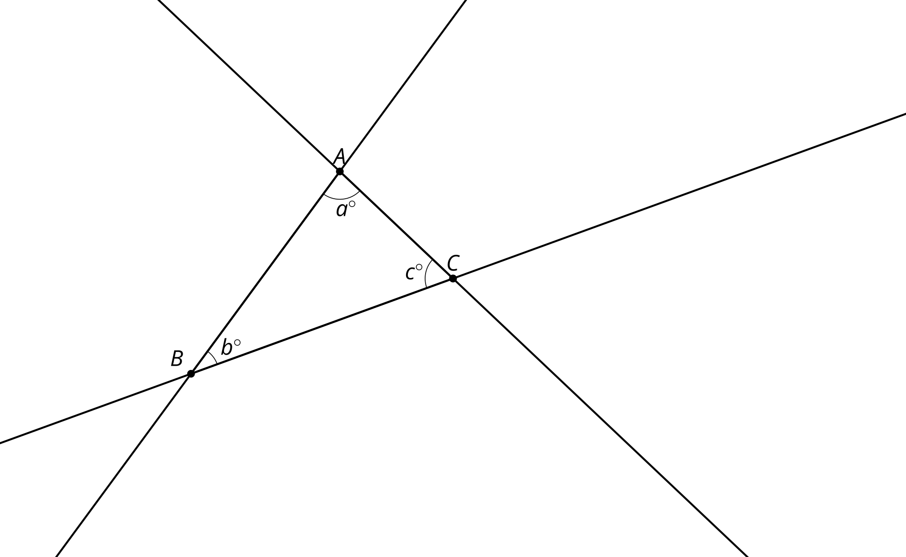
- Translate triangle $ABC$ along the directed line segment from $B$ to $C$ to make triangle $A^{′}B^{′}C^{′}$. Label the measures of the angles in triangle $A^{′}B^{′}C^{′}$.
- Translate triangle $A^{′}B^{′}C^{′}$ along the directed line segment from $A^{′}$ to $C$ to make triangle $A^{″}B^{″}C^{″}$. Label the measures of the angles in triangle $A^{″}B^{″}C^{″}$.
- Label the measures of the angles that meet at point $C$. Explain your reasoning.
- What is the value of $a+b+c$? Explain your reasoning.

Are you ready for more?
One reason mathematicians like to have rigorous proofs even when conjectures seem to be true is that it can help reveal what assertions were used. This can open up new areas to explore if we change those assumptions. For example, both of our proofs that the measures of the angles of a triangle sum to 180 degree were based on rigid transformations that take lines to parallel lines. If our assumptions about parallel lines changed, so would the consequences about triangle angle sums. Any study of geometry where these assumptions change is called non-Euclidean geometry. In some non-Euclidean geometries, lines in the same direction may intersect while in others they do not. In spherical geometry, which studies curved surfaces like the surface of Earth, lines in the same direction always intersect. This has amazing consequences for triangles. Imagine a triangle connecting the north pole, a point on the equator, and a second point on the equator one quarter of the way around Earth from the first. What is the sum of the angles in this triangle?

Lesson 21 Summary
Using rotations and parallel lines, we can understand why the angles in a triangle always add to 180 degrees. Here is triangle $ABC$.
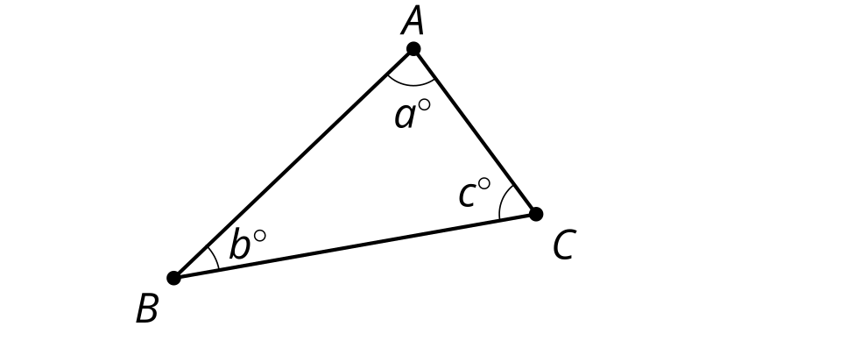
Rotate triangle $ABC$ 180 degrees around the midpoint of segment $AB$ and label the image of $C$ as $D$. Then rotate triangle $ABC$ 180 degrees around the midpoint of segment $AC$ and label the image of $B$ as $E$.
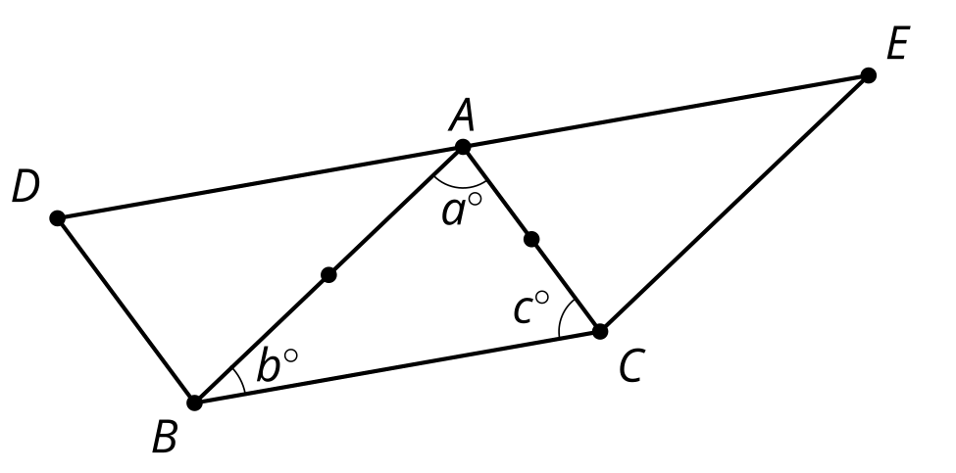
Note that each 180 degree rotation takes line $BC$ to a parallel line. So line $DA$ is parallel to $BC$ and line $AE$ is also parallel to $BC$. There is only one line parallel to $BC$ that goes through point $A$, so lines $DA$ and $AE$ are the same line. Since line $DE$ is parallel to line $BC$, we know that alternate interior angles are congruent. That means that angle $BAD$ also measures $b^{∘}$ and angle $CAE$ also measures $c^{∘}$.
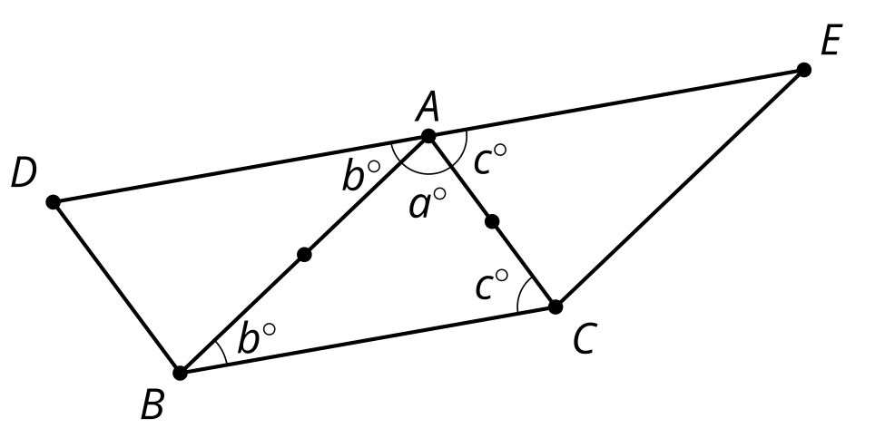
Since $DE$ is a line, the 3 angle measures at point $A$ must sum to 180 degrees. So $a+b+c=180$. This argument does not depend on the triangle we started with, so that proves the sum of the 3 angle measures of any triangle is always 180 degrees.
© CC BY 2019 by Illustrative Mathematics®

