Lesson 8: What is an Inch?
- Let’s measure in inches.

Warm-up: Notice and Wonder: Inches and Centimeters
What do you notice? What do you wonder?
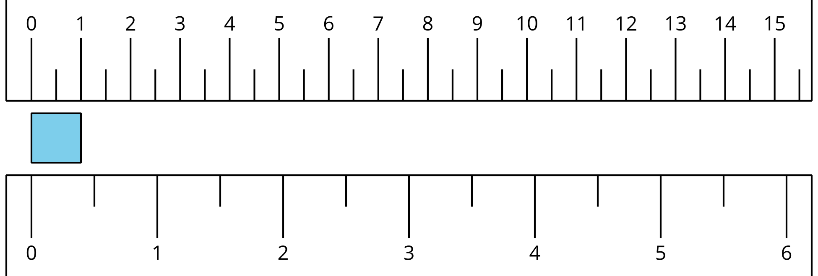

8.1: What is an Inch?
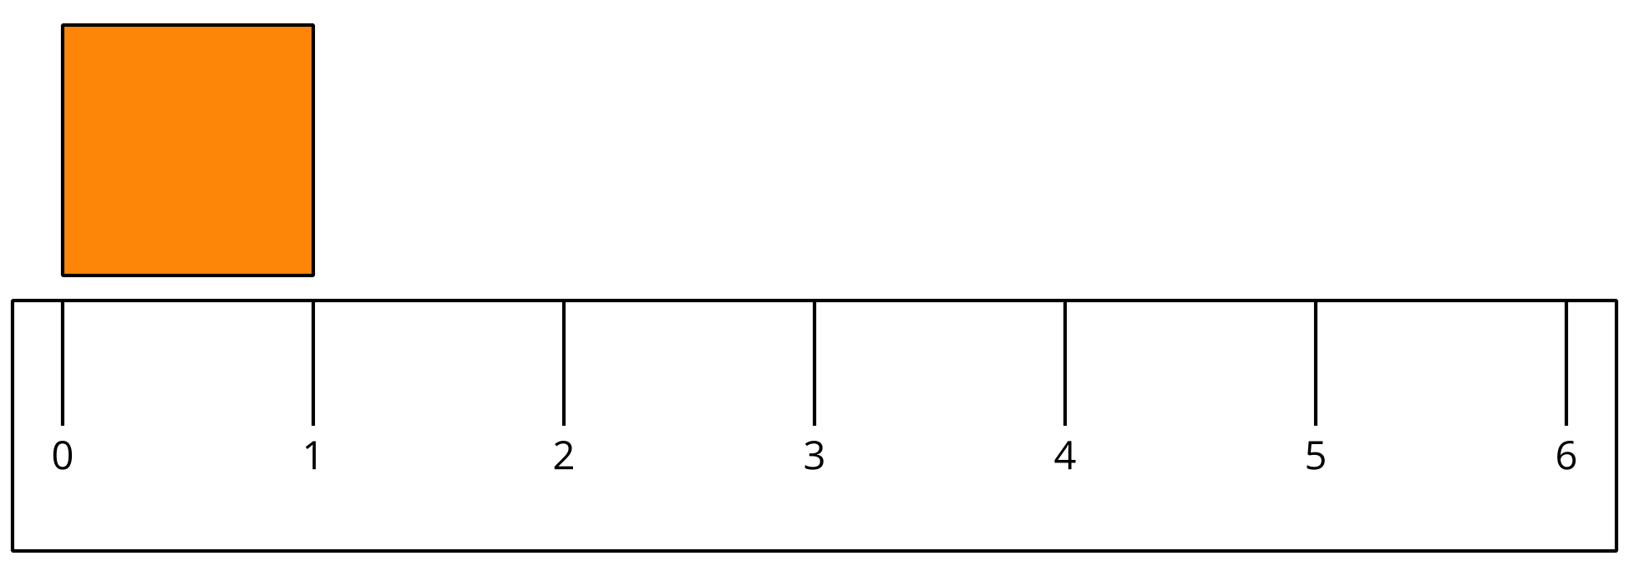
- Find 2 items that are about an inch long.
  - ________________________________________
  - ________________________________________
- Measure the length of each object.
object to measure | length in inches
marker
colored pencil
11 connecting cubes
a book
your choice objects:

8.2: Measure the Sides of Shapes
- Here is a rectangle.
- How long is the long side of the rectangle in inches?
- Estimate: ____________
- Measure the long side of the rectangle.
- Actual length: ____________
- Here is a square.
- How long is a side of the square in inches?
- Estimate: ____________
- Measure one side of the square.
- Actual length: ____________
- Here is a triangle.
- How long is the longest side of the triangle in inches?
- Estimate: ____________
- Measure the longest side of the triangle.
- Actual length: ____________
© CC BY 2021 Illustrative Mathematics®

