Unit 5 Lesson 16: Compare Fractions with the Same Numerator

WU True or False: Unit Fractions (Warm up)

Student Task Statement
Decide whether each statement is true or false. Be prepared to explain your reasoning.
- $\frac{1}{2}>\frac{1}{4}$
- $\frac{1}{4}>\frac{1}{3}$
- $\frac{1}{6}>\frac{1}{8}$

1 Five Parts of Something

Student Task Statement
- Priya says that $\frac{5}{6}$ is greater than $\frac{5}{8}$.
- Tyler says that $\frac{5}{8}$ is greater than $\frac{5}{6}$.
- Who do you agree with? Show your thinking using diagrams or number lines.
- For each pair of fractions, which fraction do you think is greater?
  - $\frac{5}{3}$ or $\frac{5}{4}$
  - $\frac{5}{8}$ or $\frac{5}{2}$
  - $\frac{5}{6}$ or $\frac{5}{4}$
- Locate and label each fraction on a number line: $\frac{5}{2}$, $\frac{5}{3}$, $\frac{5}{4}$, $\frac{5}{6}$, $\frac{5}{8}$.
- 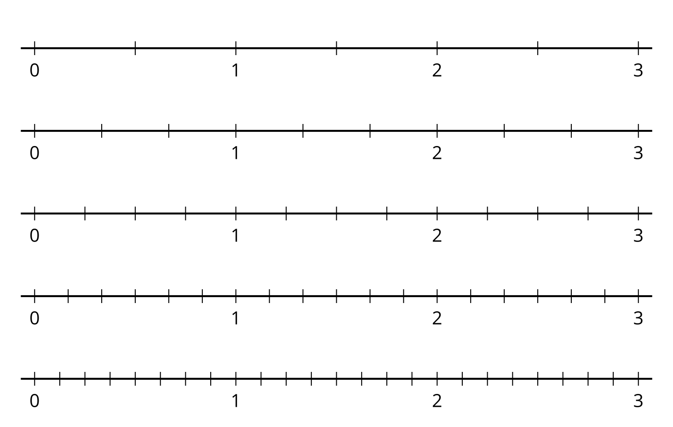
- What do you notice about the points? Make 1–2 observations.

2 Fractions with the Same Numerator

Student Task Statement
- For each pair of fractions, circle the fraction that is greater. Explain or show your reasoning.
  - $\frac{1}{4}$ and $\frac{1}{3}$
  - $\frac{3}{4}$ and $\frac{3}{8}$
  - $\frac{5}{3}$ and $\frac{5}{6}$
  - $\frac{9}{8}$ and $\frac{9}{6}$
- Use the symbols > or < to make each statement true. Be prepared to explain your reasoning.
  - 22 11 _ 26
  - 43 11 _ 48
  - 88 11 _ 84
  - 54 11 _ 53
- Write in the missing denominator of the fraction to make each statement true. Be prepared to explain your reasoning.
  - 13<10000
  - 64>60000
  - 44<40000
  - 26<20000
© CC BY 2021 Illustrative Mathematics®

