Unit 3 Lesson 7: Center Day 1

WU Choral Counting: Beyond 40 (Warm up)

Student Task Statement

1 Introduce Compare, Add and Subtract within 10

Student Task Statement

2 Centers: Choice Time

Student Task Statement
Choose a center.
Number Puzzles
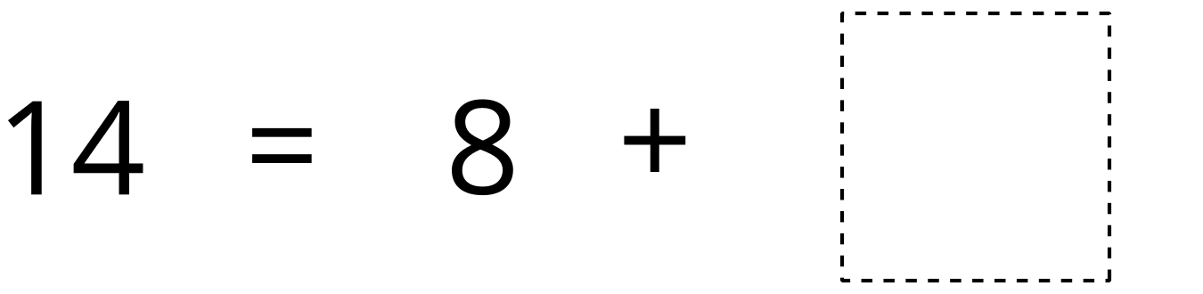
Find the Pair
Compare
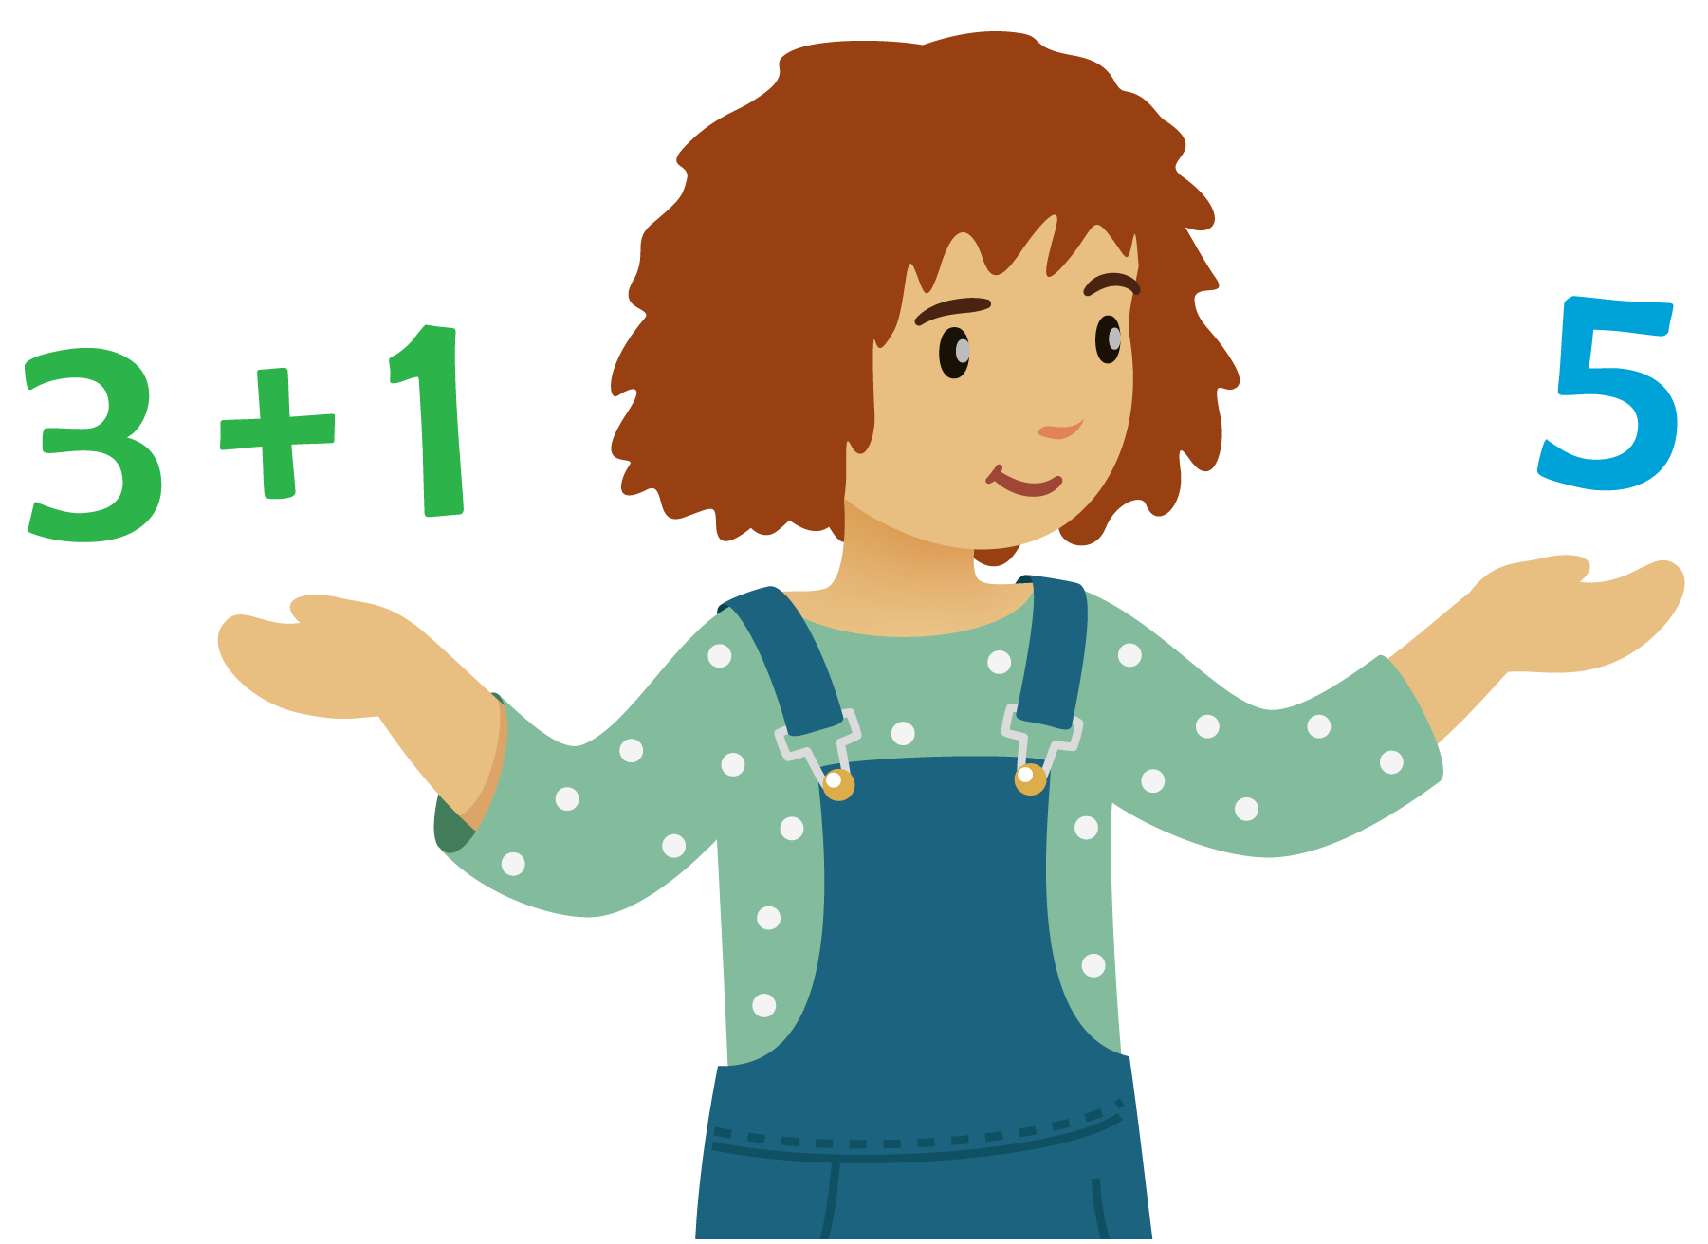
© CC BY 2021 Illustrative Mathematics®

