Lesson 3: Prime and Composite Numbers
- Let’s identify prime and composite numbers.

3.1: Card Sort: Area
Your teacher will give you a set of cards to sort.
- Sort the cards by area. Record your sorting results. Be prepared to explain your choices.
- For each group of sorted cards, think of at least one more rectangle. Name its length and width. Be prepared to explain your reasoning.
- 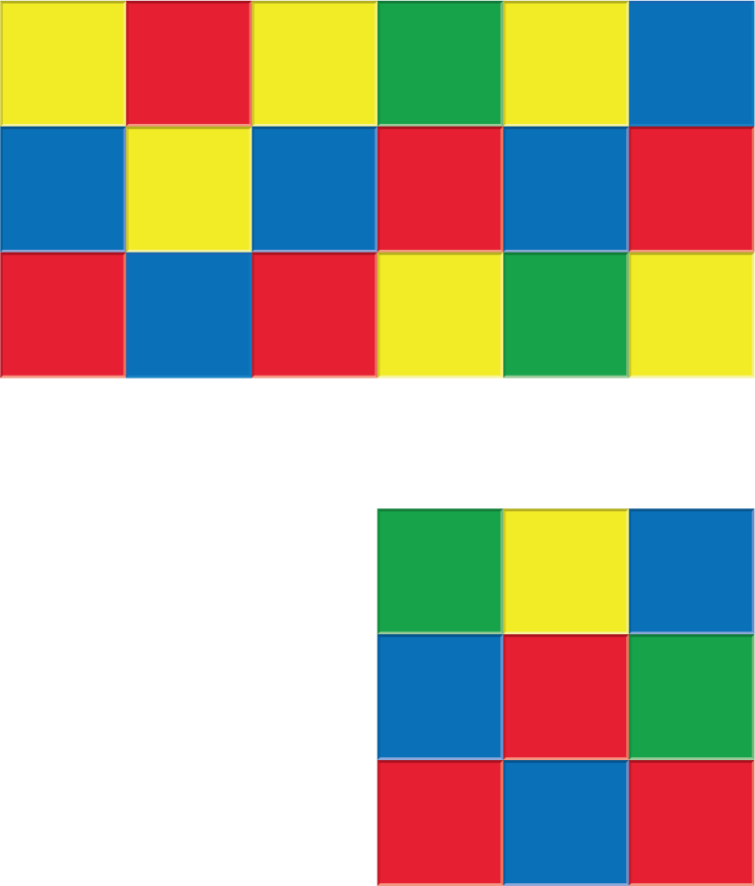

3.2: Prime or Composite?
The table shows different areas. How many rectangles can be made for each area?
Complete the table and be prepared to explain or show your reasoning.
Rectangles with the same pair of side lengths should be counted only once. For example, if you count a rectangle with 4 units across and 6 units down, you don’t need to also count a rectangle with 6 units across and 4 units down.
area | how many rectangles? | prime or composite?
2 square units
10 square units
48 square units
11 square units
21 square units
23 square units
60 square units
32 square units
42 square units
31 square units
56 square units

Section Summary
Section Summary
In this section, we used our understanding of the area of rectangles to learn about factors, multiples, factor pairs, prime numbers, and composite numbers.
If we know the side length of a rectangle, we can find the areas that the rectangle could have. For instance, a rectangle with a side length of 3 could have an area of 3, 6, 9, 12, 15, or other numbers that result from multiplying of a whole number and 3. We call these numbers multiples of 3.
If we know the area of a rectangle, we can find the side lengths that it could have. For example, a rectangle with an area of 24 square units can have side lengths of 1 and 24, 2 and 12, 3 and 8, or 4 and 6. We call these possible pairs of side lengths the factor pairs of 24.
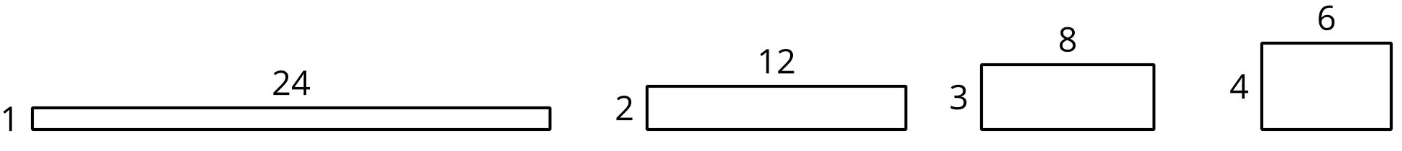
We also learned that a number that has only one factor pair—1 and the number itself—is called a prime number. For instance, 5 is prime because its only factor pair is 1 and 5.
A number that has two or more factor pairs is a composite number. For instance, 15 is composite because its factor pairs are 1 and 15, and 3 and 5.
© CC BY 2021 Illustrative Mathematics®

