Lesson 9: Differences of Fractions
- Let’s explore differences of fractions on a number line.

Warm-up: True or False: Sums of Tenths
Decide if each statement is true or false. Be prepared to explain your reasoning.
- $\frac{1}{10}+\frac{2}{10}+\frac{3}{10}=1$
- $1+\frac{7}{10}=\frac{3}{10}+\frac{4}{10}+\frac{10}{10}$
- $\frac{5}{10}+1=\frac{6}{10}$
- $\frac{2}{10}+\frac{10}{10}=1+\frac{1}{5}$

9.1: Jump to Subtract
- To subtract different fractions from $\frac{11}{6}$, Noah draws “jumps” on number lines.
- 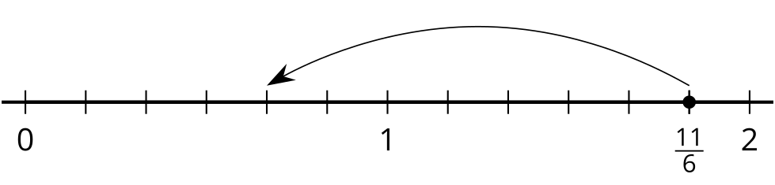
- 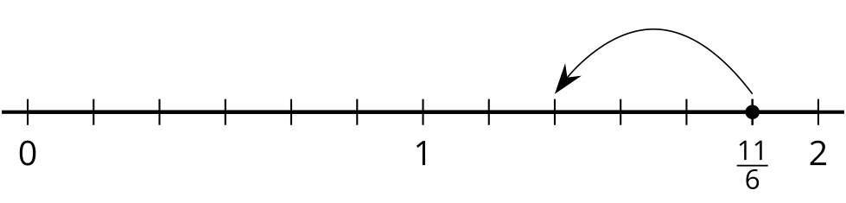
- 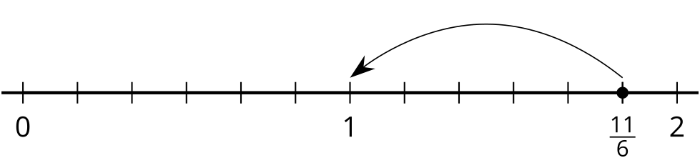
  - The first diagram shows how he finds $\frac{11}{6}−\frac{7}{6}$. What is the value of $\frac{11}{6}−\frac{7}{6}$ ?
  - Write an equation to show the difference represented by each of Noah’s diagrams.
- Here is another diagram Noah draws:
- 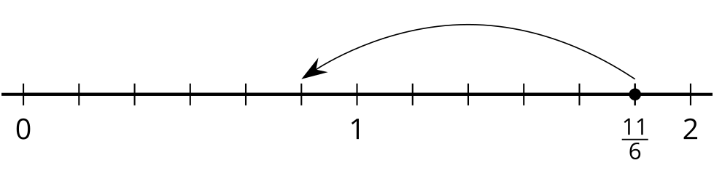
- Which equations could the diagram represent? Explain your reasoning.
- $\frac{11}{6}−\frac{6}{6}=\frac{5}{6}$
- $\frac{11}{6}−1=\frac{5}{6}$
- $1\frac{5}{6}−1=\frac{5}{6}$
- Use a number line to represent each difference and to find its value.
  - $\frac{8}{3}−\frac{2}{3}$
  - $\frac{8}{3}−\frac{4}{3}$
  - $\frac{8}{3}−1$

9.2: What’s the Difference?
Use a number line to represent each difference and to find its value.
- $\frac{13}{8}−\frac{2}{8}$
- $\frac{13}{8}−\frac{6}{8}$
- $\frac{13}{8}−1$
- $1\frac{5}{8}−\frac{7}{8}$
- $1\frac{5}{8}−1$
- $1\frac{5}{8}−1\frac{4}{8}$

9.3: Make a Jump, Subtraction Edition
Here are four number lines, each with a point on it. Label each point with a fraction it represents.
The point you labeled is your target.
- Pick a card from the set given to you. Locate and label the fraction on the number line.
- From that point, draw one or more jumps to reach the target. What do you need to subtract? Label each jump you draw.
- Write an equation to represent the difference of your two fractions.
© CC BY 2021 Illustrative Mathematics®

