## Unit 1 Lesson 15: Adding the Angles in a Triangle

### 1 Can You Draw It? (Warm up)

#### Student Task Statement

1. Complete the table by drawing a triangle in each cell that has the properties listed for its column and row. If you think you cannot draw a triangle with those properties, write “impossible” in the cell.
2. Share your drawings with a partner. Discuss your thinking. If you disagree, work to reach an agreement.

|  |  |  |  |
| --- | --- | --- | --- |
|  | acute (all angles acute) | right (has a right angle) | obtuse (has an obtuse angle) |
| scalene (side lengths all different) |  |  |  |
| isosceles (at least two side lengthsare equal) |  |  |  |
| equilateral (three side lengths equal) |  |  |  |

### 2 Find All Three (Optional)

#### Student Task Statement

Your teacher will give you a card with a picture of a triangle.

1. The measurement of one of the angles is labeled. Mentally estimate the measures of the other two angles.
2. Find two other students with triangles congruent to yours but with a different angle labeled. Confirm that the triangles are congruent, that each card has a different angle labeled, and that the angle measures make sense.
3. Enter the three angle measures for your triangle on the table your teacher has posted.

### 3 Tear It Up

#### Images for Launch

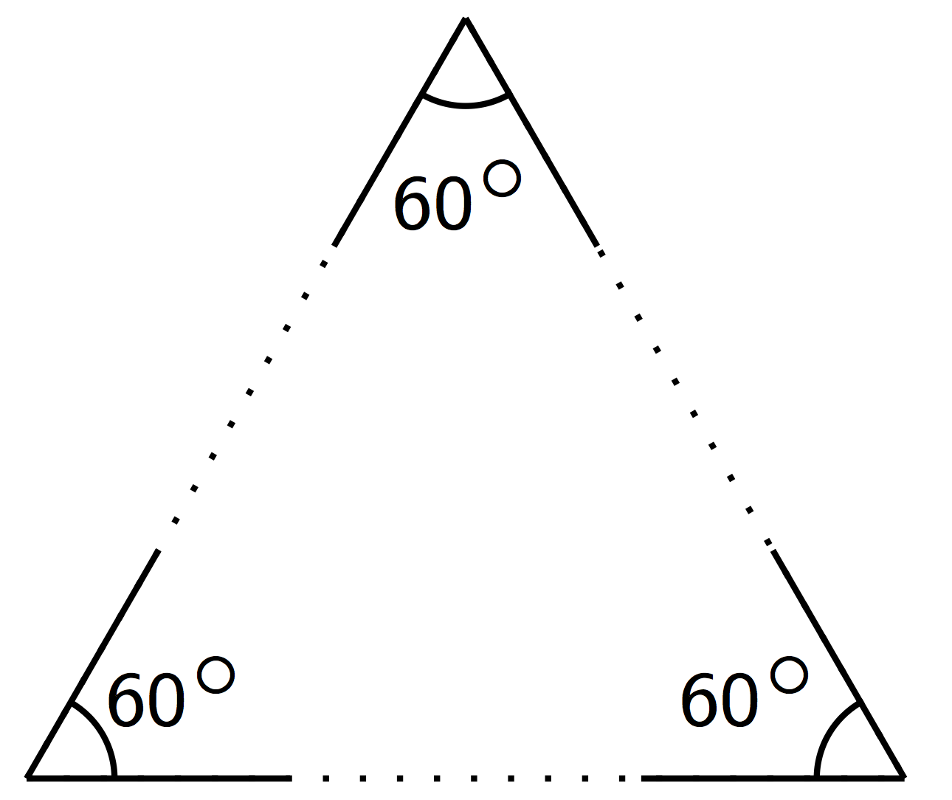

#### Student Task Statement

Your teacher will give you a page with three sets of angles and a blank space. Cut out each set of three angles. Can you make a triangle from each set that has these same three angles?



© CC BY Open Up Resources. Adaptations CC BY IM.