Unit 2 Lesson 8: Divide to Multiply Non-unit Fractions

WU True or False: A Fraction by a Whole Number (Warm up)

Student Task Statement
Decide if each statement is true or false. Be prepared to explain your reasoning.
- $2×\left(\frac{1}{3}×6\right)=\frac{2}{3}×6$
- $2×\left(\frac{1}{3}×6\right)=2×\left(6÷3\right)$
- $\frac{2}{3}×6=2×\left(\frac{1}{4}×6\right)$

1 Multiply a Whole Number by a Fraction

Student Task Statement
Find the value of each expression. Explain or show your reasoning. Draw a diagram if it is helpful.
- $\frac{1}{5}×3$
- $\frac{2}{5}×3$
- $\frac{3}{5}×3$

2 Match Expressions to Diagrams

Student Task Statement
Explain how each expression represents the shaded region.
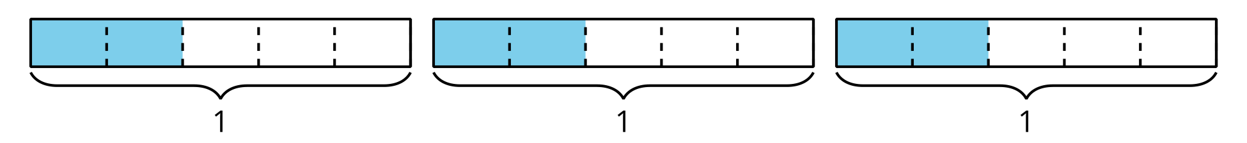
- $2×\left(3÷5\right)$
- $\frac{6}{5}$
- $3×\frac{2}{5}$
- $3×2×\frac{1}{5}$
© CC BY 2021 Illustrative Mathematics®

