Unit 7 Lesson 2: Build Shapes from Other Shapes

WU Notice and Wonder: A Shape Bridge (Warm up)

Student Task Statement
What do you notice?
What do you wonder?
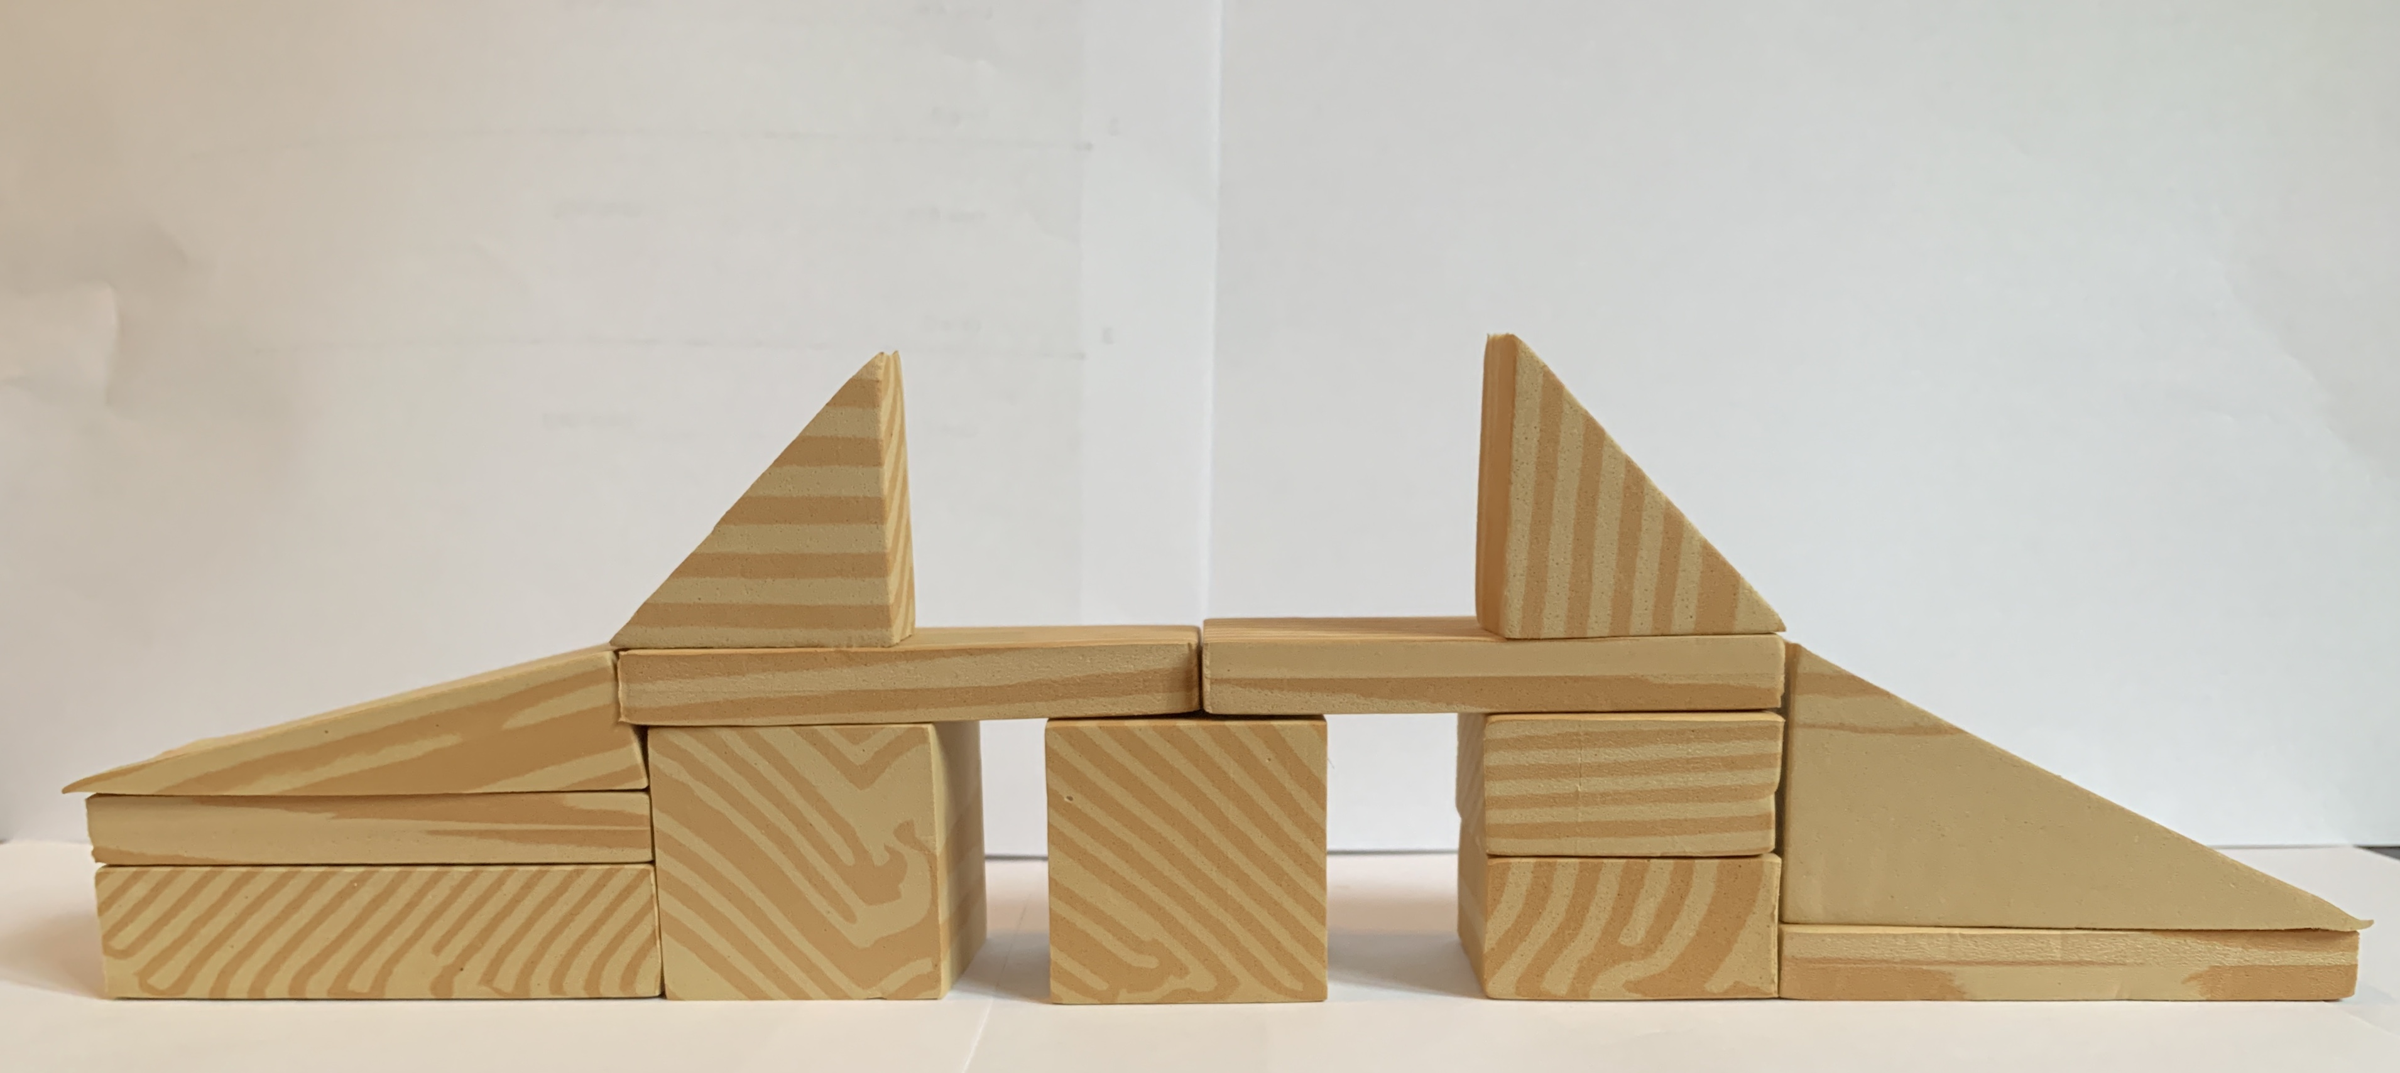

1 Build With Solid Shapes

Student Task Statement

2 Use Shapes to Make Other Shapes

Student Task Statement

3 Introduce Geoblocks, Describe and Find

Student Task Statement
© CC BY 2021 Illustrative Mathematics®

