Unit 2 Lesson 15: Center Day 3

WU Number Talk: Subtract Multiples of 10 (Warm up)

Student Task Statement
Find the value of each expression mentally.
- $25−10$
- $35−10$
- $35−20$
- $35−19$

1 Introduce Math Stories, Tape Diagrams

Student Task Statement

2 Centers: Choice Time

Student Task Statement
Choose a center.
Target Numbers
Capture Squares
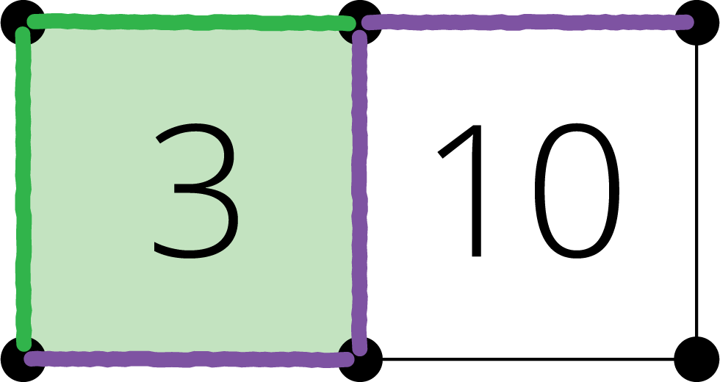
Five in a Row
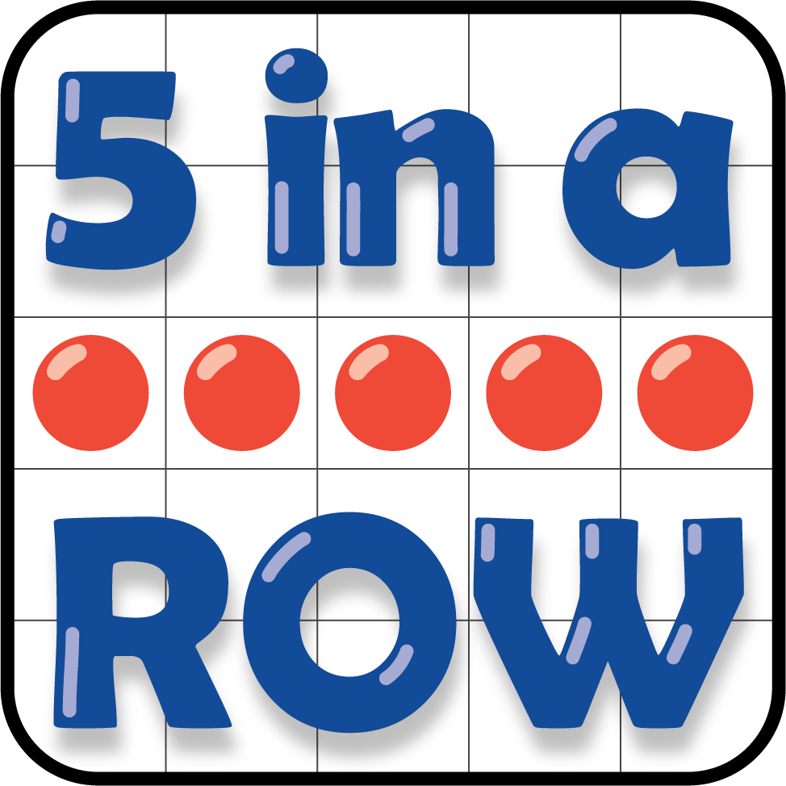
© CC BY 2021 Illustrative Mathematics®

