Lesson 12: Area and Addition

Standards Alignments
Building On | 2.NBT.B.5
Addressing | 3.MD.C.7.d
Building Towards | 3.NBT.A.2

Teacher-facing Learning Goals
- Find the area of figures composed of rectangles.
- Recognize that area is additive.

Student-facing Learning Goals
- Let's find the area of figures made up of rectangles.

Lesson Purpose
The purpose of this lesson is for students to use gridded rectangles to learn that area is additive.
Students first decompose a rectangle into parts to see that area is additive. Then, students decompose a figure composed of rectangles into rectangles in any way that makes sense to them, find the area of those rectangles, and add them together to find the area. Students learn that parentheses are grouping symbols that can be used in expressions or equations, and use them to represent how they decomposed the figure into rectangles. The work of this lesson connects to previous work because students find the area of rectangles within the figure before adding to find the total area of the figure.

Access for:

Students with Disabilities
- Action and Expression (Activity 1)

Instructional Routines
MLR7 Compare and Connect (Activity 2), Number Talk (Warm-up)

Lesson Timeline
Warm-up | 10 min
Activity 1 | 15 min
Activity 2 | 20 min
Lesson Synthesis | 10 min
Cool-down | 5 min

Teacher Reflection Question
Which students came up with an unexpected strategy in today’s lesson? What are some ways you can be more open to the ideas of each and every student?

Cool-down
(to be completed at the end of the lesson) 5min
Where are the Rectangles?

Standards Alignments
Addressing | 3.MD.C.7.d

Student-facing Task Statement
Find the area of this figure. Explain or show your reasoning.
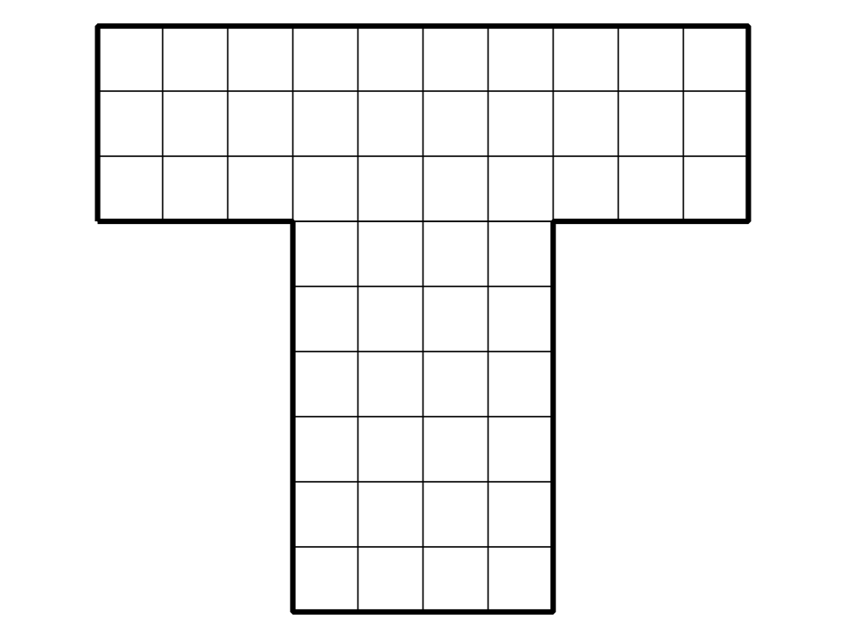

Student Responses
54 square units. Sample response: I split the figure into 2 rectangles, 1 across the top and 1 below. I found the area of the rectangle across the top by multiplying $3×10$, which is 30. I found the area of the bottom rectangle by multiplying $4×6$, which is 24. Then, I added the area of both rectangles to get 54.

