Unit 5 Lesson 18: Two Truths and a Lie

WU Notice and Wonder: Animal Facts (Warm up)

Student Task Statement
What do you notice? What do you wonder?
30 feet
130 inches
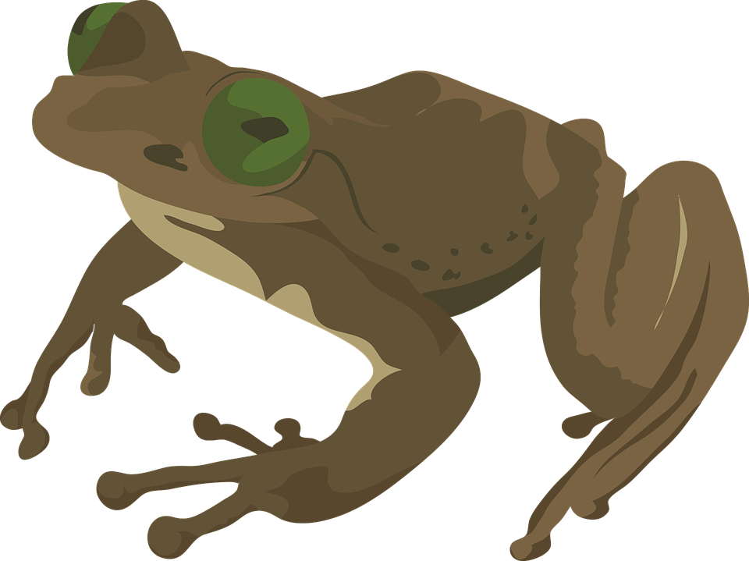
3 feet
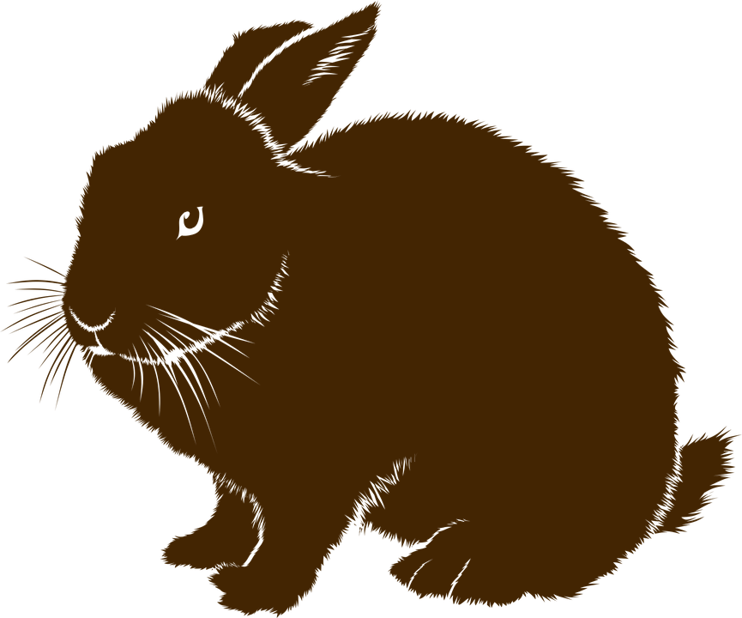

1 Two Truths and a Lie

Student Task Statement
Your teacher will give you a fact sheet about some animals or ask you to perform some research.
- Choose two animals that you would like to compare.
- Use the information from your teacher or your research to write two true comparison statements and one false comparison statement about these animals.
  - Write one statement on the front side of an index card.
  - On the back side of the card, write whether the statement is true or false.

2 Gallery Walk: Two Truths and a Lie

Student Task Statement
- Read at least 5 statements that are not yours and decide if they are true.
  - Find at least one statement that is false. Write down the statement here. Be prepared to explain or show how you know.
  - If a statement you read is unclear, use a sticky note to leave a comment or question for the writer.
- Collect your cards and any notes that your classmates might have left for you.
  - Think about how to make revisions to make your statements stronger and clearer.
  - Record your revised statements here.
© CC BY 2021 Illustrative Mathematics®

