Unit 5 Lesson 14: Towers of 10

WU What Do You Know About 10? (Warm up)

Student Task Statement
What do you know about 10?

1 Introduce What’s Behind My Back?, 10 Cubes

Student Task Statement

2 How Many Cubes Are Hidden?

Student Task Statement
Han had a tower of 10 cubes.
He snapped it into 2 parts and hid 1 part behind his back.
He showed his partner 4 cubes.
How many cubes is Han hiding behind his back?
$10=\underset{_}{}+\underset{_}{}$

Activity Synthesis
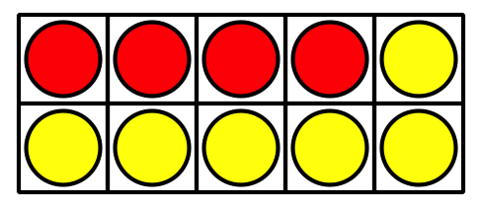
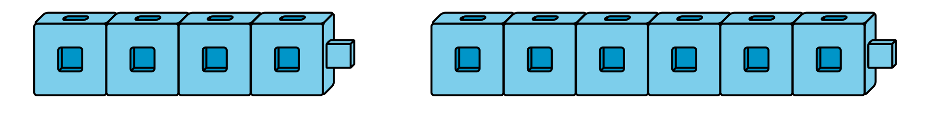

3 Centers: Choice Time

Student Task Statement
Choose a center.
What’s Behind My Back?
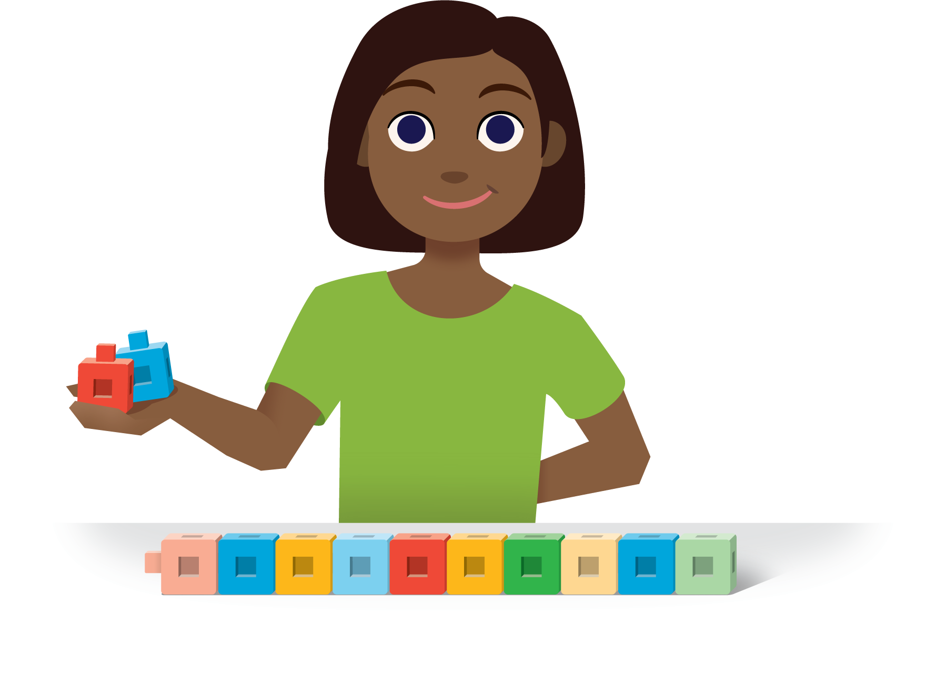
Math Fingers
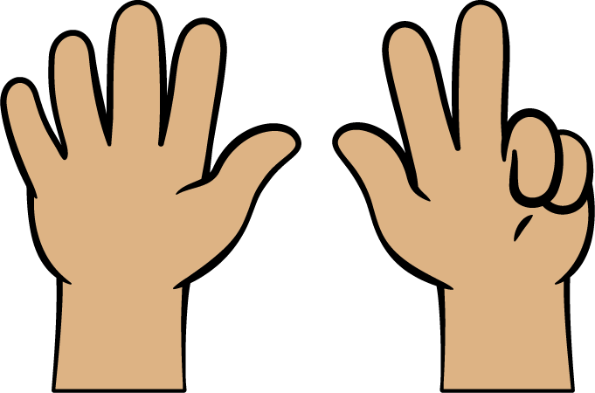
Shake and Spill
Counting Collections
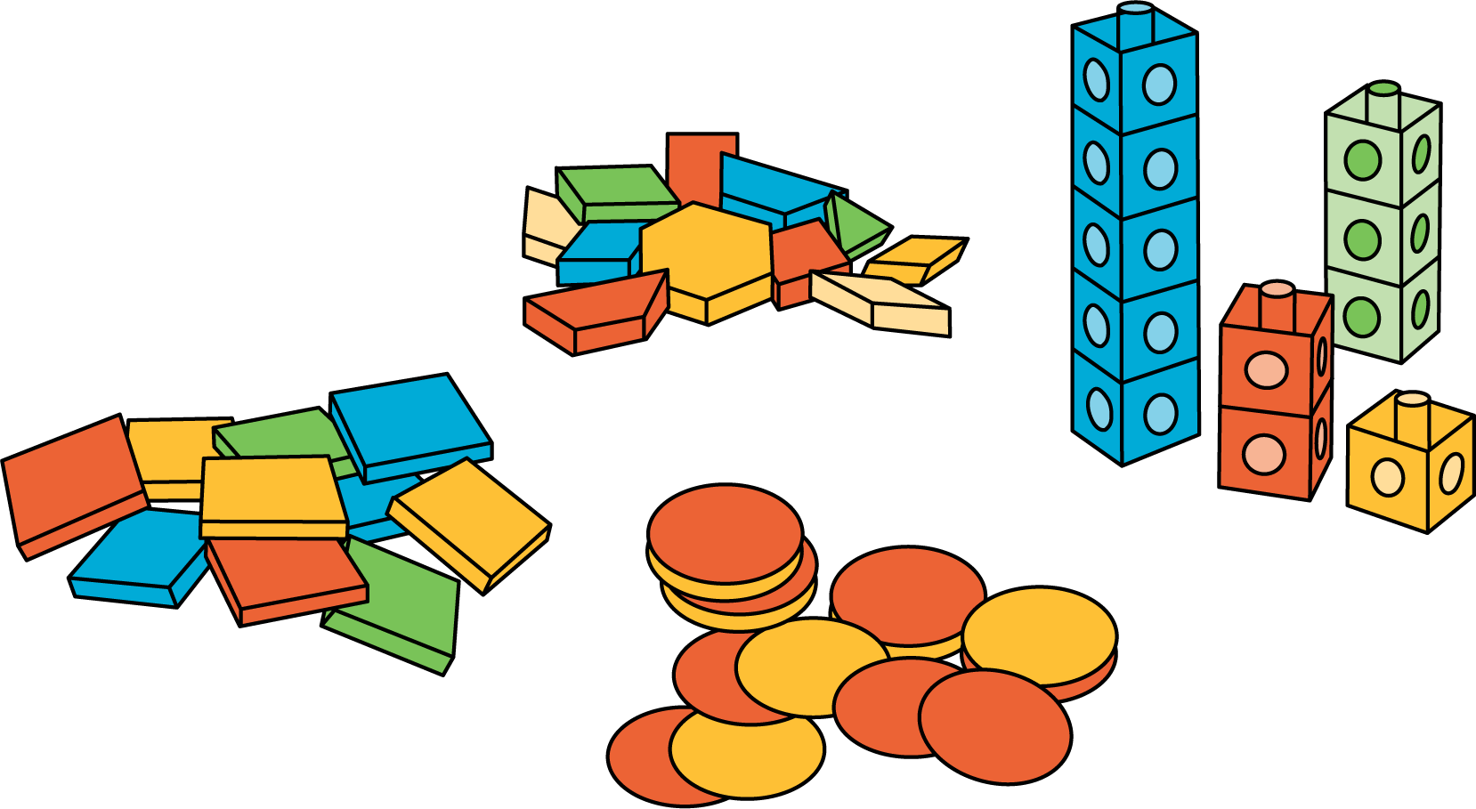
Roll and Add
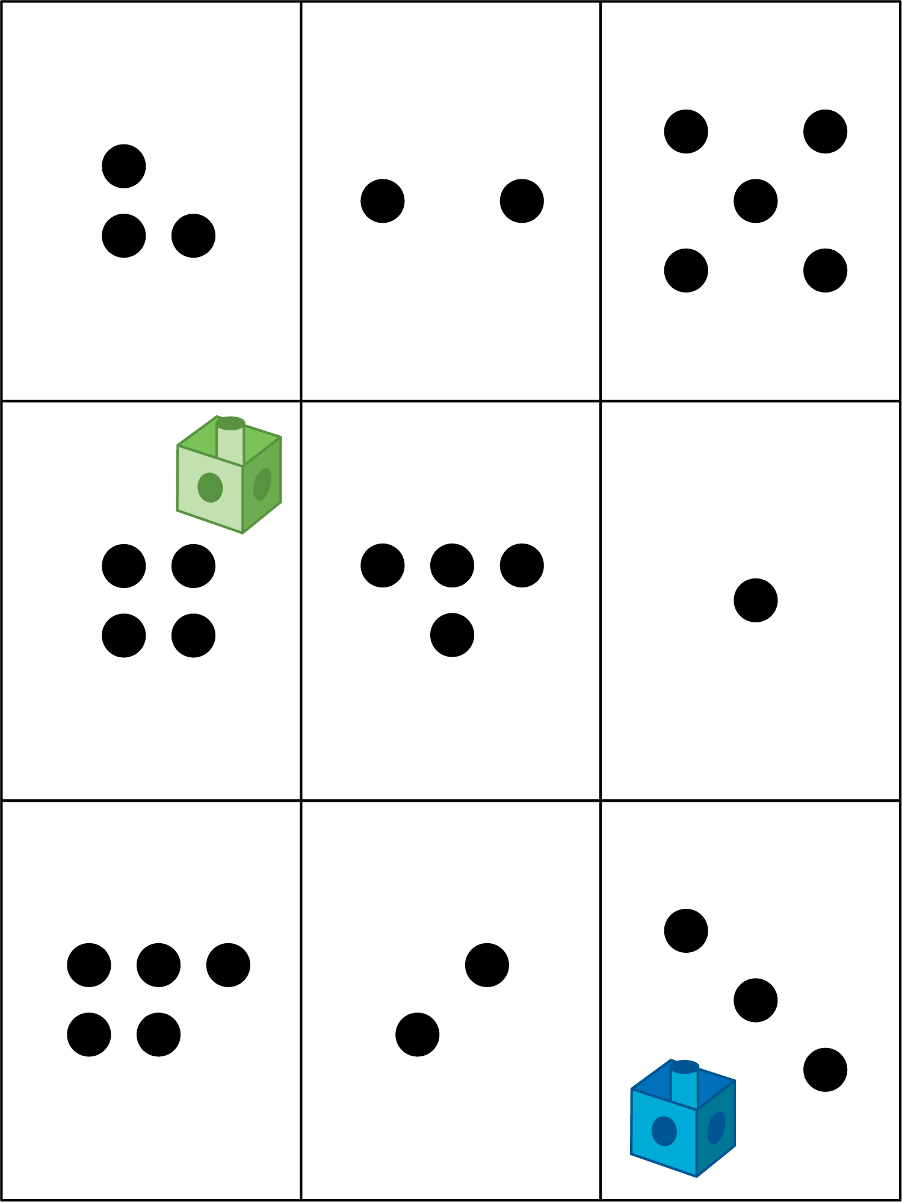

Activity Synthesis
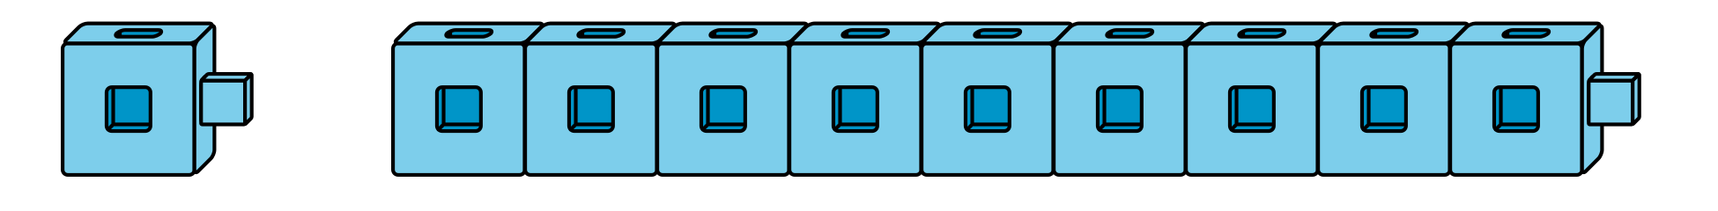

Images for Activity Synthesis
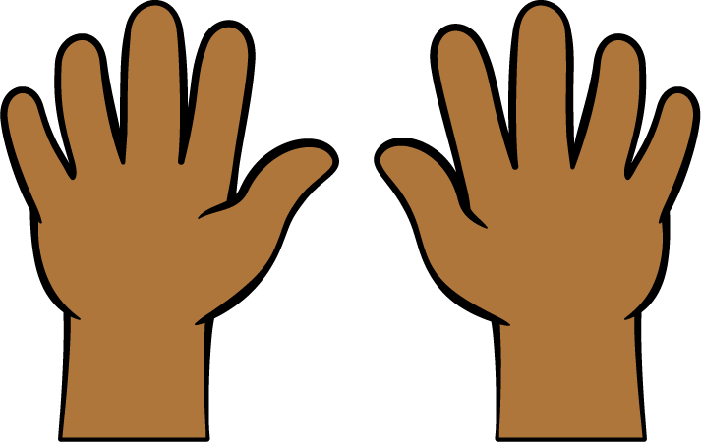
© CC BY 2021 Illustrative Mathematics®

