Lesson 14: Towers of 10
- Let’s figure out how many cubes are hidden.

Warm-up: What Do You Know About 10?
What do you know about 10?

14.2: How Many Cubes Are Hidden?
Han had a tower of 10 cubes.
He snapped it into 2 parts and hid 1 part behind his back.
He showed his partner 4 cubes.
How many cubes is Han hiding behind his back?
$10=\underset{_}{}+\underset{_}{}$

14.3: Centers: Choice Time
Choose a center.
What’s Behind My Back?
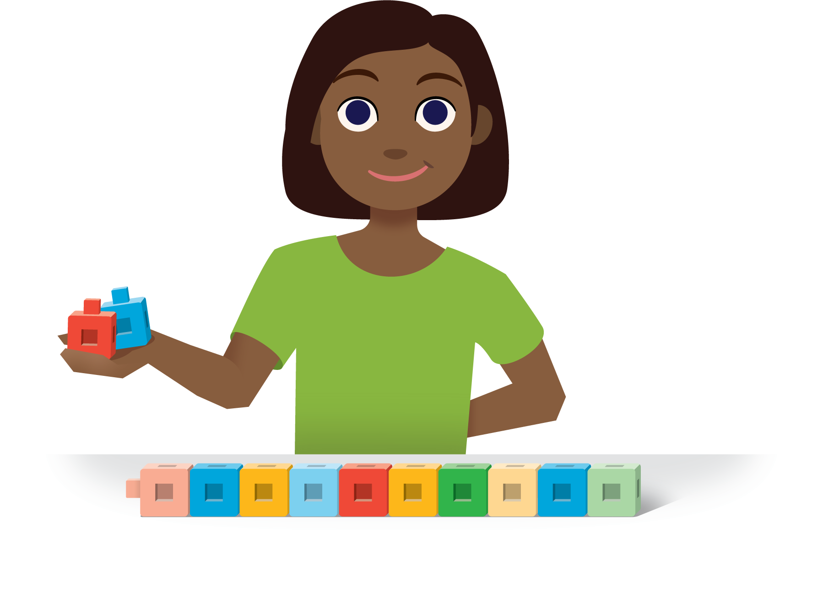
Math Fingers
Shake and Spill
Counting Collections
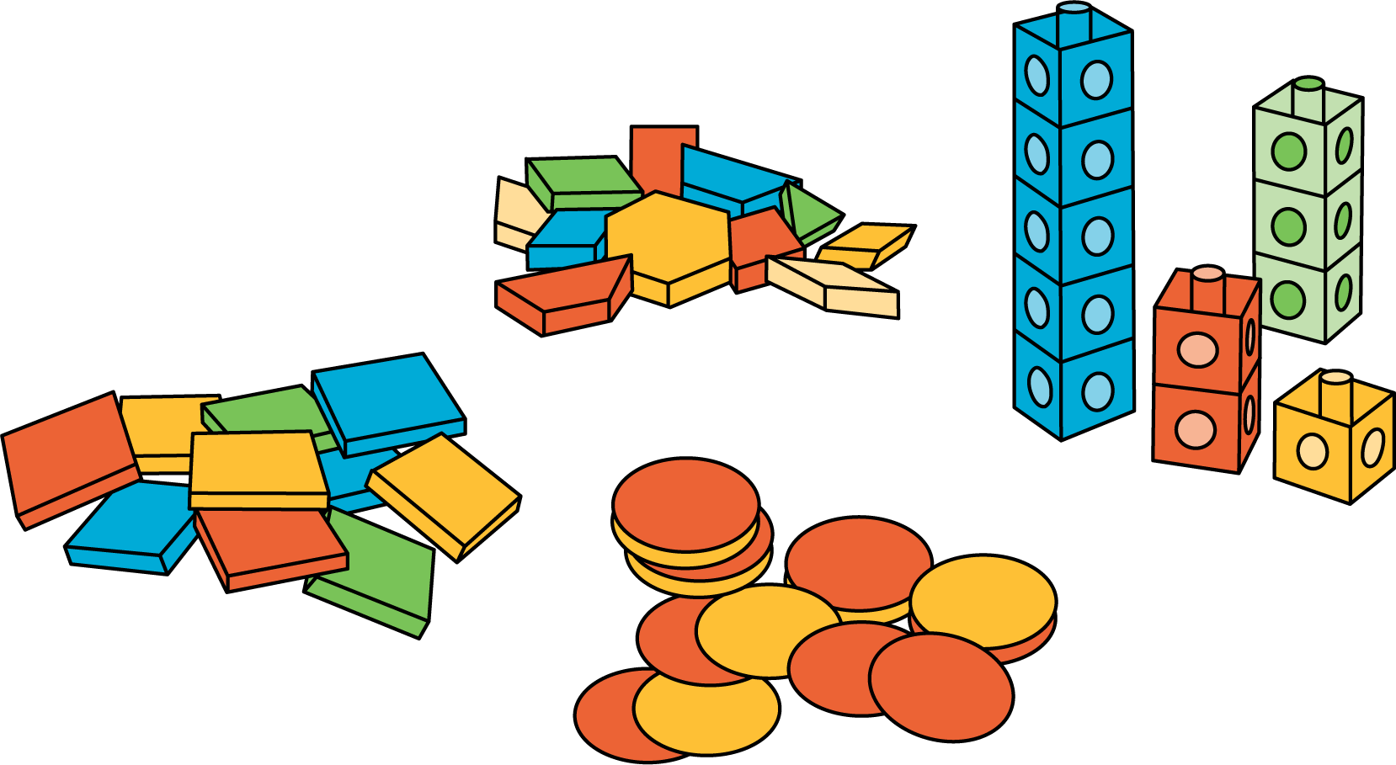
Roll and Add
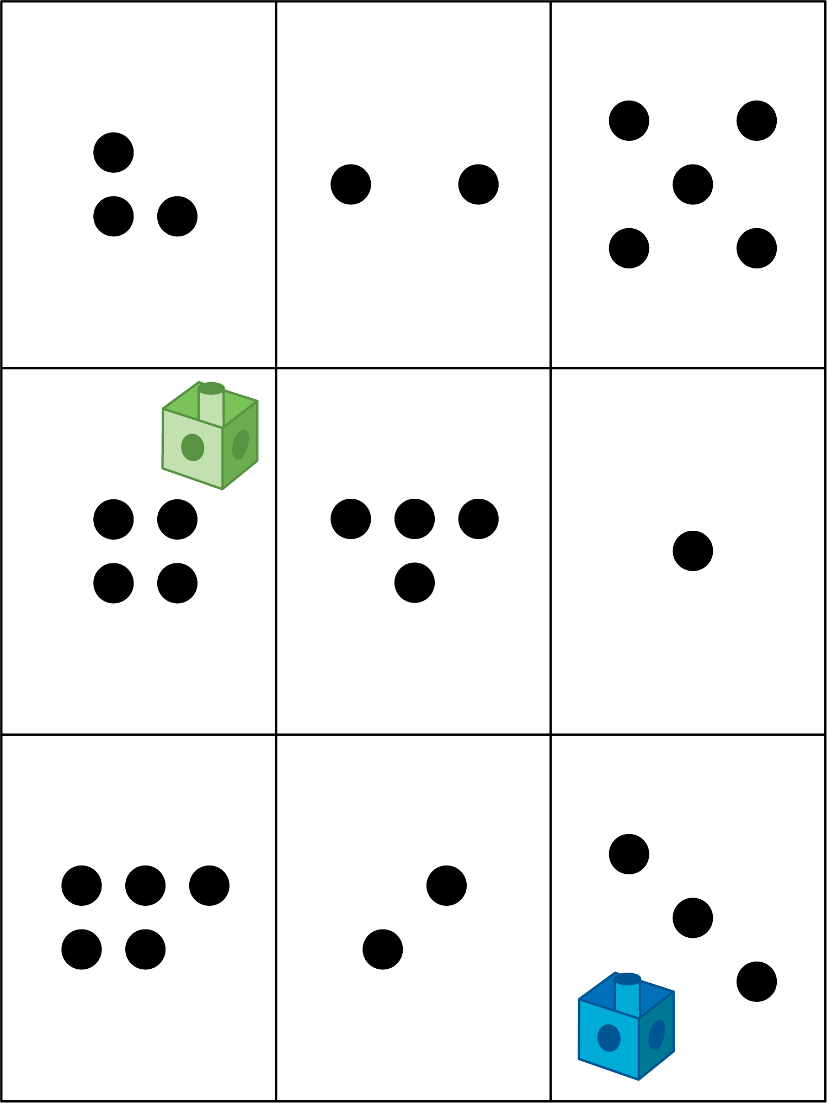

Section Summary
Section Summary
In this section, we found many different ways to make 10.
We used a 10-frame and our fingers to show numbers and figure out how many more are needed to make 10.
There are 4 counters.
We need 6 more counters to make 10.
There are 9 fingers.
We need to put up 1 more finger to make 10.
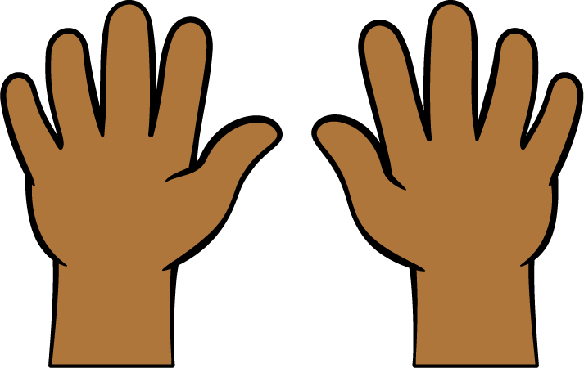
We used equations to show different ways to make 10.
$10=4+6$
$10=9+1$
© CC BY 2021 Illustrative Mathematics®

