Unit 5 Lesson 9: Cylinder Volumes

1 The Same But Different (Warm up)

Student Task Statement
Here are two solids.
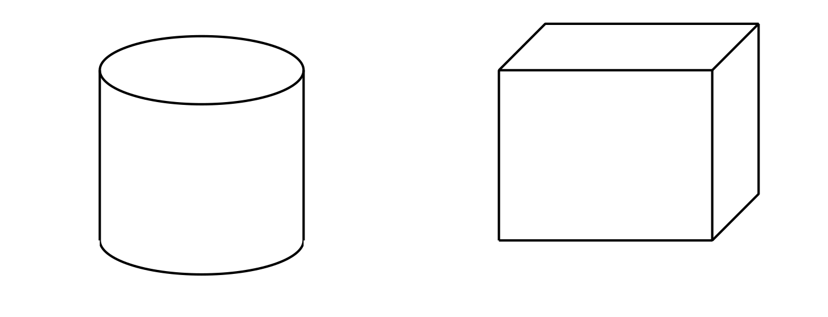
- What information would you need to calculate the volume of each solid?
- What is the same and different about how you would find the volume of each solid?

2 Water Transfer

Student Task Statement
Here are two containers. All measurements are in centimeters.
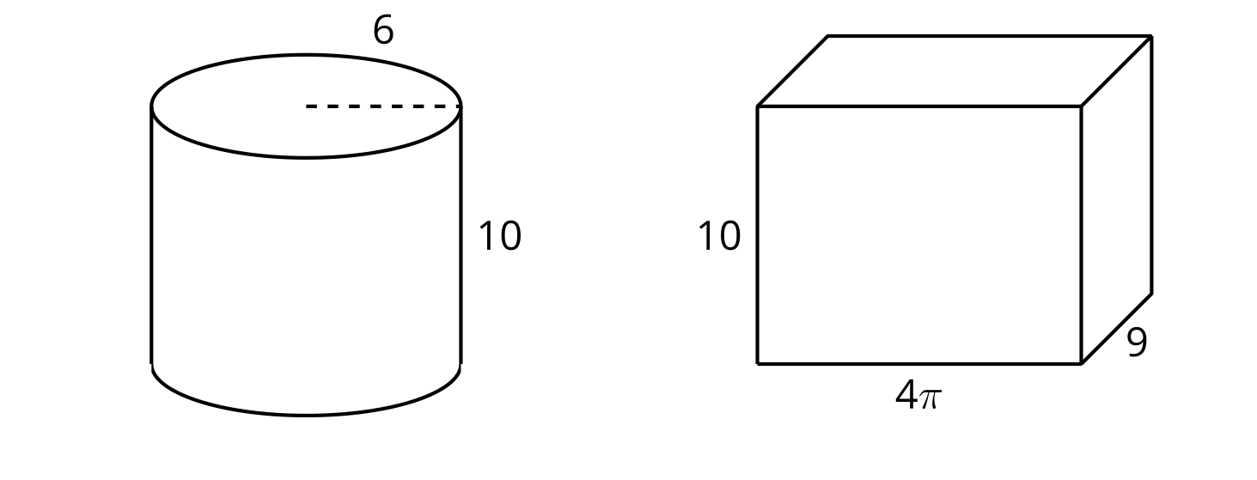
- Suppose the prism contains water that reaches a height of 1 cm.
  - Draw a representation of this situation.
  - The water is poured from the prism into the cylinder. What is the height of the water in the cylinder? Explain your reasoning.
- Suppose the prism contained water that reached a height of 3 cm instead of 1 cm. If the water were poured into the empty cylinder, what would the height of the water in the cylinder be?

3 Revisiting Rotation

Student Task Statement
Suppose each two-dimensional figure is rotated around the vertical axis shown. Each small square in the grid represents 1 square centimeter.

A
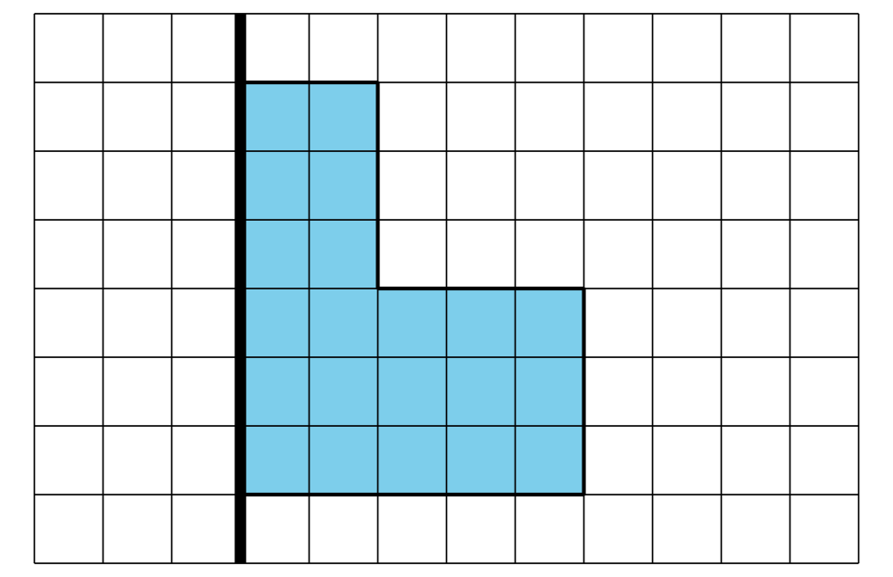

B
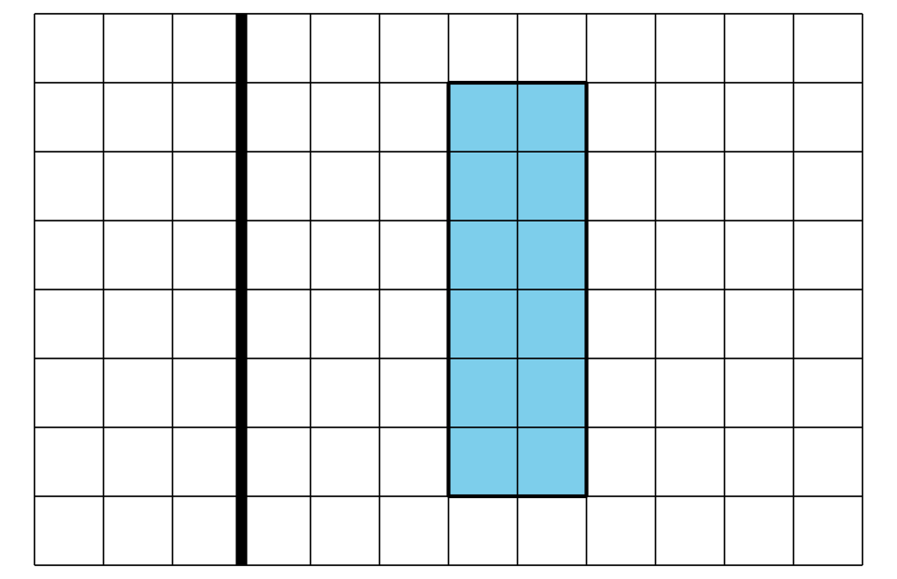
For each solid:
- Either sketch or describe in words the three-dimensional solid that would form.
- Find the solid’s volume.

Images for Activity Synthesis
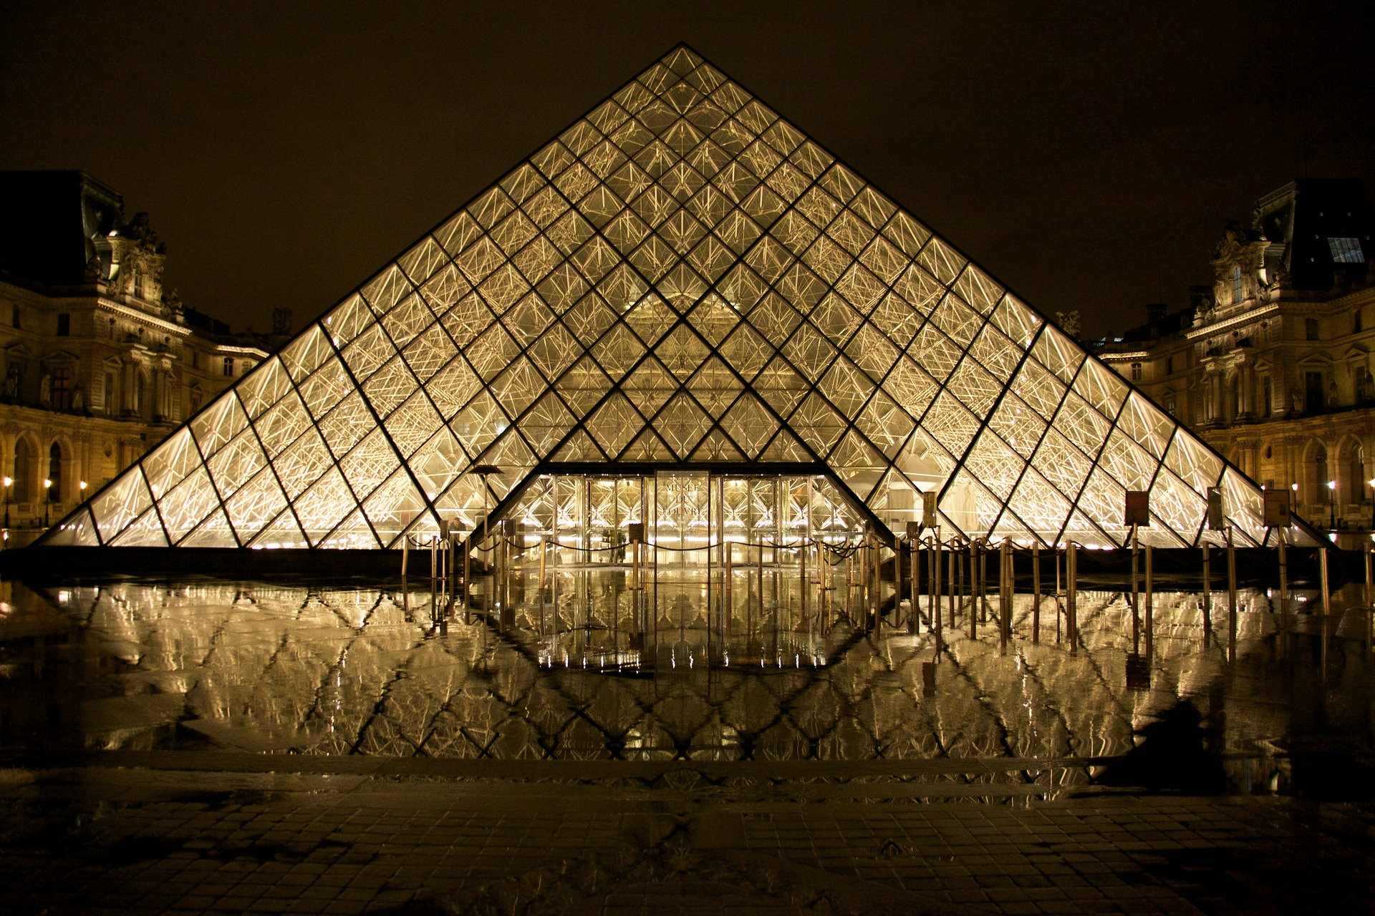
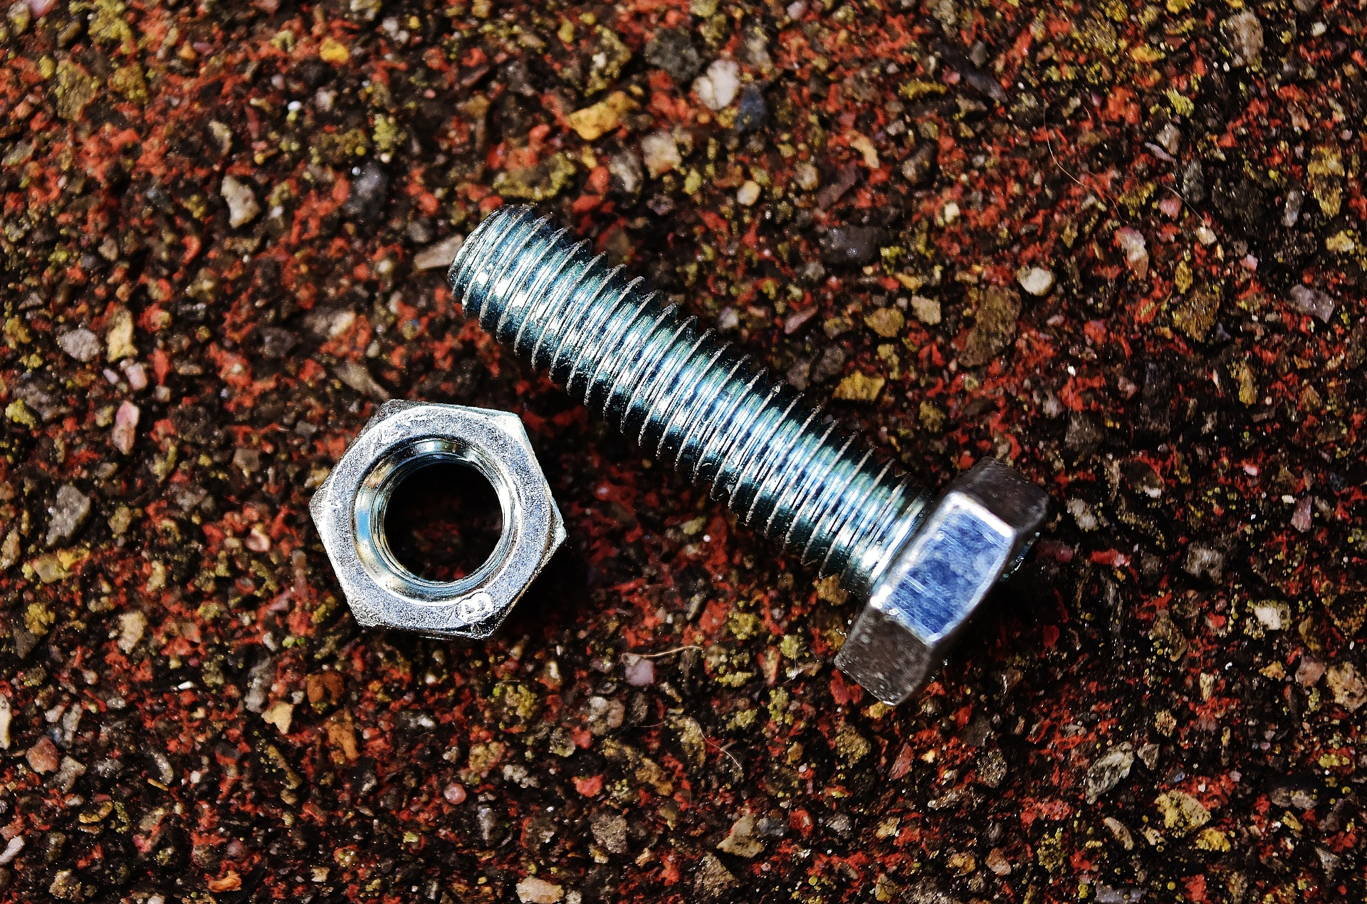
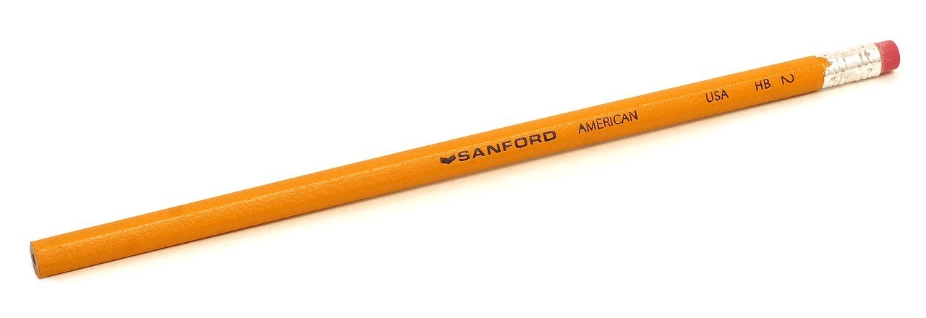
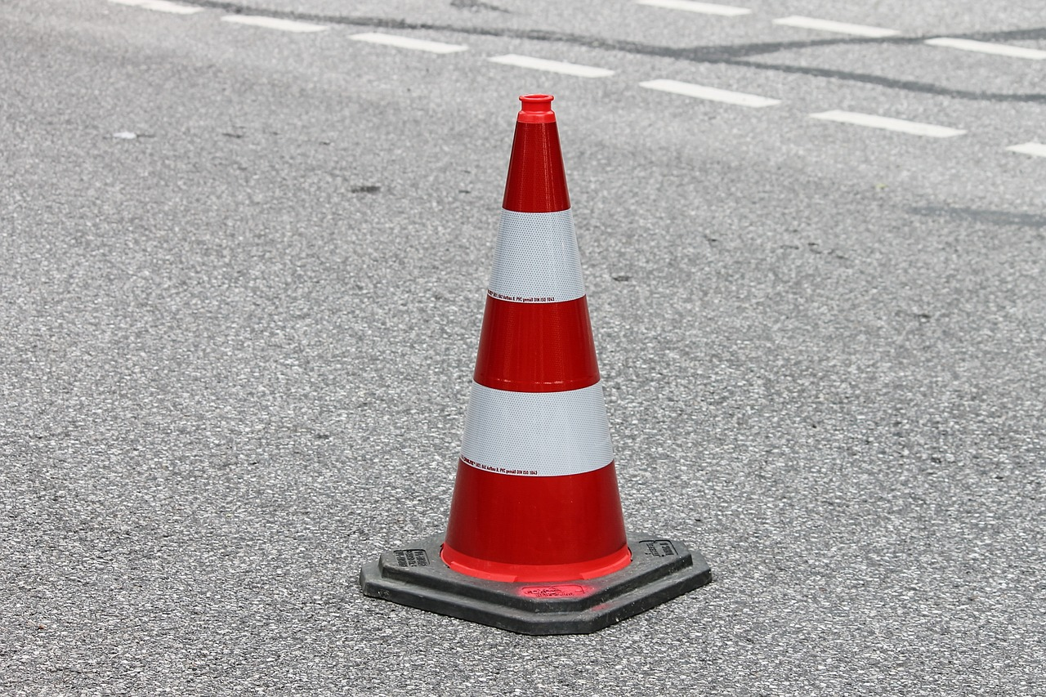
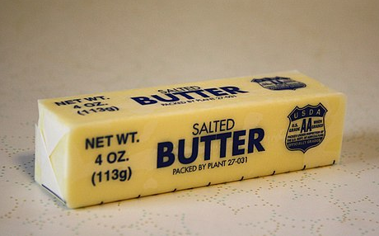
© CC BY 2019 by Illustrative Mathematics®

